|  |  |  |  |  |  |  |  |  |  |  |  |  |  |  |  |  |  |  |
| --- | --- | --- | --- | --- | --- | --- | --- | --- | --- | --- | --- | --- | --- | --- | --- | --- | --- | --- |
|  |  |  |  |  |  |  |  |  |  |  | |  |  |  |  |  |  |  |
|  |  | | | | | |  | | | |  | | | | | | | |
|  |  | | | | | |
|  |  | | | | | |
|  |  | | | | | |  | | | |  | | | | | | | |
|  |  | | | | | |  | | | |  | | | | | | | |
|  |  | | | | | |  | | | |  | | | | | | | |
|  |  | | | | | |
|  |  | | | | | |
|  |  | | | | | |  | | | |  | | | | | | | |
|  |  | | | | | |
|  |  | | |  | | |
|  |  | | |  | | |
|  |  | | |  | | |  | | | |  | | | | | | | |
|  |  | | |  | | |
|  |  | | |  | | |
|  |  | | | | | |
|  |  | | | | | |
|  | | | | | | | | | | | | | | | | | | |



|  |  |  |  |  |  |  |
| --- | --- | --- | --- | --- | --- | --- |
|  |  |  |  |  |  |  |
|  |  |  |  |  |  |  |
|  |  |  |  |  |  |  |
|  |  |  |  |  |  |  |
|  |  |  |  |  |  |  |
|  |  |  |  |  |  |  |
|  |  |  |  |  |  |  |
|  |  |  |  |  |  |  |
|  |  |  |  |  |  |  |
|  |  |  |  |  |  |  |
|  |  |  |  |  |  |  |
|  |  |  |  |  |  |  |
|  |  |  |  |  |  |  |
|  |  |  |  |  |  |  |
|  |  |  |  |  |  |  |
|  |  |  |  |  |  |  |
|  |  |  |  |  |  |  |



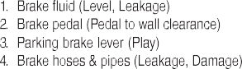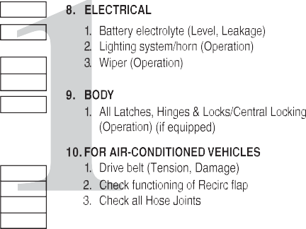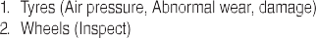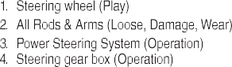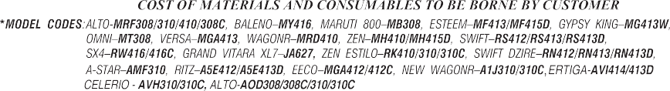

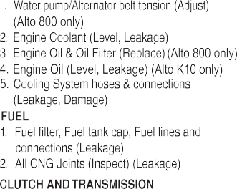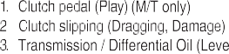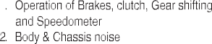

|  |
| --- |
|  |
|  |
|  |
|  |

|  |
| --- |
|  |
|  |
|  |

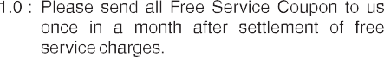

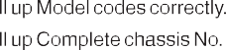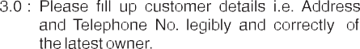

|  |
| --- |
|  |
|  |
|  |

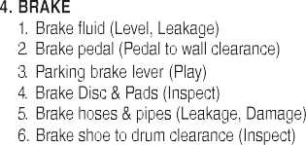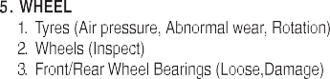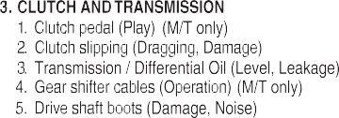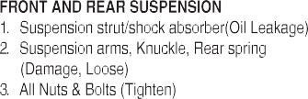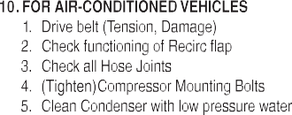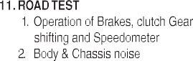

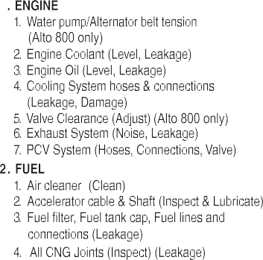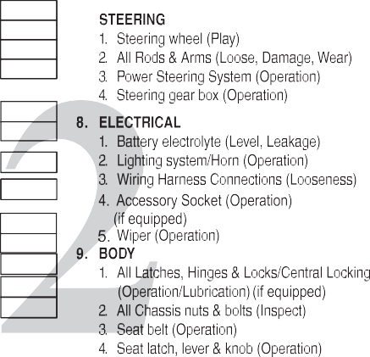

|  |
| --- |
|  |
|  |
|  |
|  |

|  |
| --- |
|  |
|  |
|  |
|  |

|  |
| --- |
|  |
|  |
|  |
|  |
|  |
|  |

|  |
| --- |
|  |
|  |
|  |
|  |
|  |

|  |
| --- |
|  |
|  |
|  |

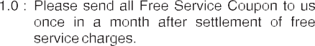

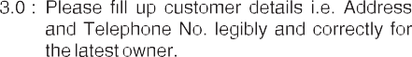

|  |
| --- |
|  |
|  |
|  |

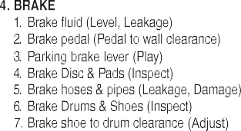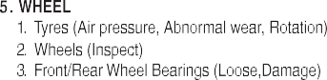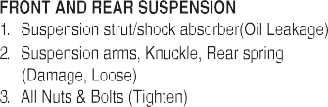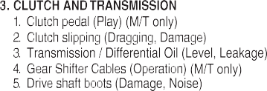

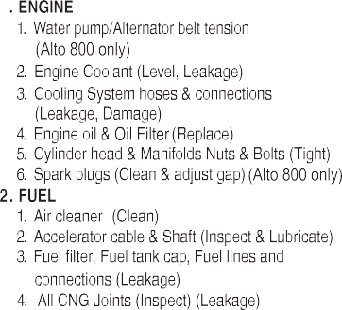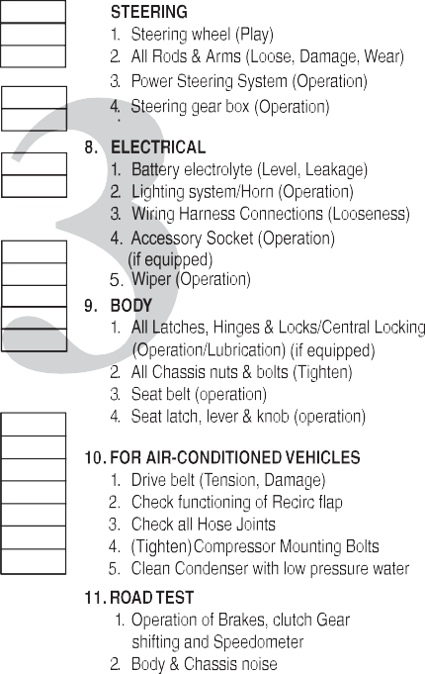

|  |
| --- |
|  |
|  |
|  |
|  |

|  |
| --- |
|  |
|  |
|  |

|  |
| --- |
|  |
|  |
|  |
|  |
|  |

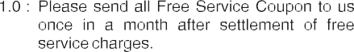

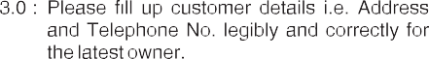

|  |
| --- |
|  |
|  |
|  |

# FOREWORD

This manual is an essential part of your vehicle and should remain with the vehicle when resold or otherwise transferred to a new owner or operator. Please read this manual carefully before operating your new MARUTI SUZUKI and review the manual from time to time. It contains important information on safety, operation and maintenance. You are invited to avail the three Free Inspection Services as described in the manual. Three free inspection coupons are attached to this manual. Please show this manual to your dealer while you take your MARUTI SUZUKI for any Service.

To prolong the life of your vehicle and reduce maintenance cost, the periodic maintenance must be carried out accord- ing to “PERIODIC MAINTENANCE

SCHEDULE” described in “INSPECTION AND MAINTENANCE” section of this man- ual. It is essential for preventing trouble and accidents to ensure your satisfaction and safety.

Daily inspection and care as per “DAILY INSPECTION CHECKLIST” described in the “INSPECTION AND MAINTENANCE”

section of this manual is essential for pro- longing the life of the vehicle and for safe driving.

MARUTI SUZUKI INDIA LIMITED believes

in conservation and protection of Earth’s natural resources.

To that end, we encourage every vehicle owner to recycle, trade-in or properly dis- pose of, as appropriate, used Engine Oil, coolant and other fluids, batteries and tyres etc.

##### MARUTI SUZUKI INDIA LIMITED

**All information in this manual is based on the latest product information avail- able at the time of publication. Due to improvements or other changes, there may be discrepancies between informa- tion in this manual and your vehicle. MARUTI SUZUKI INDIA LIMITED**

**reserves the right to make production changes at any time, without notice and without incurring any obligation to make the same or similar changes to vehicles previously built or sold.**

**This vehicle may not comply with standards or regulations of other**

**countries. Before attempting to regis- ter this vehicle in any other country,**

**check all applicable regulations and make any necessary modifications.**

**0-1**

# IMPORTANT

 **WARNING**/  **CAUTION/*NOTICE****/ NOTE*

Please read this manual and follow its instructions carefully. To emphasize spe- cial information, the symbol and the words **WARNING**, **CAUTION, *NOTICE*** and

*NOTE* have special meanings. Pay particu- lar attention to messages highlighted by these signal words:

# MODIFICATION WARNING

75F135



**Indicates a potential hazard that could result in death or serious injury.**

**WARNING**



**Do not modify your vehicle. Modifica- tion could adversely affect safety, handling, performance, or durability and may violate governmental regula- tions. In addition, damage or perfor- mance problems resulting from modification may not be covered under warranty.**

**WARNING**

The circle with a slash in this manual means “Don’t do this” or “Don’t let this hap- pen”.



**CAUTION**

**Improper installation of mobile com- munication equipment such as cellu- lar telephones, CB (Citizen’s Band) radios or any other wireless transmit- ters may cause electronic interfer- ence with your vehicle’s ignition system, resulting in vehicle perfor- mance problems. Consult your authorised Maruti Suzuki workshop or qualified service technician for advice.**

***NOTICE***

**Indicates a potential hazard that could result in minor or moderate injury.**

**Indicates a potential hazard that could result in vehicle damage.**

***NOTICE***

*NOTE:*

**Severe damage may be caused by the use of either poor quality fuel and/or lubricants not recommended by MARUTI SUZUKI.**

***NOTICE***

*Indicates special information to make maintenance easier or instructions clearer.*

**0-2**

## WARRANTY POLICY

Maruti Suzuki India Limited (hereinafter called “Maruti Suzuki”), warrants that each new Maruti Suzuki vehicle distributed in India by Maruti Suzuki and sold by an authorised Maruti Suzuki dealer will be free, under normal use and service, from any defects in material and workmanship at the time of manufacture SUBJECT TO THE FOLLOWING TERMS AND CONDITIONS:

##### Qualification:

To qualify for this warranty the vehicle must be delivered by a Maruti Suzuki authorised dealer and set-up, and serviced by a Maruti Suzuki authorised dealer / service station.

##### Term:

**The term of the warranty shall be twenty-four (24) months or 40,000 kilometers (whichever occurs first) from the date of invoice to the first owner.**

##### Maruti Suzuki Warranty Obligation:

If any defect(s) should be found in a Maruti Suzuki vehicle within the term stipulated above, Maruti Suzuki’s only obligation is to repair or replace at its sole discretion any part shown to be defec- tive, with a new part or the equivalent at no cost to the owner for parts or labour, when Maruti Suzuki acknowledges that such a defect is attributable to faulty material or workmanship at the time of manufacture. The owner is responsible for any repair or replace- ments which are not covered by this warranty.

##### Limitation:

This warranty shall not apply to:

* 1. Normal maintenance service required other than the three free services, including without limitation, oil and fluid changes, headlight aiming, fastener retightening, wheel bal- ancing, wheel alignment and tyre rotation, cleaning of injec- tors, adjustments of clutch and valve clearance.
  2. The replacement of normal wear parts including without lim- itation, bulbs, tyres and tubes, spark plugs, belts, hoses, fil- ters, wiper blades, brushes, contact points, fuses, clutch disc, brake shoes, brake pads, cable and all rubber parts (except oil seal and glass run).
  3. Any vehicle which has been used for competition or racing.
  4. Any repairs or replacement required as a result of accidents or collision.
  5. Any defects caused by misuse, negligence, abnormal use or insufficient care.
  6. Any vehicle which has been modified or altered, including without limitation, the installation of performance accesso- ries.
  7. Any vehicle on which parts or accessories not approved by Maruti Suzuki have been used.
  8. Any vehicle which has not been operated in accordance with the operating instructions in this Owner’s Manual and Ser- vice Booklet.
  9. Any vehicle which has not received, during the warranty term, the service inspections prescribed in this Owner’s Manual and Service Booklet.
  10. Any vehicle which has been assembled, disassembled, adjusted or repaired by other than an Maruti Suzuki autho- rised dealer/service station.
  11. Any vehicle which has been used for purposes other than what it was designed for.
  12. Any damage or deterioration caused by industrial pollution and bird droppings.

### 0-3

* 1. Insignificant defects which do not affect the function of the vehicle including without limitation, sound, vibration and fluid seep.
  2. Any natural wear and tear including without limitation, aging etc.
  3. Installation and usage of domestic LPG gas/LPG Cylinder.
  4. V-belts, hoses and gas leaks.
  5. Any vehicle retrofitted with LPG/CNG kits.

##### Extent of Warranty:

This warranty is the entire written warranty given by Maruti Suzuki for Maruti Suzuki vehicles and no dealer or its or his agent or employee is authorised to extend or enlarge this warranty and no dealer or its or his agent or employee is authorised to make any oral warranty on Maruti Suzuki’s behalf.

Maruti Suzuki reserves the right to add any improvements or change the design of any model at any time with no obligation to make the same changes on units previously sold.

##### Warranty Service:

To obtain warranty service, the complete vehicle must be pre- sented at the owner’s expenses to any authorised Maruti Suzuki workshop.

##### Owner’s Warranty Responsibilities:

It is responsibility of each owner to:

* Make certain that the PDl card was completed at the time of delivery of the vehicle;
* Have performed, at his own expenses, by an Maruti Suzuki authorised dealer/service station all the service inspections specified in the Maruti Suzuki “Owner’s Manual and Service Booklet and maintain adequate proof that such service inspections have been performed.
* Make certain that the Maruti Suzuki authorised dealer/ser- vice station performing the service inspection has certified the work on the “Maintenance Service Record” page in the “Owner’s Manual and Service Booklet and
* Present the Maruti Suzuki “Owner’s Manual and Service Booklet to the authorised Maruti Suzuki dealer whenever requesting service inspections or warranty service.

If the “Owner’s Manual and Service Booklet should be lost or destroyed the owner should consult the authorised Maruti Suzuki dealer from whom the vehicle was purchased for instructions con- cerning replacement of the “Owner’s Manual and Service Book- let”.

##### Disclaimer of Consequential Damage:

Maruti Suzuki assumes no responsibility for loss of vehicle, loss of

time, inconvenience or any other indirect incidental or consequen- tial damage resulting from the vehicle not being available to the

owner because of any defect covered by this warranty.

##### Change of Owner

Even if ownership of the vehicle changes, the remaining warranty period is effective for the new owner.

**0-4**

## EMISSION WARRANTY POLICY

Maruti Suzuki offers the Emission Warranty on all Maruti Suzuki vehicles (apart from the Regular Warranty and will run parallel to the regular product warranty) only in four metropolitan cities **(New Delhi, Kolkata, Mumbai and Chennai)** with effect from July 1st, 2001.

##### Terms:

The Emission Warranty will be applicable for **80,000 kms or 3 years** (Whichever comes earlier) from the date of invoice to the first owner. The remaining warranty terms will be valid in case of any change in ownership provided the production of all valid docu- ments.

##### Conditions:

1. Under Emission Warranty, Warranty claims will be admitted for a prima facie examination, in case vehicle fails to meet the Emission Standard as specified in sub rule (2) of rule no. 115 of Central Motor Vehicles Rules (CMVR), 1989.
2. The warranty claims will only be accepted after examination carried out by Maruti Suzuki or it’s dealer which leads to firm conclusions that the
   1. Original settings have not been tampered in any case.
   2. Part (as given in Annexure - A) has a manufacturing defect.
   3. Vehicle is unable to meet the Emission Standards (as given in 1.), inspite of the vehicle having been maintained and used in accordance with the instructions as specified in Owner’s Manual and Service Booklet and the used fuel and different oils (Engine oil, Transmission oil, Brake oil etc.) are also as per specification.
3. The method of examination for deciding the warranty of the parts will be at the sole discretion of Maruti Suzuki and it’s dealer and results of the examination will be final and binding. If after examination, the warrantable condition is not estab- lished, Maruti Suzuki and it’s dealer has the right to charge all, or part of the cost of such examination.
4. Under Emission Warranty, the parts (as given in Annexure - A) will be changed free of cost, but the consumables will be charged as per actual.
5. If the part covered under Emission Warranty or the associated parts, are not independently replaceable, on account of these being integral parts of a complete assembly, Maruti Suzuki and it’s dealer will have the sole discretion to replace either the entire assembly or by using some of the parts of the system through suitable repairs or modifications.
6. Any consequential repairs or replacement of parts which may be found necessary to establish compliance of Emission War- ranty, will not be considered under warranty, unless the same is under product warranty. The consumable will be charged as per actual under such repair or replacement.
7. Maruti Suzuki will not be responsible for the cost of transporta- tion of the vehicle to the nearest Maruti Suzuki dealer work- shop or any loss due to non-availability of the vehicle during the period of lodging of a warranty claim and examination and/ or repair by Maruti Suzuki dealer.
8. Maruti Suzuki will not be responsible for any penalty that may be charged by statutory authorities on account of failure to comply with the EMISSION STANDARDS.
9. Emission Warranty will not be affected on the change of owner, provided all the documents are available.

### 0-5

1. All maintenance actions (as specified in the Owner’s Manual and Service Booklet) need to be followed and recorded in the manual for emission warranty.
2. The customer needs to produce the PUC (Pollution Under Control) certificate valid for the period preceding the test during which the failure is discovered. The receipts (for the mainte- nance of the vehicle as per specification in Owner’s Manual and Service Booklet from the date of original purchase of the vehicle) will also be required.

##### Conditions under which the Emission Warranty is not APPLICABLE

1. In the absence of valid PUC certificate.
2. Vehicle not serviced from Maruti Suzuki authorised workshop as per the schedule specified in this Owner’s Manual and Ser- vice Booklet.
3. Vehicle subjected to abnormal use (accident, motor race, ral- lies or for the purpose of establishing the records etc).
4. Use of non MGP (Maruti Genuine Part).
5. Vehicle that has been tampered with.
6. Tampering with odometer so that the actual kilometer reading can not be determined.
7. Use of adulterated fuel and/or unspecified oils (Engine oil, Transmission oil and Brake oil etc).

## Annexure - A

List of parts covered under Emission Warranty

1. Fuel Injection Assembly, Pressure Regulator, Throttle Body Assembly
2. Electronic Control Module (ECM).
3. Intake Manifold.
4. EGR valve.
5. Ignition Coil.
6. Canister Assembly.
7. Vapour Liquid Seperator.
8. Fuel Tank and Filler Cap.
9. PCV (Positive Crankcase Ventilation) Valve.
10. Oil Filler Cap.
11. Catalytic Convertor.
12. Exhaust Manifold.
13. All Fuel Injection System related SENSORS.
14. High Pressure Fuel Pump.
15. Glow Plug.
16. Glow Plug Controller.

**0-6**

# TABLE OF CONTENTS

**8**

**EMERGENCY SERVICE**

**1**

**FUEL RECOMMENDATION**

**2**

**BEFORE DRIVING**

**3**

**OPERATING YOUR VEHICLE**

**4**

**DRIVING TIPS**

**5**

**OTHER CONTROLS AND EQUIPMENT**

**6**

**VEHICLE LOADING AND TOWING**

**7**

**INSPECTION AND MAINTENANCE**

**9**

**APPEARANCE CARE**

**10**

**GENERAL INFORMATION**

**11**

**SPECIFICATIONS**

**12**

**SERVICE NETWORK**

**FUEL RECOMMENDATION**

# FUEL RECOMMENDATION

**Fuel Recommendation 1-1**

**1**

**FUEL RECOMMENDATION**

## Fuel Recommendation

You must use unleaded gasoline with an octane number (RON) of 91 or higher.

**The fuel tank has an air space to allow for fuel expansion in hot weather. If you continue to add fuel after the filler nozzle has automati- cally shut off or an initial blowback occurs, the air chamber will become full. Exposure to heat when fully fuelled in this manner will result in leakage due to fuel expansion. To prevent such fuel leakage, stop filling after the filler nozzle has automati- cally shut off, or when using an alter- native non-automatic system, initial vent blowback occurs.**

***NOTICE***

Gasoline/Ethanol blends

Blends of unleaded gasoline and ethanol (grain alcohol), also known as gasohol, are commercially available in some areas. Blends of this type may be used in your vehicle if they are no more than 10% etha- nol. Make sure this gasoline-ethanol blend has octane ratings no lower than those recommended for gasoline.

Gasoline/Methanol blends

Blends of unleaded gasoline and methanol (wood alcohol) are also commercially avail- able in some areas. DO NOT USE fuels containing more than 5% methanol under any circumstances. Fuel system damage or vehicle performance problems resulting from the use of such fuels are not the responsibility of MARUTI SUZUKI and may not be covered under the New Vehicle Warranty. Fuels containing 5% or less methanol may be suitable for use in your vehicle if they contain cosolvents and cor- rosion inhibitors.

**Be careful not to spill fuel containing alcohol while refueling. If fuel is spilled on the vehicle body, wipe it up immediately. Fuels containing alco- hol can cause paint damage, which is not covered under the New Vehicle Warranty.**

***NOTICE***

*NOTE:*

*If you are not satisfied with the driveability or fuel economy of your vehicle when you are using a gasoline/alcohol blend, you should switch back to unleaded gasoline containing no alcohol.*

**1-1**

# BEFORE DRIVING

**BEFORE DRIVING**

Keys 2-1

Ignition Key Reminder (if equipped) ................................. 2-2 2

Door Locks 2-2

Keyless Entry System (if equipped) 2-5

Windows 2-10

Mirrors 2-11

Front Seats 2-12

Rear Seats 2-13

Seat Belts and Child Restraint Systems 2-14

Supplemental Restraint System

(air bags) (if equipped) 2-22

Instrument Cluster .............................................................. 2-28

Warning and Indicator Lights 2-30

Speedometer 2-34

Fuel Gauge 2-35

Information Display 2-36

Lighting Control Lever 2-38

Headlight Leveling Switch 2-40

Turn Signal Control Lever 2-40

Hazard Warning Switch 2-41

Windshield Wiper and Washer Lever 2-41

Horn 2-43

**BEFORE DRIVING**

## Keys



**EXAMPLE**

51KM024

##### Immobilizer System

This system is designed to help prevent vehicle theft by electronically disabling the engine starting system.

The engine can be started only with your vehicle’s original immobilizer ignition key which has an electronic identification code programmed into it. The key communi- cates the identification code to the vehicle when the key is turned to the “ON” posi- tion. If you need to make spare keys, see your MARUTI SUZUKI dealer. The vehicle must be programmed with the correct iden- tification code for the spare keys. A key made by an ordinary locksmith will not work.

*NOTE:*

* *If you lose your immobilizer ignition key, see your MARUTI SUZUKI dealer as soon as possible to have the lost one deactivated, then have the new key made by them.*
* *If you own other vehicles with immobi- lizer keys, keep those keys away from the ignition switch when using your MARUTI SUZUKI, or the engine may not be started because they may interfere with your MARUTI SUZUKI’s immobi- lizer system.*
* *If you attach any metal objects to the immobilizer key, it may not start the engine.*

Your vehicle comes with a pair of keys. The key(s) may or may not be equipped with a transmitter depending on model variant. Keep the spare key in a safe place. One key can open all of the locks on the vehicle.

The key identification number is stamped on a metal tag provided with the keys or on the keys. Keep the tag (if equipped) in a safe place. If you lose your keys, you will need this number to have new keys made. Write the number below for your future ref- erence.

KEY NUMBER:

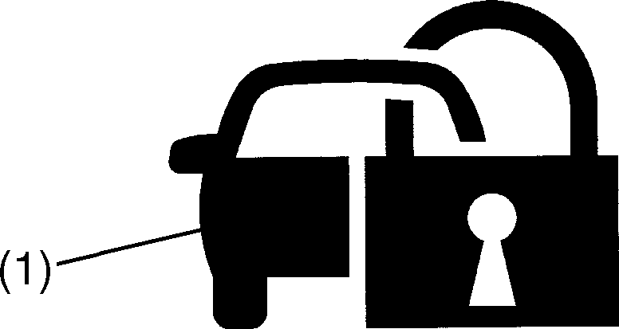

54G003

**The immobilizer key is a sensitive electronic instrument. To avoid dam- aging the immobilizer key:**

* **Do not expose it to impacts, mois- ture or high temperature such as on the dashboard under direct sun- light.**
* **Keep the immobilizer key away from magnetic objects.**

***NOTICE***

If the immobilizer system light (1) blinks when the ignition switch is in the “ON” posi- tion, there may be something wrong with your key or with the immobilizer system. Ask your MARUTI SUZUKI dealer to inspect the system.

**2-1**

## Ignition Key Reminder (if equipped)

A buzzer sounds intermittently to remind you to remove the ignition key if it is in the ignition switch when the driver’s door is opened.

## Door Locks

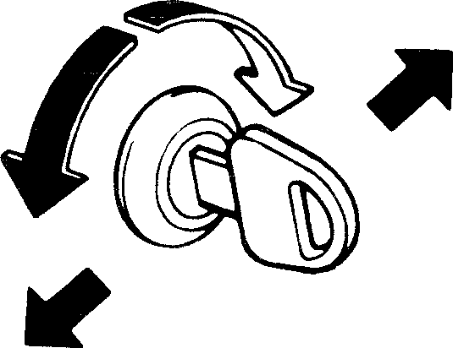

UNLOCK

LOCK

Front

Rear

60B008

To lock a driver’s door from outside the vehicle:

* Insert the key and turn the top of the key toward the rear of the vehicle, or
* Push the lock knob downward, then pull and hold the door handle as you close the door.

To unlock a driver’s door from outside the vehicle, insert the key and turn the top of the key toward the front of the vehicle.

To lock a front passenger’s door from out- side the vehicle, push the lock knob down, then pull and hold the door handle as you close the door.

#### BEFORE DRIVING

##### Side Door Locks (if equipped)



LOCK

UNLOCK

Rear

Front

60B008

To lock a driver’s door from outside the vehicle:

* Insert the key and turn the top of the key toward the rear of the vehicle, or
* Push the lock knob downward, then pull and hold the door handle as you close the door.

To unlock a driver’s door from outside the vehicle, insert the key and turn the top of the key toward the front of the vehicle.

### 2-2

#### BEFORE DRIVING

To lock a rear door from outside the vehi- cle, push the lock knob down and close the door. You do not need to pull and hold the door handle as you close the door.



**EXAMPLE**

UNLOCK

LOCK

##### Central Door Locking System (if equipped)

**Driver’s door**



**EXAMPLE**

LOCK

UNLOCK

Rear

Front

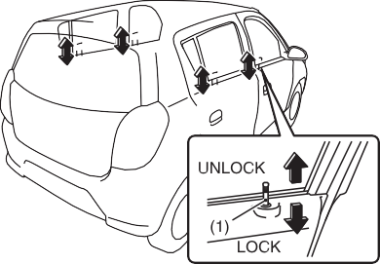

**EXAMPLE**

53MH0201

To lock a door from inside the vehicle, push the lock knob down. Pull the lock knob up to unlock the door.

60B008

You can lock and unlock all doors simulta- neously by using the key in the driver’s door lock.

To lock all doors simultaneously, insert the key in the driver’s door lock and turn the top of the key toward the rear of the vehicle.

To unlock all doors simultaneously, insert the key in a driver’s door lock and turn the top of the key toward the front of the vehicle.

53M-04-006

You can also lock or unlock doors by push- ing down or pulling up the driver’s door lock knob (1).

### 2-3

#### BEFORE DRIVING

##### Child-Proof Locks (rear door) Tailgate

1. LOCK
2. UNLOCK

53M-04-007

53M-04-008

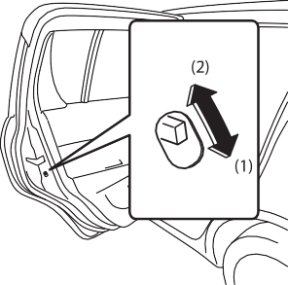

**EXAMPLE**

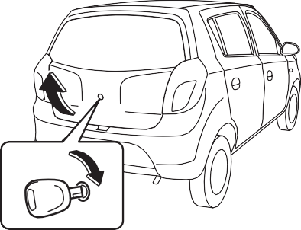

**EXAMPLE**

To open the tailgate, insert the key and

53M-04-009

You can also unlatch the tailgate by pulling

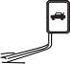

**EXAMPLE**

the release lever (if equipped) located on



**Always make sure that the tailgate is closed and latched securely. Com- pletely closing the tailgate helps pre- vent occupants from being thrown from the vehicle in the event of an accident. Completely closing it also helps keep exhaust gases from enter- ing the vehicle.**

**WARNING**

Each of the rear doors is equipped with a child-proof lock which can be used to help prevent unwanted opening of the door from inside the vehicle. When the lock lever is in the “LOCK” position (1), the rear door can only be opened from outside. When the lock lever is in the “UNLOCK” position (2), the rear door can be opened from inside or outside.

turn it clockwise to unlatch and lift the tail- gate.

**Do not use the key to lift up the tail- gate, or the key may break off in the lock.**

***NOTICE***

the outboard side of the driver’s seat.



**Be sure to place the child-proof lock in the “LOCK” position whenever children are seated in the rear.**

**WARNING**

### 2-4

**BEFORE DRIVING**

## Keyless Entry System (if equipped)

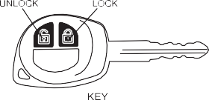

**EXAMPLE**

53M-04-010

##### Keyless Entry

You can lock / unlock all doors simultane- ously by operating the transmitter near the vehicle.

* To lock all doors, press “LOCK” button once. All indicator lights will flash once when doors are locked.
* To unlock all doors, press “UNLOCK” button once. All indicator lights will flash twice when doors are unlocked.

*NOTE:*

* *The operating distance of the keyless entry system transmitter is about 20 meters, but this may vary depending on the condition of transmitter’s battery and surroundings especially near other transmitting devices such as radio tow- ers.*
* *The door locks cannot be operated with the transmitter if the ignition key is inserted in the key cylinder or if any door is open.*
* *Be sure to close the doors and windows before locking.*
* *If you lose any of the transmitters (keys), contact your MARUTI SUZUKI autho- rised dealer as soon as possible for erasing the transmitter ID from vehicle controller memory. In case you need a new transmitter, place an order with your dealer.*
* *Key cylinder mentioned in this section is the key hole mounted on steering col- umn, where key is inserted to start the vehicle.*

**The transmitter is a sensitive elec- tronic instrument. To avoid damaging the transmitter:**

* **Do not expose it to impacts, mois- ture, dust or high temperature such as leaving it on the dashboard under direct sunlight.**
* **Do not tamper with internal parts.**
* **Keep the transmitter away from magnetic objects such as a televi- sion.**

***NOTICE***

##### GENERAL FEATURES

Illuminated Entry

When vehicle is unlocked, the room lamp will turn ON to facilitate illuminated entry into the vehicle. The room lamp will turn OFF when the door is closed.

Illuminated Exit

When door is opened to exit the vehicle, the room lamp will turn ON and will turn OFF when the door is closed.

Auto Relock

In case of accidental Unlock/Disarm of vehicle by Key, vehicle will automatically Lock within 30 sec. without any indication. Auto relock cycle gets canceled if user does any of the following operation within 30 sec:

1. Open any door.
2. Insert key in cylinder.
3. Any door is locked/unlocked by door knob.

Radio Frequency Lock Out

Key Lock/Unlock/Panic will cease to func- tion when Key is inside Key cylinder.

### 2-5

#### BEFORE DRIVING

Car Locator

53M-04-011



**EXAMPLE**

###### PROGRAMMABLE FEATURES

System has some features which can be programmed by user according to their choice.

Auto Lock Mode

Drive lock mode can be set to Auto Lock mode or can be turned OFF. If drive lock mode is set to auto lock, all the vehicle doors will lock when vehicle attains the speed of 15 Km/hr. If drive is set to OFF, no door will lock by speed.

*NOTE:*

Auto Unlock Mode

Drive unlock can be set to Auto Unlock mode or can be turned OFF. When set to Auto Unlock mode, turning Ignition ON to OFF and then removing the key from the key cylinder will unlock all the doors. If Drive Unlock mode is set to OFF then no door will unlock by removing key from key cylinder.

Car Locator feature can be used to locate the vehicle in congested parking area.

* 1. Press and hold the Key LOCK & UNLOCK button simultaneously for 3 seconds or more.
  2. Car Locator will be activated and indi- cator lights will flash for 27 seconds.
  3. Press and release the Key LOCK & UNLOCK button simultaneously to can- cel the Car Locator.

*Auto Lock Mode will get cancelled if any door is open while driving.*

### 2-6

#### BEFORE DRIVING

Programming Auto Lock/Unlock Mode

1. When the ignition switch is in the “ON” position and the vehicle is stationary, push the odometer/trip meter/meter illu- mination selector knob, to switch the information display indication to the odometer reading.



1. Push and hold the odometer/trip meter/ meter illumination selector knob until the display shows “A-LOC”.
2. Push the odometer/trip meter/meter illumination selector knob to select a function that you want to set up accord- ing to the below mentioned table.
3. 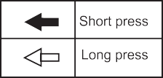To program a Auto Lock/Auto Unlock mode function first select the desired function and the press and hold the odometer/trip meter/meter illumination selector knob.
   * One flash of the indicator light will con- firms that Auto Lock/Auto Unlock mode is activated.
   * Two flash of the indicator light confirm that Auto Lock /Auto Unlock mode is deactivated.

53M-04-012

**2-7**

## Transmitter battery

**Replacement of the Battery**

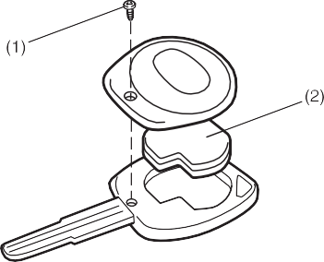

**EXAMPLE**

#### BEFORE DRIVING

53M-04-013

If the transmitter battery gets discharged, replace the battery with a new one.

To replace the battery of the transmitter:

1. Remove the screw (1), and open the transmitter cover.
2. Remove the transmitter (2).
3. Put the edge of a flat blade screw driver in the slot of the transmitter (2) and pry it open.
4. Replace the battery (3) (Lithium disc type CR1620) so that its +ve terminal faces the bottom cover of the transmit- ter (5).

53M-04-014

1. Close the transmitter and install it into the transmitter holder.

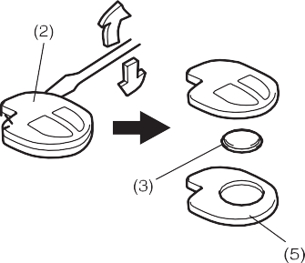

**EXAMPLE**



**CAUTION**

1. Close the transmitter cover, install and tighten the screw (1).

**Dispose off the used battery properly according to applicable rules or regu- lations. Do not dispose off lithium batteries with ordinary household trash.**

1. Make sure the door locks can be oper- ated with the transmitter.

*NOTE:*

*Normal battery life is approximately 2 years, but varies depending on usage. It is advisable to get battery replaced from MARUTI SUZUKI Authorized workshop.*



**Swallowing a lithium battery may cause serious internal injury. Do not allow anyone to swallow a lithium battery. Keep lithium batteries away from chil- dren and pets. If swallowed, contact a physician immediately.**

**WARNING**

**Do not remove the screw from the key unnecessarily as it damages the screw head. Kindly replace the screw once the transmitter battery is changed.**

**CAUTION**

53M-04-015

### 2-8

**BEFORE DRIVING**

**TROUBLESHOOTING**

|  |  |  |
| --- | --- | --- |
| **SYMPTOMS** | **PROBABLE CAUSES** | **REMEDIES** |
| Transmitter function (Unlock/Lock/Car Locator) not working | 1. Battery of the transmitter is weak. 2. Transmitter is exposed to water or it is wet. 3. D/L or Dome fuse for controller is blown in the vehicle. 4. In case if any door is open or door sen- sor is shorted with the body ground, remote will not activate the central lock- ing. | 1. Check the battery. 2. Dry the transmitter and check it. 3. Check and replace the D/L or Dome fuse. 4. Check if all doors are properly closed and door switch functioning is O.K. |
| Operation distance of the transmitter is less than 20m but still transmitter (Unlock/ Lock/Car Locator) is not working | 1. Battery of the transmitter is weak. 2. Strong RF interference. (e.g. Radio Towers, High Voltage Transmission line near by) | 1. Check the battery. 2. Drive the vehicle away from the particu- lar spot and re-test the control distance. |
| It is difficult to activate or deactivate the system in certain area using the transmitter. | 1. The strong interference caused by excessive RF activity in a particular area | 1. The interference is temporary and only while the vehicle is in that area. |

**2-9**

## Windows

##### Manual Window Control (if equipped)

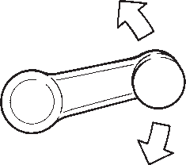

**EXAMPLE**

53M-04-016

Raise or lower the door windows by turning the handle located on the door panel.

##### Electric Window Controls (if equipped)

The electric windows can only be operated when the ignition switch is in the “ON” posi- tion.

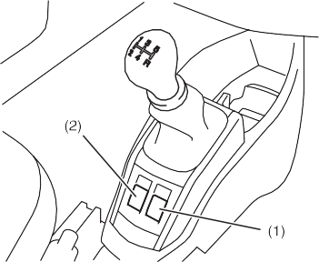

**EXAMPLE**

53M-04-017

The center console has a switch (1) to operate the driver’s window, and a switch

1. to operate the front passenger’s win- dow.

#### BEFORE DRIVING

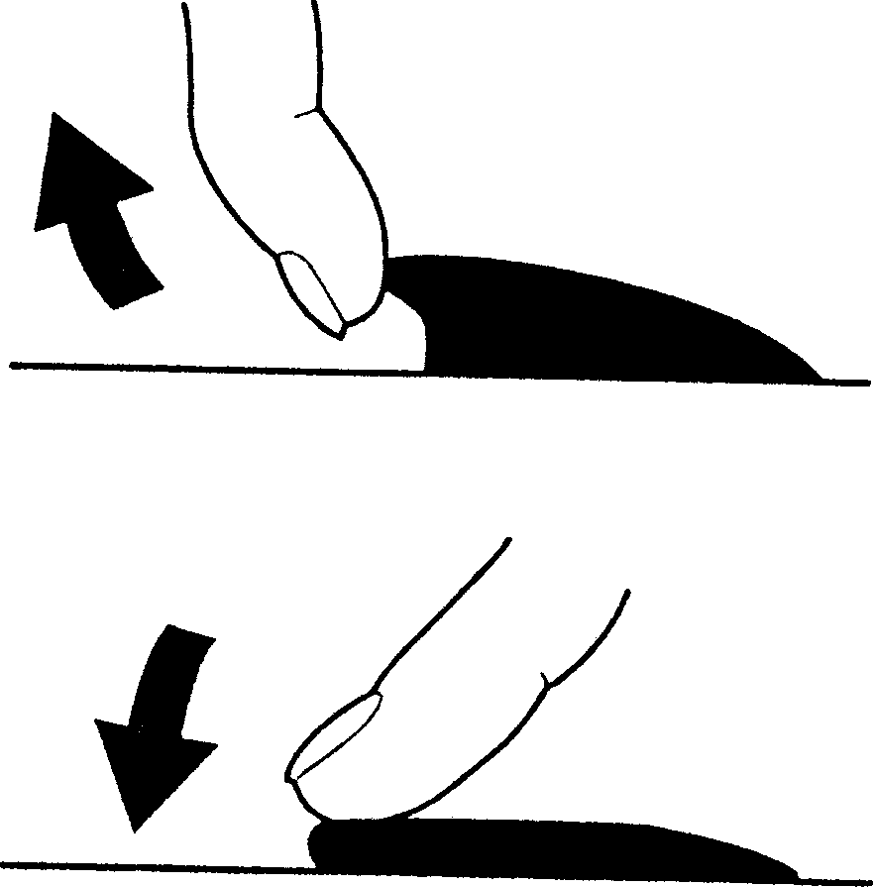

**EXAMPLE**

81A009

To open a window, push the top part of the switch and to close the window, lift up the top part of the switch.

### 2-10

#### BEFORE DRIVING

## Mirrors



* **To avoid injuring an occupant by window entrapment, be sure no part of the occupant’s body such as hands or head is in the path of the electric windows when closing them.**
* **Always remove the ignition key when leaving the vehicle even if only for a short time. Also do not leave children alone in a parked vehicle. Unattended children could use the electric window switches and get trapped by the window.**

**WARNING**

##### Inside Rearview Mirror

Type 1



**EXAMPLE**



**EXAMPLE**

*NOTE:*

*If you drive with one of the rear windows open, you may hear a loud sound caused by air vibration. To reduce the sound, open the driver’s or front passenger’s window, or narrow the rear window opening.*

53M-04-019

You can adjust the inside rearview mirror by hand so as to see the rear of your vehi- cle in the mirror.

##### Outside Rearview Mirrors

Adjust the outside rearview mirrors so you can just see the side of your vehicle in the mirrors.

Type 2

53M-04-020

53M-04-021

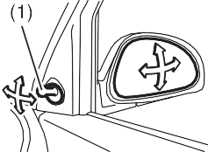

**EXAMPLE**

You can adjust the outside rearview mir- rors by hand with the knob (1) located on the driver’s or front passenger’s door panel (if equipped).



**Be careful when judging the size or distance of a vehicle or other object seen in the side convex mirror. Be aware that objects look smaller and appear farther away than when seen in a flat mirror.**

**WARNING**

**2-11**

## Front Seats

##### Seat Adjustment

##### Adjusting Seat Position

**Type 1**

#### BEFORE DRIVING

adjustment lever and slide the seat forward or rearward.

After adjustment, try to move the seat for- ward and rearward to ensure that it is securely latched.

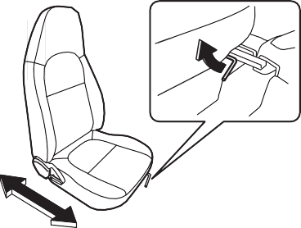

**EXAMPLE**

##### Adjusting Seatbacks



**All seatbacks should always be in an upright position when driving, or seat belt effectiveness may be reduced. Seat belts are designed to offer maxi- mum protection when seatbacks are in the upright position.**

**WARNING**

53M-04-022



**To avoid excessive seat belt slack, which reduces the effectiveness of the seat belts as a safety device, make sure that the seats are adjusted before the seat belts are fastened.**

**WARNING**

**Never attempt to adjust the driver’s seat or seatback while driving. The seat or seatback could move unex- pectedly, causing loss of control. Make sure that the driver’s seat and seatback are properly adjusted before you start driving.**

**WARNING**

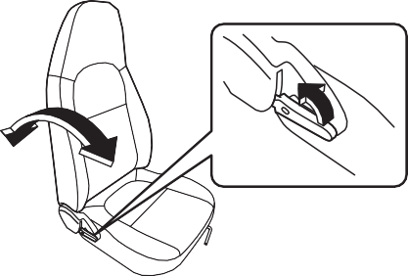

**EXAMPLE**

Type 2

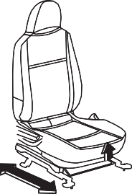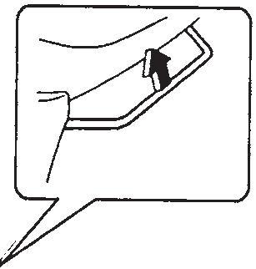

**EXAMPLE**

53M-04-023

The adjustment lever for each front seat is located under the front of the seat. To adjust the seat position, pull up on the

53MH0209

To adjust the seatback angle of front seats, pull up the lever on the outboard side of the seat, move the seatback to the desired position, and release the lever to lock the seatback in place.

### 2-12

**BEFORE DRIVING**

## Rear Seats

##### Folding Rear Seat

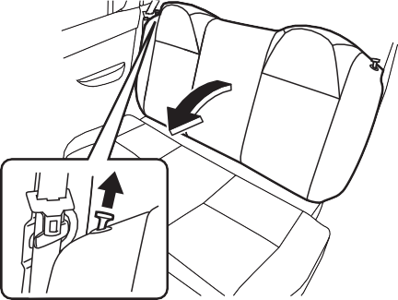

**EXAMPLE**



To return the seat to the normal position, follow the procedure below.

**When returning the rear seatback to the normal position, make sure that there is nothing around the striker. Any foreign materials prevent the seatback from being locked securely.**

**WARNING**

**If you need to carry cargo in the pas- senger compartment with the rear seat back folded forward, be sure to secure the cargo or it may be thrown about, causing injury. Never pile cargo higher than the seatback.**

**WARNING**

The rear seat of your vehicle can be folded forward to provide additional cargo space. To fold the rear seat forward:

53MH0212

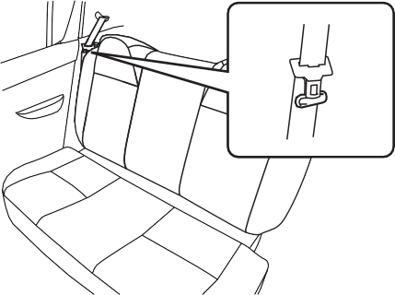

**EXAMPLE**

2) Pull up the release lock knobs on the top of the seat, and fold the seatback forward.

53MH0211



**CAUTION**

**After folding the rear seatback for- ward, do not allow any foreign mate- rial to enter the lock opening. This may cause damage to the inside of the lock and prevent the seatback from being locked securely.**

***NOTICE***

* 1. Hook the webbing of the outboard lap- shoulder belts in the belt hangers.

**When returning the rear seatback to the normal position, be careful that your finger is not caught between the lock and the striker.**

* **When you move a seatback, make sure the belt webbing is hooked in the seat belt hangers so the seat belts are not caught by the seat- back, seat hinge, or seat latch. This helps prevent damage to the belt system.**
* **Make sure the belt webbing is not twisted.**

***NOTICE***

### 2-13

**BEFORE DRIVING**

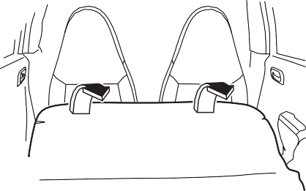

**EXAMPLE**

* **When returning the rear seatback to the normal position, do not allow any foreign material to enter the lock opening. This may prevent the seatback from being locked securely.**
* **When returning the rear seatback to the normal position, be sure to handle it carefully by hand to avoid any damage to the lock itself. Do not push it by using some material or by applying excessive force.**
* **As the lock is designed exclusively for securing the rear seatback, do not use it for any other purpose. Incorrect use of it may cause dam- age to the inside of the lock and prevent the seatback from being locked securely.**

***NOTICE***

## Seat Belts and Child Restraint Systems

53MH0213

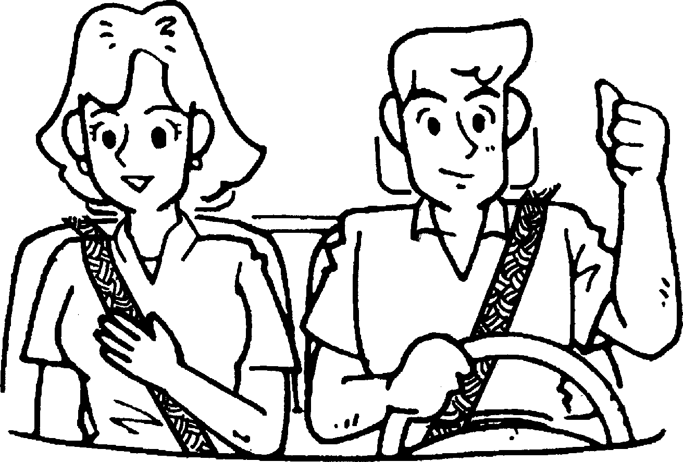

65D231S

**An air bag supplements, or adds to, the frontal crash protection offered by seat belts. The driver and all pas- sengers must be properly restrained by wearing seat belts at all times, whether or not an air bag is mounted at their seating position, to minimize the risk of severe injury or death in the event of a crash.**

**WARNING**

**Wear Your Seat Belts at All Times.**

**WARNING**

**EXAMPLE**

Raise the seatback until it locks into place. After returning the seat, try moving the seatback to make sure they are securely latched.



**CAUTION**

**Do not put your hand into the rear seatback lock opening, or your finger may get caught and be injured.**

### 2-14

**BEFORE DRIVING**

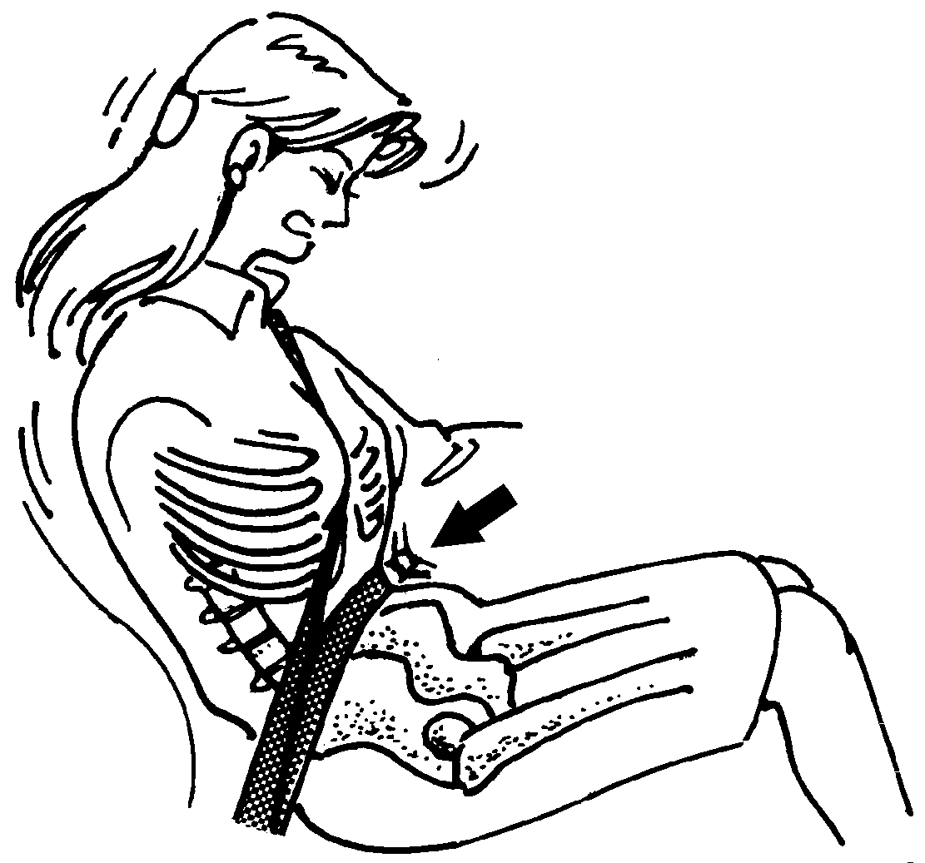

65D606

* **Never allow persons to ride in the cargo area of a vehicle. In the event of an accident, there is a much greater risk of injury for persons who are not riding in a seat with their seat belt securely fastened.**
* **Seat belts should always be adjusted as follows:**
  + **the lap portion of the belt should be worn low across the pelvis, not across the waist.**
  + **the shoulder straps should be worn on the outside shoulder only, and never under the arm.**
  + **the shoulder straps should be away from your face and neck, but not falling off your shoulder.**

(Continued)

**WARNING**

**EXAMPLE**

Above the pelvis

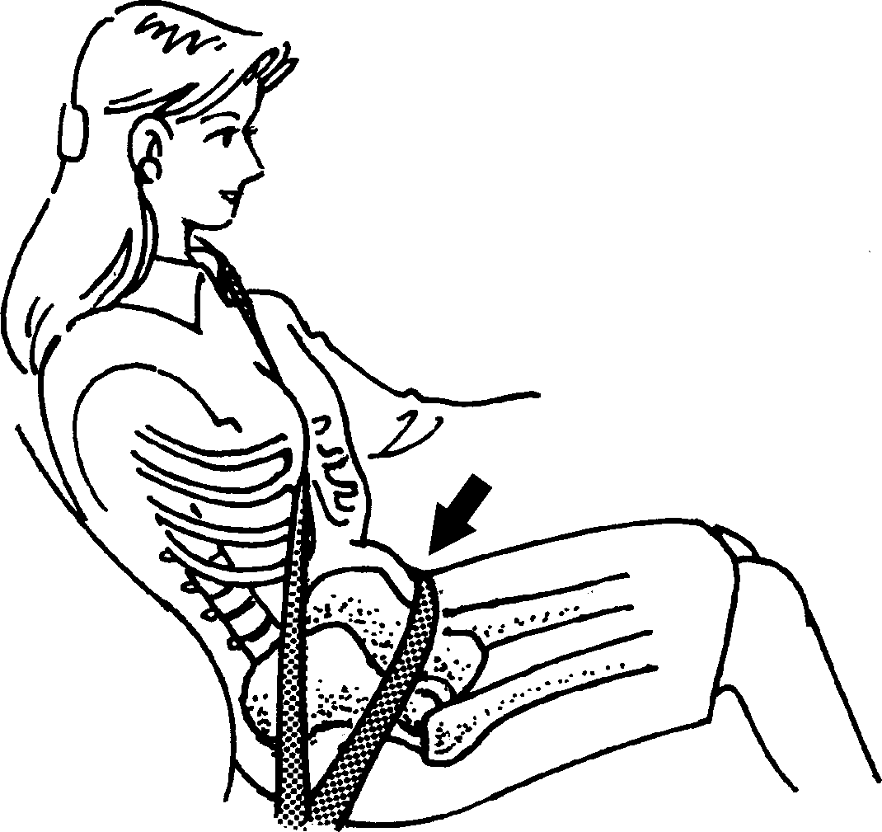

65D201

(Continued)

* **Seat belts should never be worn with the straps twisted and should be adjusted as tightly as is com- fortable to provide the protection for which they have been designed. A slack belt will provide less pro- tection than one which is snug.**
* **Make sure that each seat belt buckle is inserted into the proper buckle catch. It is possible to cross the buckles in the rear seat.**

(Continued)

**WARNING**

**EXAMPLE**

Across the pelvis

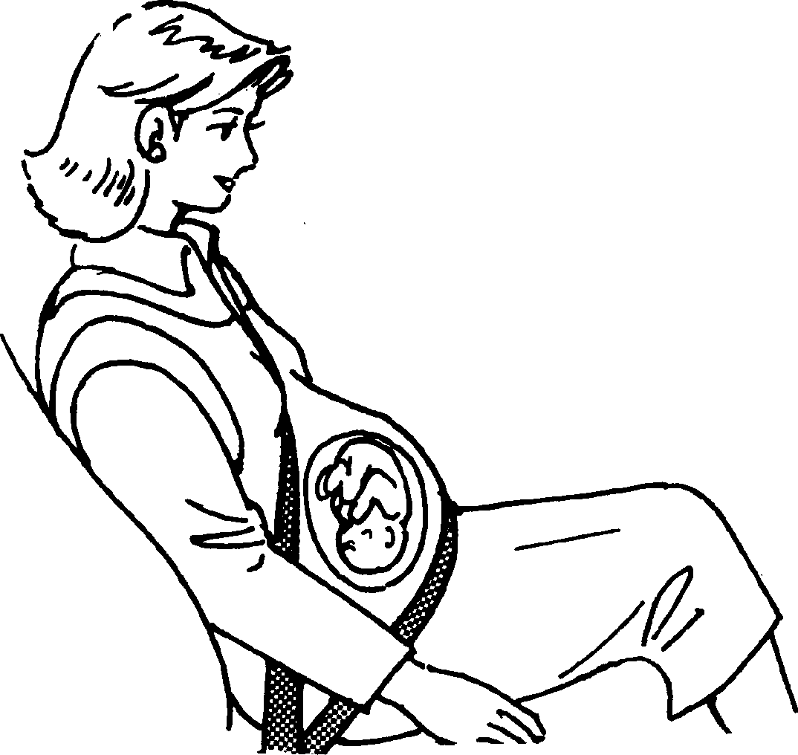

65D199

(Continued)

* **Pregnant women should use seat belts, although specific recommen- dations about driving should be made by the woman’s medical advi- sor. Remember that the lap portion of the belt should be worn as low as possible across the hips, as shown in the diagram.**
* **Do not wear your seat belt over hard or breakable objects in your pockets or on your clothing. If an accident occurs, objects such as glasses, pens, etc. under the seat belt can cause injury.**

(Continued)

**WARNING**

**EXAMPLE**

as low as possible across the hips

### 2-15

#### BEFORE DRIVING

Lap-Shoulder Belt

**Emergency Locking Retractor (ELR) (if equipped)**



(Continued)

* **Never use the same seat belt on more than one occupant and never attach a seat belt over an infant or child being held on an occupant’s lap. Such seat belt use could cause serious injury in the event of an accident.**
* **Periodically inspect seat belt assemblies for excessive wear and damage. Seat belts should be replaced if webbing becomes frayed, contaminated, or damaged in any way. It is essential to replace the entire seat belt assembly after it has been worn in a severe impact, even if damage to the assembly is not obvious.**
* **Children age 12 and under should ride properly restrained in the rear seat.**
* **Infants and small children should never be transported unless they are properly restrained. Restraint systems for infants and small chil- dren can be purchased locally and should be used. Make sure that the system you purchase meets appli- cable safety standards. Read and follow all the directions provided by the manufacturer.**

(Continued)

**WARNING**



(Continued)

* **For children, if the shoulder belt irritates the neck or face, move the child closer to the center of the vehicle.**
* **Avoid contamination of seat belt webbing by polishes, oils, chemi- cals, and particularly battery acid. Cleaning may safely be carried out using mild soap and water.**
* **Do not insert any items such as coins, clips, etc. into the seat belt buckles, and be careful not to spill liquids into these parts. If foreign materials get into a seat belt buckle, the seat belt may not work properly.**
* **All seatbacks should always be in an upright position when driving, or seat belt effectiveness may be reduced. Seat belts are designed to offer maximum protection when seatbacks are in the upright posi- tion.**

**WARNING**

The seat belt has an emergency locking retractor (ELR), which is designed to lock the seat belt only during a sudden stop or impact. It also may lock if you pull the belt across your body very quickly. If this hap- pens, let the belt go back to unlock it, then pull the belt across your body more slowly.

Safety reminder

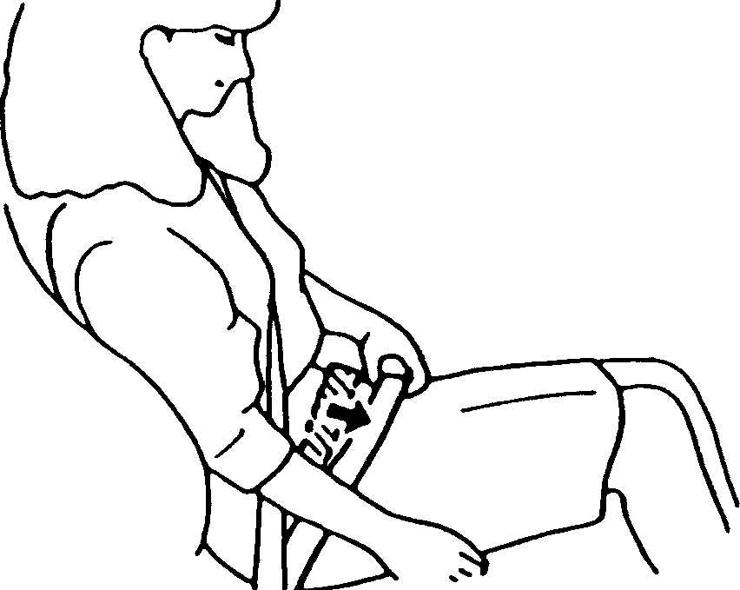

Sit up straight and fully back

Low on hips

**EXAMPLE**

60A038

### 2-16

#### BEFORE DRIVING

##### All Seat Belts Except Rear Center

All seat belts except rear center are the lap-shoulder belt.

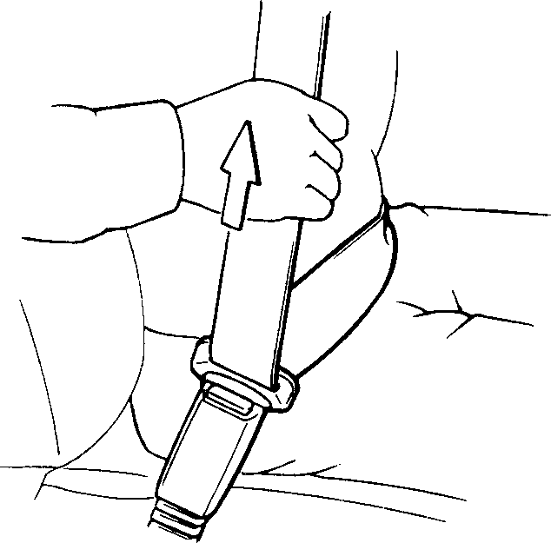

**EXAMPLE**

Low on hips

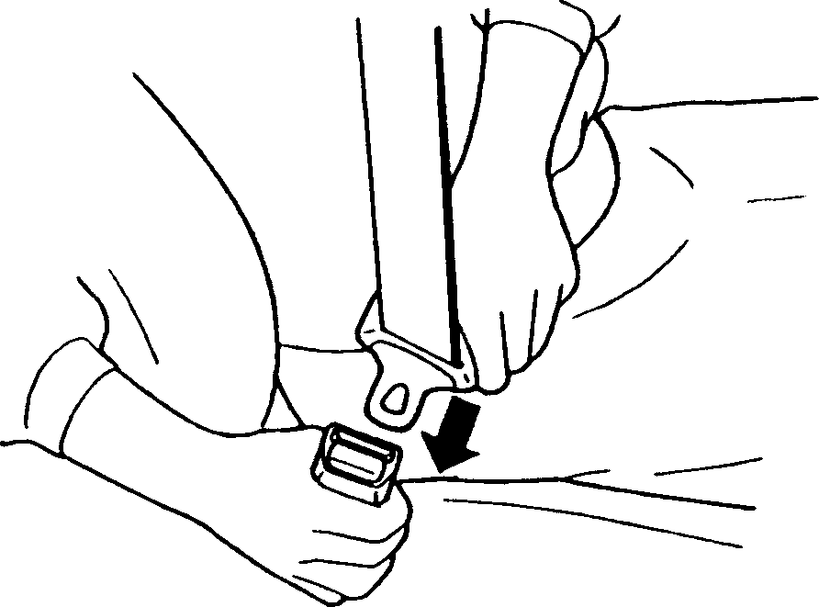

**EXAMPLE**

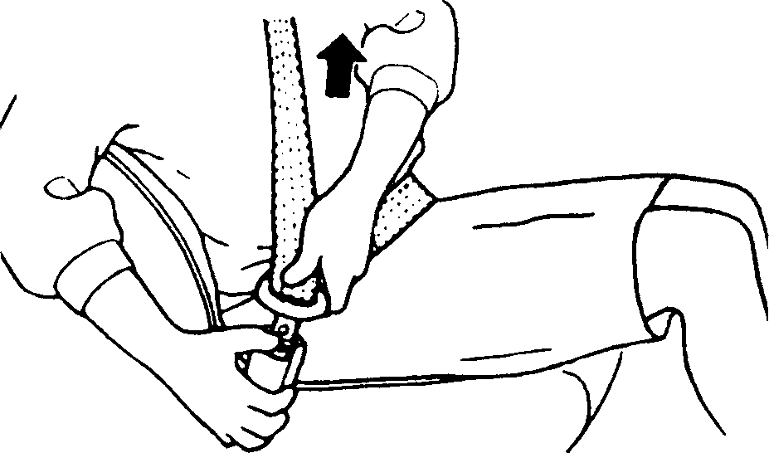

**EXAMPLE**

60A040

To reduce the risk of sliding under the belt during a collision, position the lap portion of the belt across your lap as low on your hips as possible and adjust it to a snug fit by pulling the shoulder portion of the belt upward through the latch plate. The length of the diagonal shoulder strap adjusts itself to allow freedom of movement.

60A036

To fasten the seat belt, sit up straight and well back in the seat, pull the latch plate attached to the seat belt across your body and press it straight into the buckle until you hear a “click”.

60A039

To unfasten the seat belt, push the button on the buckle and retract the belt slowly while attaching a hand to the belt or/and the latch plate.

##### Rear Center Seat Belt

Rear center seat belt is the lap belt.

To fasten the belt, pull the latch plate attached to the seat belt across your hips and press it straight into the buckle until you hear a “click”. To reduce the risk of sliding under the belt during a collision, position the belt across your lap as low on your hips as possible and adjust it to a snug fit.

### 2-17

#### BEFORE DRIVING

the belt. The latch plate should then be refitted into the buckle and the belt tight- ened as previously described.

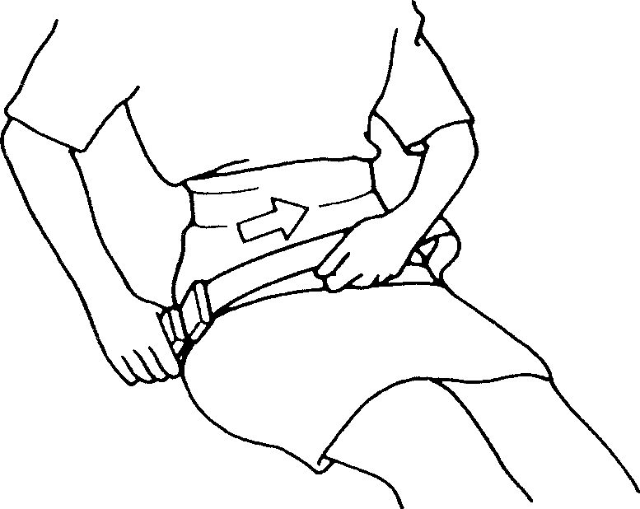

**TO TIGHTEN**

Low on hips

**EXAMPLE**

To unfasten the belt, press the release but- ton on the buckle catch.

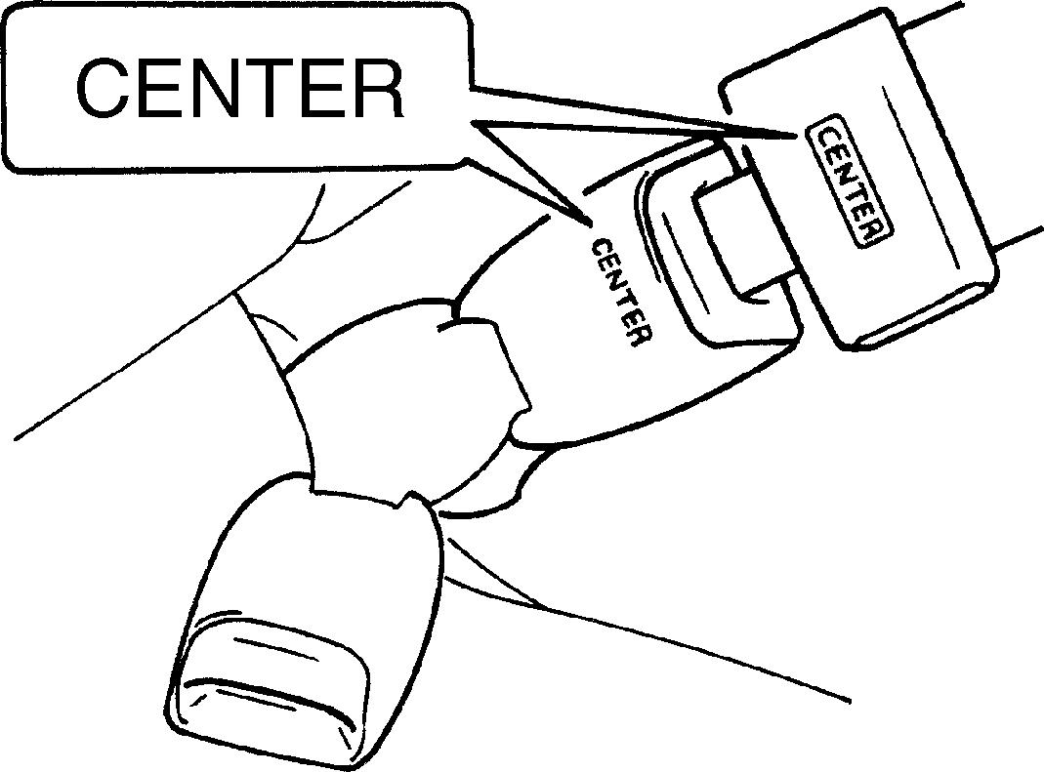

**EXAMPLE**

##### Seat Belt Hanger

80JS028

To tighten the belt, pull the free end of the belt across alongside the lap strap.

53MH0214

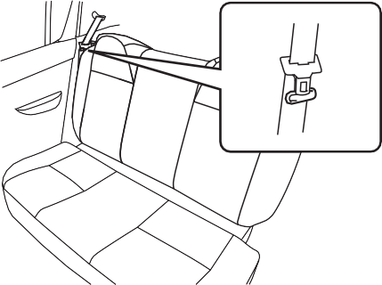

**EXAMPLE**

80JS031

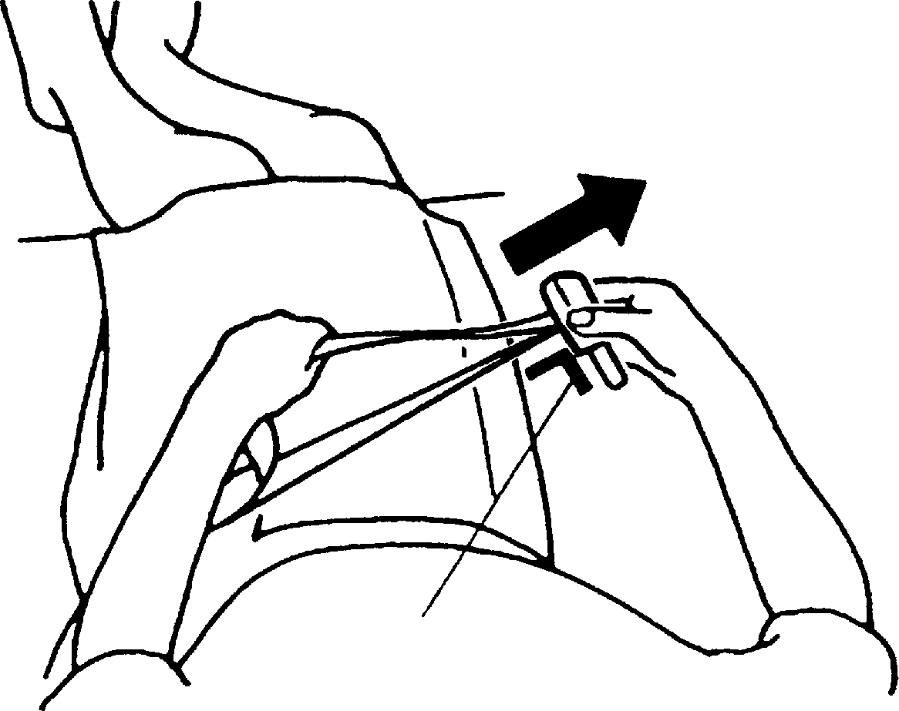

**TO LOOSEN**

Right angle

**EXAMPLE**

* **When you move a seatback, make sure the webbing is hooked in the seat belt hangers so the seat belts are not caught by the seatback, seat hinge, or seat latch. This helps prevent damage to the belt system.**
* **Make sure the belt webbing is not twisted.**

***NOTICE***

*NOTE:*

*To identify the center seat belt buckle and latch plate in the rear seat, “CENTER” is marked on the buckle and latch plate of the center lap belt. The buckles are designed so a latch plate cannot be inserted into the wrong buckle.*

80JS029

To lengthen, release the latch plate from the buckle, pull the latch plate (adjuster) in the direction of the arrow, at right angles to

### 2-18

#### BEFORE DRIVING

##### Seat Belt Inspection

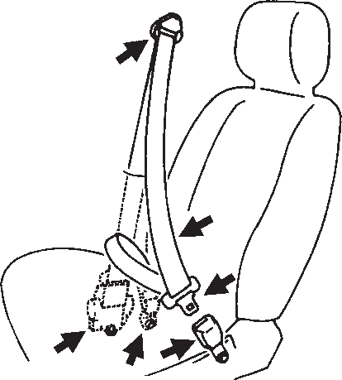

**EXAMPLE**

**Child Restraint Systems**

Child restraint

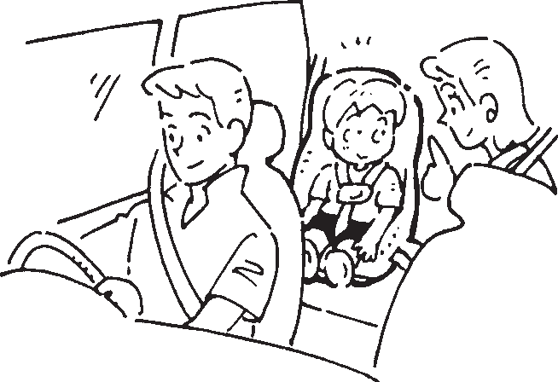

**EXAMPLE**



**EXAMPLE**

53M-04-040

Periodically inspect the seat belts to make sure they work properly and are not dam- aged. Check the webbing, buckles, latch plates, retractors, anchorages, and guide loops. Replace any seat belts which do not work properly or are damaged.

Infant restraint

53M-04-041

Booster seat

53M-04-043

53M-04-042 53M-04-044



**Be sure to inspect all seat belt assemblies after any collision. Any seat belt assembly which was in use during a collision (other than a very minor one) should be replaced, even if damage to the assembly is not obvious. Any seat belt assembly which was not in use during a colli- sion should be replaced if it does not function properly, it is damaged in any way.**

**WARNING**



**EXAMPLE**

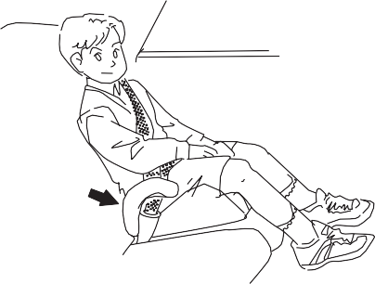

**EXAMPLE**

### 2-19

#### BEFORE DRIVING

MARUTI SUZUKI highly recommends that you use a child restraint system to restrain infants and small children. Many different types of child restraint systems are avail- able; make sure that the restraint system you select meets applicable safety stan- dards.

All child restraint systems are designed to be secured on vehicle seats by either seat belts (lap belts or the lap portion of lap- shoulder belts). Whenever possible, MAR- UTI SUZUKI recommends that child restraint systems be installed on the rear seat. According to accident statistics, chil- dren are safer when properly restrained in rear seating positions than in front seating positions.



**If you install a child restraint system in the rear seat, slide the front seat far enough forward so that the child’s feet do not touch the front seatback. This will help avoid injury to the child in the event of an accident.**

**WARNING**

**If your vehicle is equipped with a front passenger air bag, do not install a rear-facing child restraint in the front passenger’s seat. If the passen- ger’s air bag inflates, a child in a rear- facing child restraint could be killed or seriously injured. The back of a rear-facing child restraint would be too close to the inflating air bag.**

**WARNING**

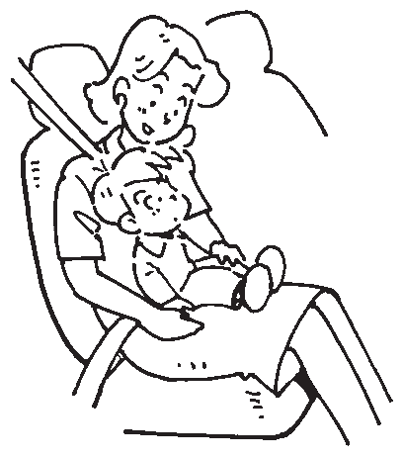

53M-04-047

**Children could be endangered in a crash if their child restraints are not properly secured in the vehicle. When installing a child restraint sys- tem, be sure to follow the instruc- tions below. Be sure to secure the child in the restraint system accord- ing to the manufacturer’s instruc- tions.**

**WARNING**

**EXAMPLE**

If you must use a front-facing child restraint in the front passenger’s seat, adjust the passenger’s seat as far back as possible.

*NOTE:*

*Observe any statutory regulation about child restraints.*

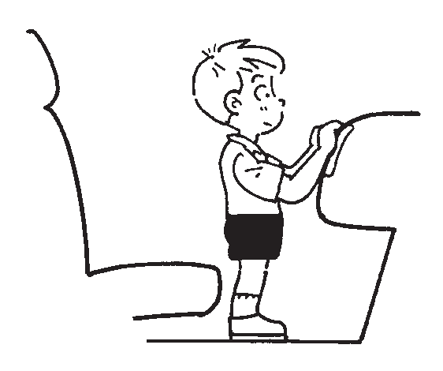

**EXAMPLE**

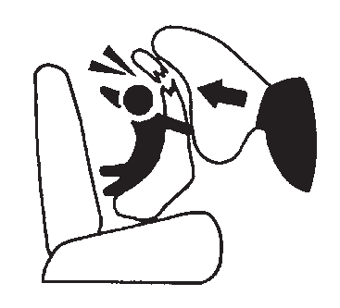

**EXAMPLE**

53M-04-045 53M-04-046

### 2-20

**BEFORE DRIVING**

## Child Restraint System for India

##### Child Restraint

The suitability of each passenger’s seat position for carriage of children and fitting of child restraint system is shown in the table below. Whenever you carry children up to 12 years of age, properly use the child restraints which conform to AIS 072, the standard for child restraints, referring to the table.

|  |  |  |  |  |  |
| --- | --- | --- | --- | --- | --- |
| MASS GROUP | Seating position (or other site) | | | | |
| Front Passenger | Rear Outboard | Rear Centre | Intermediate Outboard | Intermediate Centre |
| Group 0 Up to 10 kg | X | U | X | N.A. | N.A. |
| Group 0+ Up to 13 kg | X | U | X | N.A. | N.A. |
| Group I  9 to 18 kg | X | U | X | N.A. | N.A. |
| Group II 15 to 25 kg | X | U | X | N.A. | N.A. |
| Group III 22 to 36 kg | X | U | X | N.A. | N.A. |

Key of letters to be inserted in the above table:

U =Suitable for ‘universal’ category restraints approved for use in this mass group X =Seat position not suitable for children in this mass group

N.A = Seat position not available for children in this mass group. NOTE: ‘universal’ is the category in the AIS 072.

: ‘Outboard’ indicates window side seat.

### 2-21

Installation with Lap-Shoulder Seat Belts

**ELR type belt (if equipped)**

## Supplemental Restraint System (air bag) (if equipped)

#### BEFORE DRIVING

53MM02013

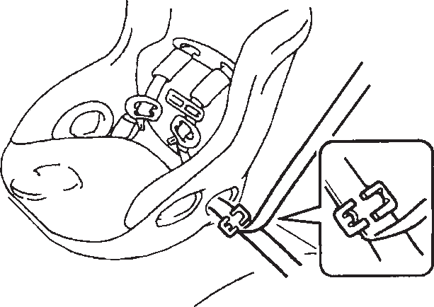

**EXAMPLE**



**This section of the owner’s manual describes the protection provided by your MARUTI SUZUKI SUPPLEMEN- TAL RESTRAINT SYSTEM (air bag).**

**Please read and follow ALL these instructions carefully to minimize your risk of severe injury or death in the event of a collision.**

**WARNING**

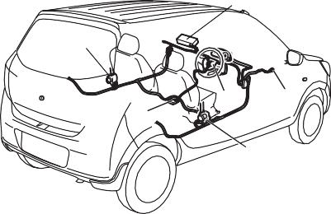

(2)

(3)

(4)

(1) (5)

(3)

**EXAMPLE**

53M-04-048

Install your child restraint system accord- ing to the instructions provided by the child restraint system manufacturer.

Make sure that the seat belt is securely latched.

Try to move the child restraint system in all directions to make sure it is securely installed.

Your vehicle is equipped with a Supple- mental Restraint System consisting of the following components in addition to a lap- shoulder belt at each front seating position.

1. Driver’s front air bag module (if equipped)
2. Front passenger’s front air bag module (if equipped)
3. Seat belt pretensioners (if equipped)
4. Air bag controller (if equipped)
5. Forward crash sensor (if equipped)



53M-04-050

If the “AIR BAG” light on the instrument cluster does not blink or come on when the ignition switch is first turned to the “ON” position, or the “AIR BAG” light stays on, or comes on while driving, the air bag system may not work properly. Have the air bag system inspected by an authorized MAR- UTI SUZUKI dealer as soon as possible.

### 2-22

#### BEFORE DRIVING

##### Front Air Bag (Driver side)

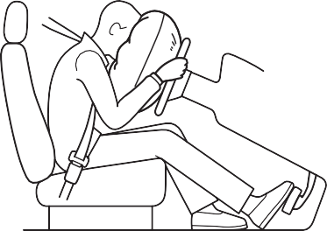

**EXAMPLE**

Frontal collision range

53M-04-051

53M-04-053

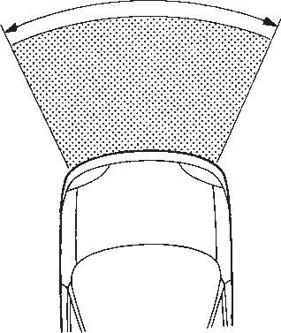

**EXAMPLE**

Front air bag is designed to inflate in severe frontal collisions.

Conditions of front air bags deployment (inflation)



53M-04-055

* In collisions such as above at an angle of about 30 degrees (1) or less from the front.



**Conditions of front air bags may inflate** Receiving a strong impact to the lower body of your vehicle, the front air bags will inflate in many cases.



53M-04-052

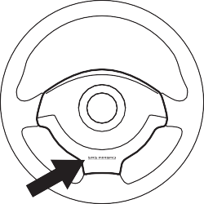

**EXAMPLE**

The driver’s front air bag is located behind the center pad of the steering wheel. The word “SRS AIRBAG” is molded into the air bag cover to identify the location of the air bag.

53M-04-054

* In frontal collisions with a fixed wall that does not move or deform in more than about 25 km/h (15 mph).
* Hitting a curb or medial strip

53M-04-056

### 2-23

#### BEFORE DRIVING

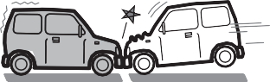

* + Falling into a deep hole or ditch
  + Landing hard or falling

53M-04-057

53M-04-058

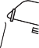

* Collision from the side



* Vehicle rollover

53M-04-060

53M-04-061



53M-04-062

* Approximately 50 km/h (30 mph) or lower speed frontal collision to a stopped vehicle



53M-04-063

Front air bags may inflate in a strong impact

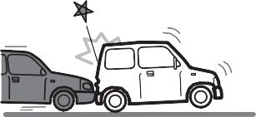

Front air bags may not inflate

The front air bags may not inflate when the impact is absorbed since the collision object moved, vehicle body deformed, or collision angle was greater than about 30 degrees from the front.

* Collision that the front of your vehicle goes under the bed of a truck etc.

53M-04-059

* + Collision from the rear

### 2-24

#### BEFORE DRIVING



53M-04-064

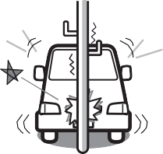

* + Collision with a utility pole or stumpage



53M-04-065

* + Collision with a fixed wall or guardrail at an angle of greater than about 30 degrees (1) from the front



53M-04-066

* + In frontal collisions with a fixed wall that does not move or deform in less than about 25 km/h (15 mph)

53M-04-067

* Collision angle is offset from the vehicle angle (offset collision)

Front air bags are not designed to inflate in rear impacts, side impacts, rollovers or minor frontal collisions, since they would offer no protection in those types of acci- dents. Remember, since an air bag deploys only one time during an accident, seat belts are needed to restrain occu- pants from further movements during the accident.

Therefore, an air bag is NOT a substitute for seat belts. To maximize your protection, ALWAYS WEAR YOUR SEAT BELTS. Be

aware that no system can prevent all pos- sible injuries that may occur in an accident.



**An air bag supplements, or adds to, the crash protection offered by seat belts. The driver and all passengers must be properly restrained by wear- ing seat belts at all times, whether or not an air bag is mounted at their seating position, to minimize the risk of severe injury or death in the event of a crash.**

**WARNING**

Please refer to “Seat Belts and Child Restraint Systems” in this section for details on securing your child.



58MS030

**Do not install a child restraint in the front passenger’s seat. If the passen- ger’s front air bag inflates, a child in a child restraint could be killed or severely injured. Child restraint would be too close to the inflating air bag.**

**WARNING**

**EXAMPLE**

### 2-25

#### BEFORE DRIVING

Air bag symbol (if equipped) meaning



**If the AIR BAG light in the instrument cluster ever comes on and stays on, it means that something may be wrong with the air bag system. If this ever happens, have the vehicle ser- viced immediately, because the air bags may not offer the protection for which they were designed.**

**WARNING**

Please refer to the “Seat Belts and Child Restraint Systems” section in this section for details on securing your child.

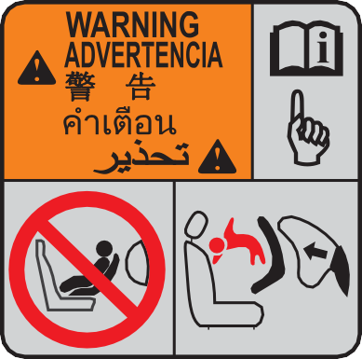

57L20203

You may find this label on the sun visor.

**Do not use a restraint on a seat pro- tected by an airbag in front of it.**

**WARNING**

**EXAMPLE**

##### Door Lock Canceller System (if equipped)

If SRS Airbag system is activated all doors are unlocked automatically.

*NOTE:*

*In case door lock wiring and/or motor are damaged, doors may not unlock automati- cally.*

How the system works

In a frontal collision, the crash sensors will detect rapid deceleration, and if the con- troller judges that the deceleration rep- resents a severe frontal crash, the controller will trigger the inflators. The infla- tors inflate the air bags with nitrogen or argon gas. The inflated air bags provide a cushion for your head and upper body. The air bag inflates and deflates so quickly that you may not even realize that it has acti-

vated. The air bag will neither hinder your view nor make it harder to exit the vehicle.

Air bags must inflate quickly and forcefully in order to reduce the chance of serious or fatal injuries. However, an unavoidable consequence of the quick inflation is that the air bag may irritate bare skin, such as the facial area. Also, upon inflation, a loud noise will occur and some powder and smoke will be released. These conditions are not harmful and do not indicate a fire in the vehicle. Be aware, however, that some air bag components may be hot for a while after inflation.

A seat belt helps keep you in the proper position for maximum protection when an air bag inflates. Adjust your seat as far back as possible while still maintaining control of the vehicle. Sit fully back in your seat; sit up straight; do not lean over the steering wheel. Please refer to the “Front Seat” section and the “Seat Belts and Child Restraint Systems” section in this section for details on proper seat and seat belt adjustments.

### 2-26

#### BEFORE DRIVING

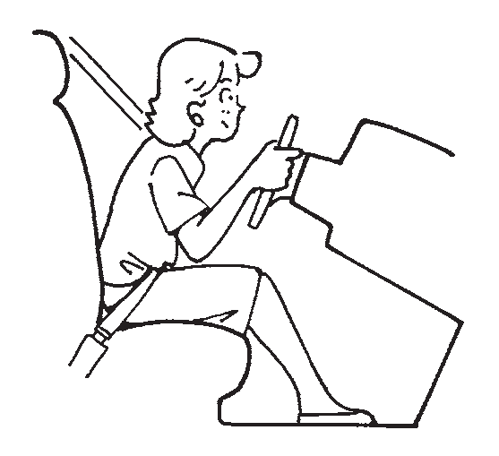

53M-04-068

* **The driver should not lean over the steering wheel. In these situations, the out-of-position occupant would be too close to an inflating air bag, and may suffer severe injury.**
* **Do not attach any objects to, or place any objects over, the steering wheel. Do not place any objects between the air bag and the driver. These objects may interfere with air bag operation or may be propelled by the air bag in the event of a crash. Either of these conditions may cause severe injury.**

**WARNING**

**EXAMPLE**

Note that even though your vehicle may be moderately damaged in a frontal collision, the collision may not have been severe

enough to trigger the air bags to inflate. If your vehicle sustains ANY front-end dam- age, have the air bag system inspected by an MARUTI SUZUKI authorized dealer to ensure it is in proper working order. Your vehicle is equipped with a diagnostic module which records information about the air bag system if the air bags deploy in a crash. The module records information about overall system status, which sensors activated the deployment, and for a certain vehicle only, whether the driver’s seat belt was in use.

Servicing the air bag system

If the air bags inflate, have the air bags and related components replaced by an autho- rized MARUTI SUZUKI dealer as soon as possible.

If your vehicle ever gets in deep water and the driver’s floor is submerged, the air bag controller could be damaged. If it does, have the air bag system inspected by the MARUTI SUZUKI dealer as soon as possi- ble.

Special procedures are required for servic- ing or replacing an air bag. For that reason, only an authorized MARUTI SUZUKI dealer should be allowed to service or replace your air bags. Please remind any- one who services your MARUTI SUZUKI that it has air bag.

Service on or around air bag components or wiring must be performed only by an MARUTI SUZUKI authorized dealer. Improper service could result in unin-

tended air bag deployment or could render the air bag inoperative. Either of these two conditions may result in severe injury.

To prevent damage or unintended inflation of the air bag system, be sure the battery is disconnected and the ignition switch has been in the “LOCK” position for at least 90 seconds before performing any electrical service work on your MARUTI SUZUKI. Do not touch air bag system components or wires. The wires are wrapped with yellow tape or yellow tubing, and the couplers are yellow for easy identification.

Scrapping a vehicle that has an uninflated air bag can be hazardous. Ask your dealer, body repair shop or scrap yard for help with disposal.

**2-27**

## Instrument Cluster

(5)

(1)

(5)

**EXAMPLE**

(2)

(4)

(3)

##### ALTO 800

1. Speedometer
2. Odometer/Trip meter
3. Odometer/Trip meter/Meter illumination selector knob
4. Fuel gauge
5. Warning and indicator lights

**Type 1**

**Type 2**

#### BEFORE DRIVING

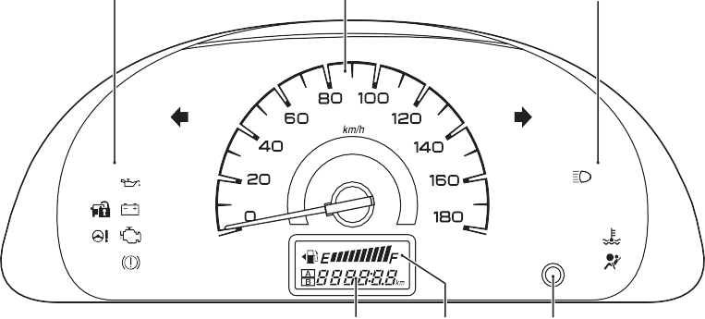

53M-04-069

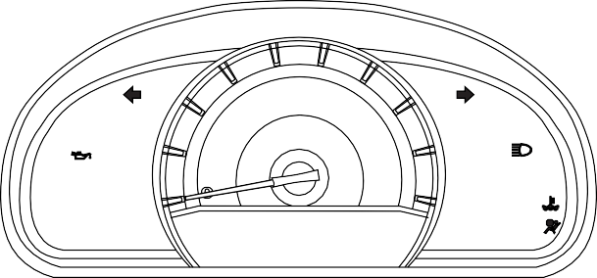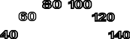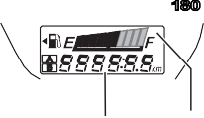

(3)

(4)

(2)

(5)

(5)

**EXAMPLE**

(1)

53MH0237

### 2-28

**BEFORE DRIVING**

## Instrument Cluster

##### ALTO K10

1. Speedometer
2. information display
3. Odometer/Trip meter/Meter illumination selector knob
4. Fuel gauge
5. Warning and indicator lights
6. Tachometer (if equipped)

without tachometer

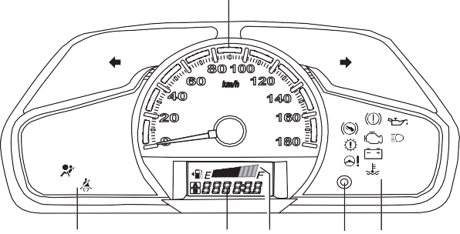

**EXAMPLE**

(1)

(5)

(2) (4)

(3) (5)

53M-04-070

with tachometer

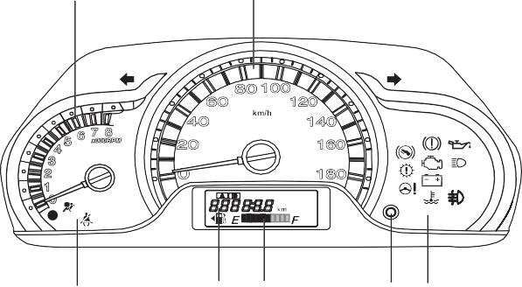

**EXAMPLE**

(6)

(1)

(5)

(2) (4)

(3) (5)

53M-04-071

**2-29**

## Warning and Indicator Lights

##### Brake System Warning Light

mean that there is something wrong with the vehicle’s brake system. If this happens, you should:

1. Pull off the road and stop carefully.



**Remember that stopping distance may be longer, you may have to push harder on the pedal, and the pedal may go down farther than normal.**

**WARNING**

#### BEFORE DRIVING



53M-04-072

Three different types of operations exist depending on the vehicle’s specification.

* 1. The light comes on briefly when the ignition switch is turned to the “ON” position.
  2. The light comes on when the parking brake is engaged with the ignition switch in the “ON” position.
  3. The light comes on when under either or both of above two conditions.

The light also comes on when the fluid in the brake fluid reservoir falls below the specified level.

The light should go out after starting the engine and fully releasing the parking brake, if the fluid level in the brake fluid res- ervoir is adequate.

The light also comes on together with the ABS warning light when the rear brake force control function (proportioning valve function) of the ABS system fails.

If the brake system warning light comes on while you are driving the vehicle, it may

1. Test the brakes by carefully starting and stopping at the side of the road.

* If you determine that it is safe, drive carefully at low speed to the nearest dealer for repairs, or



**If any of the following conditions occur, you should immediately ask your MARUTI SUZUKI dealer to inspect the brake system.**

* **If the brake system warning light does not go out after the engine has been started and the parking brake has been fully released.**
* **If the brake system warning light does not come on when the igni- tion switch is turned to the “ON” position.**
* **If the brake system warning light comes on at any time during vehi- cle operation.**

**WARNING**

* Have the vehicle towed to the nearest

dealer for repairs. *NOTE:*

*Because the disc brake system is self- adjusting, the fluid level will drop as the brake pads become worn. Replenishing the brake fluid reservoir is considered nor- mal periodic maintenance.*

##### Seat Belt Warning Light (if equipped)

53M-04-073

### 2-30

#### BEFORE DRIVING

If the driver’s seat belt is unbuckled when the ignition switch is turned to the “ON” position, this light will blink until the driver’s seat belt is buckled.

For details about the seat belt reminder, refer to “Seat Belts and Child Restraint Systems” in this section.

##### “AIR BAG” Light (if equipped)

**Malfunction Indicator Light**

53M-04-075

**Continuing to drive the vehicle when the malfunction indicator light is on can cause permanent damage to the vehicle’s emission control system, and can affect fuel economy and driveability.**

***NOTICE***

53M-04-074

This light blinks or comes on for several seconds when the ignition switch is turned

Your vehicle has a computer-controlled emission control system. A malfunction indicator light is provided on the instrument panel to indicate when it is necessary to have the emission control system serviced. The malfunction indicator light comes on when the ignition switch is turned to “ON” position to let you know the light is working and goes out when the engine is started.

If the malfunction indicator light comes on

##### Transaxle Warning Light (if equipped)

53M-04-076

to the “ON” position so you can check if the light is working.

The light will come on and stay on if there is a problem in the air bag system.



**If the “AIR BAG” light does not blink or come on briefly when the ignition switch is turned to the “ON” position, stays on for more than 10 seconds, or comes on while driving, the air bag system may not work properly. Have both systems inspected by an MARUT SUZUKI authorized dealer.**

**WARNING**

when the engine is running, there is a damage with the emission control system. Bring the vehicle to your MARUTI SUZUKI dealer to have the damage fixed.

Also, if the light comes on, there may be something wrong with the transaxle sys- tem. Have the system inspected by MAR- UTI SUZUKI authorized dealer.

This light comes on briefly when the igni-

tion switch is turned to the “ON” position or the engine switch is pressed to change the ignition mode to “ON” so you can check the light is working.

If this light comes on when the engine is running, there is the problem with the auto- matic transaxle system. Ask your MARUTI SUZUKI dealer to have the system inspected.

*NOTE:*

*If the automated manual transaxle system temperature becomes too high, this light will blink. Stop the vehicle in a safe place and let the system cool down.*

### 2-31

#### BEFORE DRIVING

##### Electric Power Steering Light (if equipped)



light will come on and remain on if there is insufficient oil pressure. If the light comes on when driving, pull off the road as soon as you can and stop the engine.

Check the oil level and add oil if necessary. If there is enough oil, the lubrication sys- tem should be inspected by your MARUTI SUZUKI dealer before you drive the vehi- cle again.

##### Charging Light



53M-04-079

53M-04-077

This light comes on when the ignition switch is turned to the “ON” position, and goes out when the engine is started.

If this light comes on while driving, the power steering system may not work prop- erly. Have the system inspected by your MARUTI SUZUKI dealer.

*NOTE:*

*If the power steering system does not work properly, you will feel heavier to steer but you still will be able to steer.*

##### Oil Pressure Light

53M-04-078

This light comes on when the ignition switch is turned to the “ON” position, and goes out when the engine is started. The

This light comes on when the ignition switch is turned to the “ON” position, and goes out when the engine is started. The light will come on and remain on if there is something wrong with the battery charging system. If the light comes on when the engine is running, the charging system

should be inspected immediately by your MARUTI SUZUKI dealer.

* **If you operate the engine with this light on, severe engine damage can result.**
* **Do not rely on the Oil Pressure Light to indicate the need to add oil. Be sure to periodically check the engine oil level.**

***NOTICE***

##### High Engine Coolant Temperature Warning Light



53M-04-080

When the ignition switch is turned to the “ON” position, this light comes on briefly so you can check that the light is working. If this light blinks while driving, it means the engine is running hot. Avoid driving condi- tions that may lead to actual overheating. If

### 2-32

#### BEFORE DRIVING

the light stays on without blinking, then the engine is overheating. Follow the instruc- tions in the “If the Engine Overheats” of “EMERGENCY SERVICE” section.

**Continuing to drive the vehicle when engine overheating is indicated can result in severe engine damage.**

***NOTICE***

##### Immobilizer System Light

53M-04-081

This light comes on when the ignition switch is turned to the “ON” position, and goes out when the engine is started. If this light blinks with the ignition switch turned to “ON”, there may be something wrong with the immobilizer system. Ask your MARUTI SUZUKI dealer to have the system inspected.

##### Door Lock Canceller Indicator Light (if equipped)

53M-04-082

This indicator light will come on and keep blinking continuously if there is some prob- lem with door lock canceller system. Have the vehicle inspected by MARUTI SUZUKI authorized dealer.

*NOTE:*

*In case door lock wiring and/or motor are damaged, Door Lock Canceller Indicator Light will not blink.*

##### Gear Shift Indicator (if equipped)

Manual Transaxle



53M-04-083

This indicator informs about upshifting or downshifting the gear while the vehicle is running.

There are three indications:

 Upshift Indicator

This symbol indicates that lower gear posi- tion is selected for vehicle’s current speed and / or engine revolution. Changing to higher gear position is recommended.

 Stay Indicator

This symbol indicates that current gear position is optimal for vehicle’s current speed and / or engine revolution. No gear shifting is required.

*NOTE:*

*While driving in optimal gear position, the upshift/downshift indicator does not appear.*

 Downshift Indicator

This symbol indicates that higher gear position is selected for the vehicle’s current speed and / or engine revolution. Changing to lower gear position is recommended.

### 2-33

##### Turn Signal Indicators



53M-04-084

When you turn on the left or right turn sig- nals, the corresponding green arrow on the instrument panel will flash along with the respective turn signal lights. When you turn on the hazard warning switch, both arrows will flash along with all of the turn signal lights.

##### Main Beam (high beam) Indicator Light



53M-04-085

This indicator comes on when headlight main beams (high beams) are turned on.

##### Front Fog Light Switch (if equipped)

53M-04-086

The front fog light comes on when front fog light operates.

## Speedometer

##### ALTO 800

**Type 1**

**Type 2**

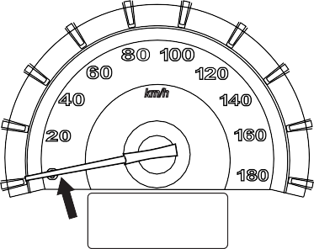

**EXAMPLE**

#### BEFORE DRIVING

53M-04-087

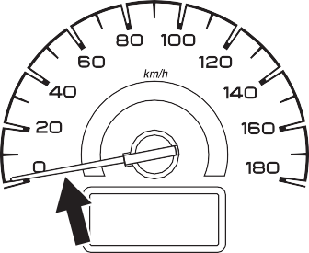

**EXAMPLE**

53MH0238

### 2-34

#### BEFORE DRIVING

##### ALTO K10

Type 1

## Fuel Gauge

##### ALTO 800

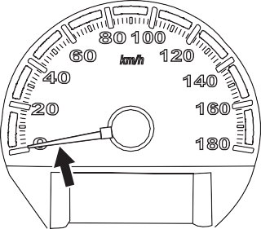

**EXAMPLE**

Type 1



**EXAMPLE**

With tachometer



**EXAMPLE**

**Type 2**

53M-04-090

Automated Manual Transaxle

53M-04-092

53M-04-088



**EXAMPLE**

(1)



**EXAMPLE**

Type 2

53M-04-089

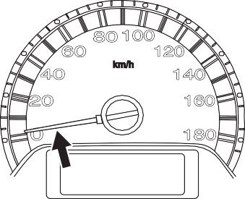

**EXAMPLE**

The speedometer indicates vehicle speed in km/h.

##### ALTO K10

Without tachometer

53MH0239

53M-04-091



**EXAMPLE**

53M-04-093

When the ignition switch is in the “ON” position, this gauge gives an approximate indication of the amount of fuel in the fuel tank. “F” stands for full and “E” stands for empty.

The mark (1) indicates that the fuel filler door is located on the left side of the vehi- cle.

### 2-35

When the fuel meter indicator shows only

## Information Display

**ALTO K10**

#### BEFORE DRIVING

one segment to “E”, refill the tank as soon as possible.

*NOTE:*

* *If the last segment blinks, it means that the fuel is almost empty.*
* *The fuel meter indicator varies depend- ing on road conditions (for example, slope or curve) and driving conditions because of fuel moving in the tank.*

**Depress Brake Pedal Indicator (if equipped)**

**ALTO 800**

**Manual transaxle**

Without tachometer

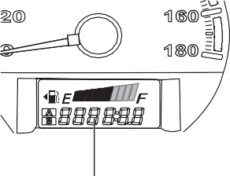

**EXAMPLE**

(1) (2)

(3)

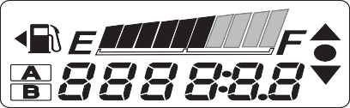

**EXAMPLE**

**With tachometer**

53M-04-096

53MM02003

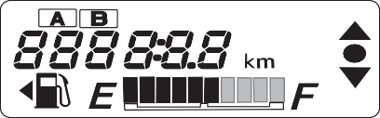

**EXAMPLE**

53M-04-094

##### Automated Manual transaxle

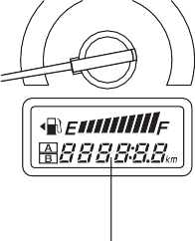

**EXAMPLE**

Without tachometer

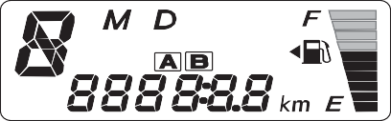

**EXAMPLE**

53M-04-097

1. Clock (if equipped)
2. Odometer/Trip meter

53M-04-095

53M-04-098

1. Odometer/Trip meter/Meter illumina- tion control knob

### 2-36

#### BEFORE DRIVING

With tachometer

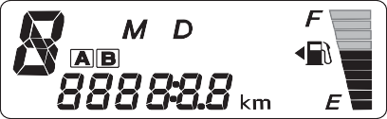

53M-04-099

**If you attempt to adjust the display while driving, you could lose control of the vehicle.**

**Do not attempt to adjust the display while driving.**

**WARNING**

**EXAMPLE**

##### Clock (1) (if equipped)

The clock is shown when the ignition switch is in the “ON” position.

To set the clock, follow the instructions below.

* Hold in the indication selector and meter illumination control knob (3) for more than 2 seconds. Push the indication selector and meter illumination control knob (3) to advance the minute display while the minute display is flashing. Release the indication selector and meter illumination control knob (3) for 5 seconds to set the minute display.
* The hour display flash after the minute display is set. Push the indication selec-

### 2-37

tor and meter illumination control knob

(3) to advance the hour display. Release the indication selector and meter illumi- nation control knob (3) for 5 seconds to set the hour display.

##### Odometer/Trip meter (2)

The odometer/trip meter is shown when the ignition switch is in the “ON” position. The odometer records the total distance the vehicle has been driven. The trip meter can be used to measure the distance trav- eled on short trips or between fuel stops.

**Keep track of your odometer reading and check the maintenance sched- ule regularly for required services. Increased wear or damage to certain parts can result from failure to per- form required services at the proper mileage intervals.**

***NOTICE***

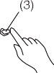

**EXAMPLE**

53M-04-100

When the ignition switch is turned to “ON” with the lighting switch is in the “OFF” posi- tion, the display shows three types of indi- cation; odometer (A), trip meter A (B), trip meter B (C) and clock (D). Push the “MODE” knob (3) quickly to switch the indi- cation among the four.

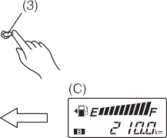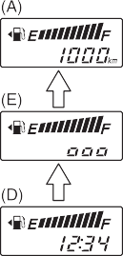

**EXAMPLE**

53M-04-101

When the ignition switch is turned to “ON” and the position lights, tail lights and/or the headlights are on, the display shows four types of indication; odometer (A), trip meter A (B), trip meter B (C), clock (D) and indication of illumination intensity (E). Push the “MODE” knob (3) quickly to switch the indication among the five. When the indica- tion shows (E), you can control the meter illumination intensity. Refer to “Meter illumi- nation control” section below for details on how to dim or brighten the meter illumina- tion.

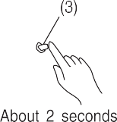

**EXAMPLE**

**EXAMPLE**

53M-04-102

To reset the trip meter to zero, hold in the “MODE” knob (3) for about 2 seconds.

Meter illumination control

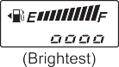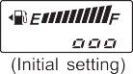

**EXAMPLE**

53M-04-103

When the display shows the indication of illumination intensity (E), you can dim or brighten the meter illumination.

To change the meter illumination bright- ness, continue to hold in the “MODE” knob

(3). The indication will change as shown in the illustration. The illumination gets dim- mer then returns to the brightest condition after it reaches the dimmest.

*NOTE:*

*When you reconnect the negative (–) ter- minal to the battery, the brightness of the instrument panel lights will be reinitialized. Readjust the brightness according to your preference.*

**BEFORE DRIVING**

## Lighting Control Lever

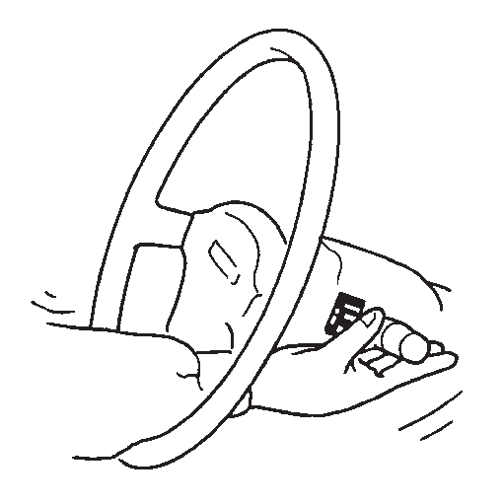

53M-04-104

**To avoid possible injury, do not oper- ate controls by reaching through the steering wheel.**

**WARNING**

**EXAMPLE**

### 2-38

#### BEFORE DRIVING

##### Lighting Operation

**Type 1**

###### OFF (1)

All lights are off.

 **(2)**

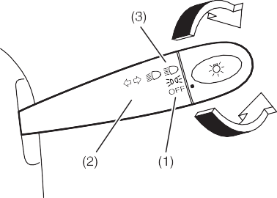

**EXAMPLE**

Front position lights, tail lights, license plate light and instrument lights are on, but headlights are off.

 **(3)**

Front position lights, tail lights, license plate light, instrument lights and head lights are on.

Type 1

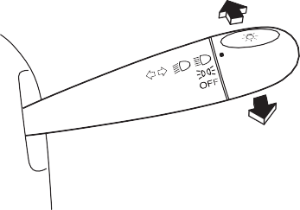

**EXAMPLE**

**Type 2**

53M-04-108

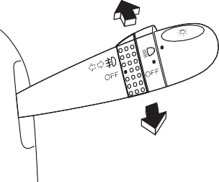

**EXAMPLE**

Type 2

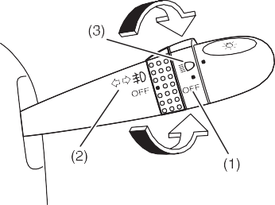

**EXAMPLE**

53M-04-105

53M-04-107

With the headlights on, push the lever for- ward to switch to the high beams (main beams) or pull the lever toward you to switch to the low beams. When the high beams (main beams) are on, a light on the instrument panel will come on. To momen- tarily activate the high beams (main beams) as a passing signal, pull the lever slightly toward you and release it when you have completed the signal.

53M-04-106

To turn the lights on or off, twist the knob on the end of the lever. There are three positions:

**2-39**

## Headlight Leveling Switch

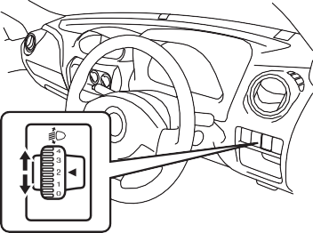

**EXAMPLE**

53M-04-109

Level the headlight beam according to the load condition of your vehicle by turning this switch. The chart below shows the appropriate switch position for different vehicle-load conditions.

|  |  |  |  |  |
| --- | --- | --- | --- | --- |
| **Vehicle Load Condition** | **Switch Position** | | | |
| **Alto 800** | | **Alto K10** | |
| **Petrol** | **CNG** | **Petrol** | **CNG** |
| Driver only | 0 | 0 | 0 | 0 |
| Driver + 1 passenger (in front seat) | 0 | 0 | 0 | 0 |
| Driver + 4 passen- gers, No cargo | 1 | 1 | 1 | 1 |

|  |  |  |  |  |
| --- | --- | --- | --- | --- |
| Driver + 4 passen- gers, Cargo added | 2 | NA | 3 | NA |
| Driver + Full cargo | 3 | NA | 4 | NA |

## Turn Signal Control Lever

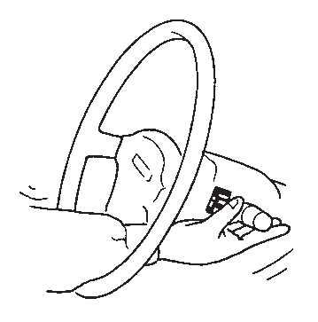

53M-04-110

**To avoid possible injury, do not oper- ate controls by reaching through the steering wheel.**

**WARNING**

**EXAMPLE**

##### Turn Signal Operation

With the ignition switch in the “ON” posi- tion, move the lever up or down to activate the right or left turn signals.

#### BEFORE DRIVING

##### Normal turn signal

Type 1

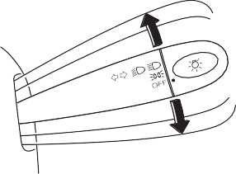

**EXAMPLE**

53M-04-111

Move the lever all the way upward or down- ward to signal. When the turn is com- pleted, the signal will cancel and the lever will return to its normal position.

Type 2

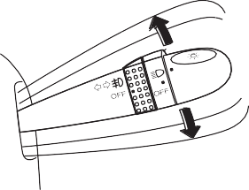

**EXAMPLE**

53M-04-112

### 2-40

#### BEFORE DRIVING

##### Lane change signal

Type 1

## Hazard Warning Switch

## Windshield Wiper and Washer Lever

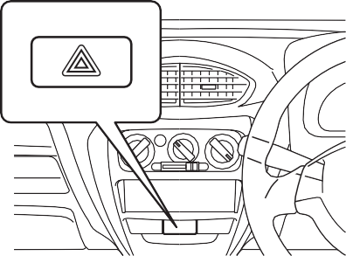

**EXAMPLE**

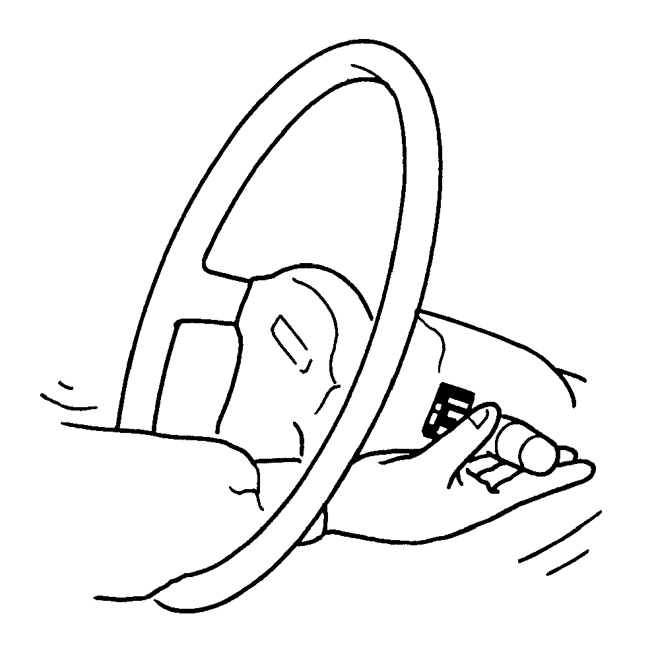

65D611

**To avoid possible injury, do not oper- ate controls by reaching through the steering wheel.**

**WARNING**

**EXAMPLE**

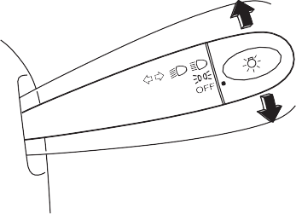

**EXAMPLE**

Type 2

53M-04-113

53M-04-114

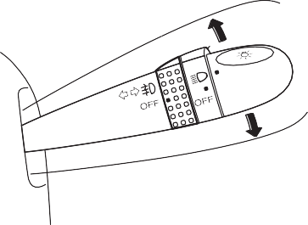

**EXAMPLE**

53MH0227

Push in the hazard warning switch to acti- vate the hazard warning lights. All turn sig- nal lights and both turn signal indicators will flash simultaneously. To turn off the lights, push the switch again.

Use the hazard warning lights to warn other traffic during emergency parking or when your vehicle could otherwise become a traffic hazard.

Wiper and Washer Operation

When the ignition switch is in the “ON” position, you can use the wiper/washer

Sometimes, such as when changing lanes,

the steering wheel is not turned far enough to cancel the turn signal. For convenience, you can flash the turn signal by moving the lever part way and holding it there. The lever will return to its normal position when you release it.

lever or switch (if equipped).

### 2-41

#### BEFORE DRIVING

##### Windshield Wipers

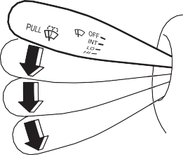

**EXAMPLE**

OFF

INT LO

HI

53MH0228

To turn the windshield wipers on, move the lever down to one of the three operating positions. In the “INT” position, the wipers operate intermittently. The “INT” position is very convenient for driving in mist or light rain. In the “LO” position, the wipers oper- ate at a steady low speed. In the “HI” posi- tion, the wipers operate at a steady high speed. To turn off the wipers, move the lever back to the “OFF” position.

##### Windshield Washer

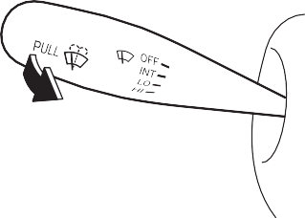

**EXAMPLE**

53MH0229

To spray windshield washer fluid, pull the lever toward you. The windshield wipers will automatically turn on at low speed if they are not already on and the “INT” posi- tion is equipped.



* **To prevent windshield icing in cold weather, turn on the defroster to heat the windshield before and during windshield washer use.**
* **Do not use radiator antifreeze in the windshield washer reservoir. It can severely impair visibility when sprayed on the windshield, and can also damage your vehicle’s paint.**

**WARNING**

**To help prevent damage to the wind- shield wiper and washer system components, you should take the fol- lowing precautions:**

* **Do not continue to hold in the lever when there is no windshield washer fluid being sprayed or the washer motor can be damaged.**
* **Do not attempt to remove dirt from a dry windshield with the wipers or you can damage the windshield and the wiper blades. Always wet the windshield with washer fluid before operating the wipers.**
* **Clear ice or packed snow from the wiper blades before using the wip- ers.**
* **Check the washer fluid level regu- larly. Check it often when the weather is bad.**
* **Only fill the washer fluid reservoir 3/4 full during cold weather to allow room for expansion if the tempera- ture falls low enough to freeze the solution.**

***NOTICE***

### 2-42

**BEFORE DRIVING**

## Horn



**EXAMPLE**

53MH0230

Press the horn button of the steering wheel to sound the horn. The horn will sound with the ignition switch in any position.

### 2-43

**OPERATING YOUR VEHICLE**

# OPERATING YOUR VEHICLE

**Exhaust Gas Warning 3-1**

**Daily Inspection Checklist 3-1**

**Engine Oil Consumption 3-2**

**Ignition Switch ..................................................................... 3-3 3**

**Parking Brake Lever 3-5**

**Pedal 3-6**

**Starting the Engine 3-7**

**Using the Transaxle 3-7**

**Braking 3-16**

**OPERATING YOUR VEHICLE**

## Exhaust Gas Warning

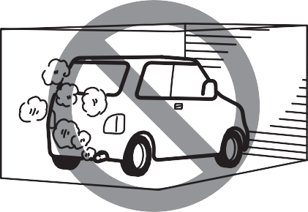

52D334

**Avoid breathing exhaust gases. Exhaust gases contain carbon mon- oxide, a potentially lethal gas that is colorless and odorless. Since carbon monoxide is difficult to detect by itself, be sure to take the following precautions to help prevent carbon monoxide from entering your vehicle.**

* **Do not leave the engine running in garages or other confined areas.**

(Continued)

**WARNING**

**EXAMPLE**

## Daily Inspection Checklist

##### Before Driving



(Continued)

* **Do not park with the engine run- ning for a long period of time, even in an open area. If it is necessary to sit for a short time in a parked vehi- cle with the engine running, make sure the air intake selector is set to “FRESH AIR” and the fan is at high speed.**
* **Avoid operating the vehicle with the tailgate or trunk open. If it is necessary to operate the vehicle with the tailgate or trunk open, make sure all windows are closed, and the blower is at high speed with the air intake selector set to “FRESH AIR”.**
* **To allow proper operation of your vehicle’s ventilation system, keep the air inlet grille in front of the windshield clear of snow, leaves, or other obstructions at all times.**
* **Keep the exhaust tailpipe area clear of snow and other material to help reduce the buildup of exhaust gases under the vehicle. This is particularly important when parked in blizzard conditions.**
* **Have the exhaust system inspected periodically for damage and leaks. Any damage or leaks should be repaired immediately.**

**WARNING**

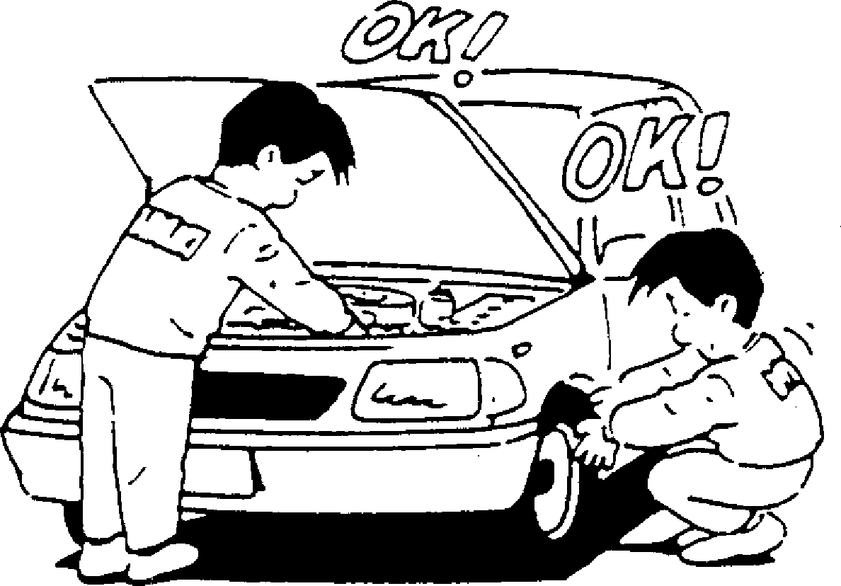

**EXAMPLE**

60A187S

1. Make sure that windows, mirrors, lights, and reflectors are clean and unob- structed.
2. Visually check the tires for the following points:

* the depth of the tread groove
* abnormal wear, cracks and damage
* loose wheel nuts
* existence of foreign material such as nails, stones, etc.

Refer to “Tires” in “INSPECTION AND MAINTENANCE” section for details.

1. Look for fluid and oil leaks.

*NOTE:*

*It is normal for water to drip from the air conditioning system during use.*

### 3-1

1. Make sure the hood is fully closed and latched.
2. Check the headlights, turn signal lights, brake lights and horn for proper opera- tion.
3. Adjust the seat and head restraint (if equipped).
4. Check the brake pedal and the parking brake lever.
5. Adjust the mirrors.
6. Make sure that you and all passengers have properly fastened your seat belts.
7. Make sure that all warning lights come on as the key is turned to the “ON” posi- tion.
8. Check all gauges.
9. Make sure that the BRAKE SYSTEM WARNING light turns off when the parking brake is released.

Once a week, or each time you fill your fuel tank, perform the following under-hood checks:

1. Engine oil level
2. Coolant level
3. Brake fluid level
4. Windshield washer fluid level
5. Battery solution level
6. Hood latch operation

Pull the hood release handle inside the vehicle. Make sure that you cannot open the hood all the way without releasing the secondary latch. Be sure to close the hood securely after check- ing for proper latch operation. See “All

latches, hinges & locks” of “CHASSIS AND BODY” in the “Periodic Mainte- nance Schedule” in the “INSPECTION AND MAINTENANCE” section for lubri- cation schedule.



**Make sure the hood is fully closed and latched before driving. If it is not, it can fly up unexpectedly during driving, obstructing your view and resulting in an accident.**

**WARNING**

Once a month, or each time you fill your fuel tank, check the tire pressure using a tire pressure gauge. Also check the tire pressure of the spare tire.

**OPERATING YOUR VEHICLE**

## Engine Oil Consumption

It is normal for the engine to consume some engine oil during normal vehicle operation.

The amount of engine oil consumed depends on the viscosity of the oil, the quality of the oil and the conditions the vehicle is driven under.

More oil is consumed during high-speed driving and when there is frequent acceler- ation and deceleration. Under high loads, your engine also will consume more oil.

A new engine also consumes more oil, since its pistons, piston rings and cylinder walls have not yet become conditioned. New engines reach the normal level of oil consumption only after approximately 5000 km (3000 miles) driving.

Oil consumption:

**Max. 1.0 L per 1000 km**

When judging the amount of oil consump- tion, note that the oil may become diluted and make it difficult to accurately judge the true oil level.

As an example, if a vehicle is used for repeated short trips, and consumes a nor- mal amount of oil, the dipstick may not show any drop in the oil level at all, even after 1000 km or more of driving. This is because the oil is gradually becoming diluted with fuel or moisture, making it appear that the oil level has not changed.

### 3-2

#### OPERATING YOUR VEHICLE

You should also be aware that the diluting ingredients evaporate out when the vehicle is subsequently driven at high speeds, such as on an expressway, making it appear that oil is excessively consumed after high-speed driving.

## Ignition Switch

52KM052

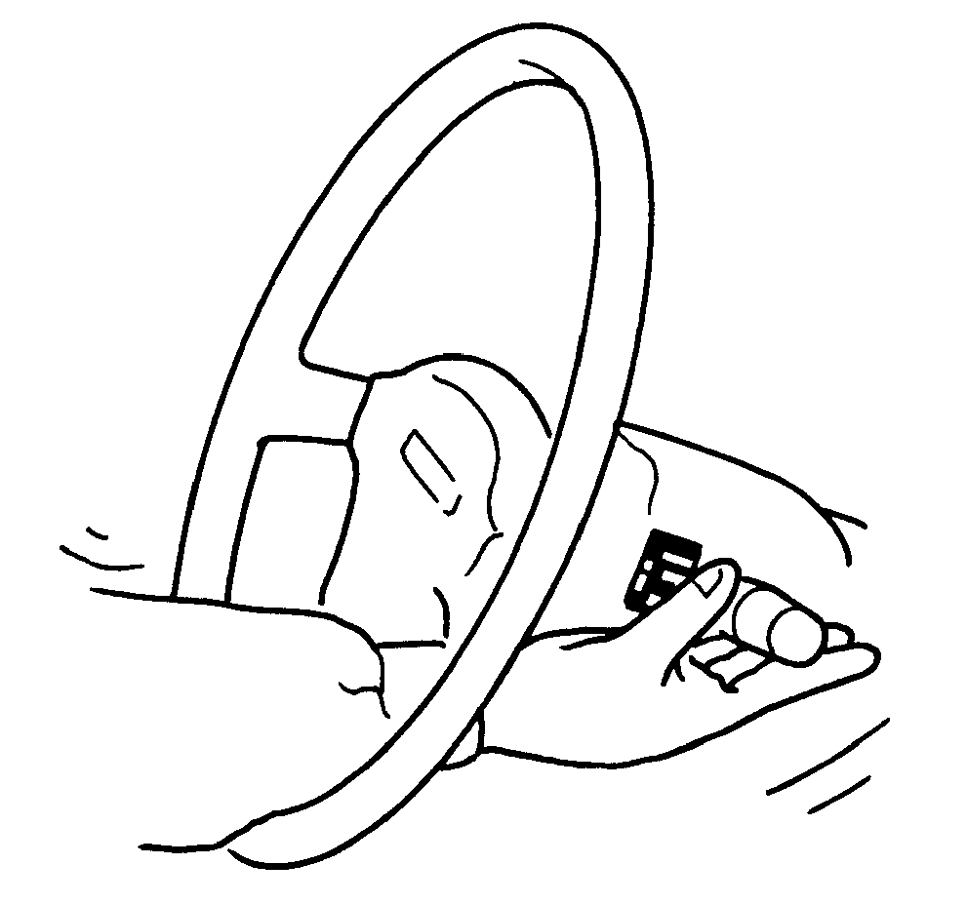

65D611

**To avoid possible injury, do not oper- ate controls by reaching through the steering wheel.**

**WARNING**

**EXAMPLE**

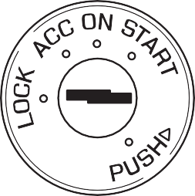

**EXAMPLE**

The ignition switch has the following four positions:

###### LOCK

This is the normal parking position. It is the only position in which the key can be removed.

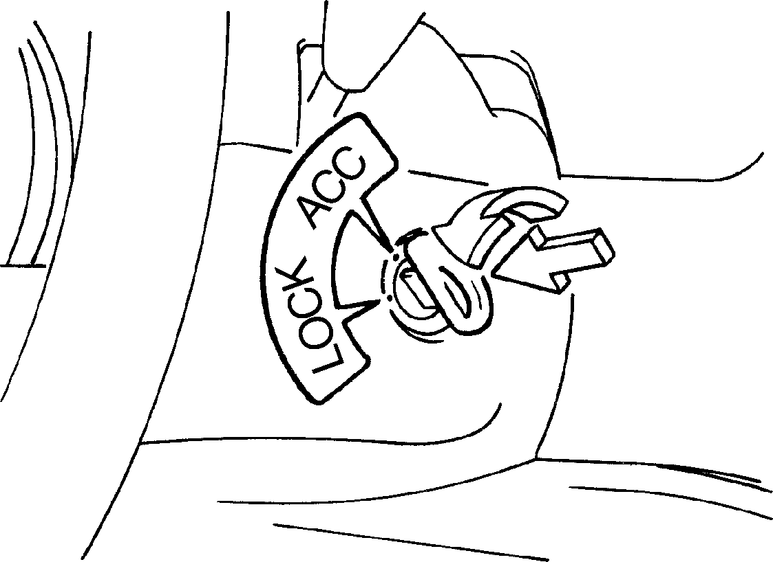

Turn to “LOCK”

Push

**EXAMPLE**

60G033

### 3-3

#### OPERATING YOUR VEHICLE

It locks the ignition, and prevents normal use of the steering wheel after the key is removed.

To release the steering lock, insert the key and turn it clockwise to one of the other positions. If you have trouble turning the key to unlock the steering, try turning the steering wheel slightly to the right or left while turning the key.

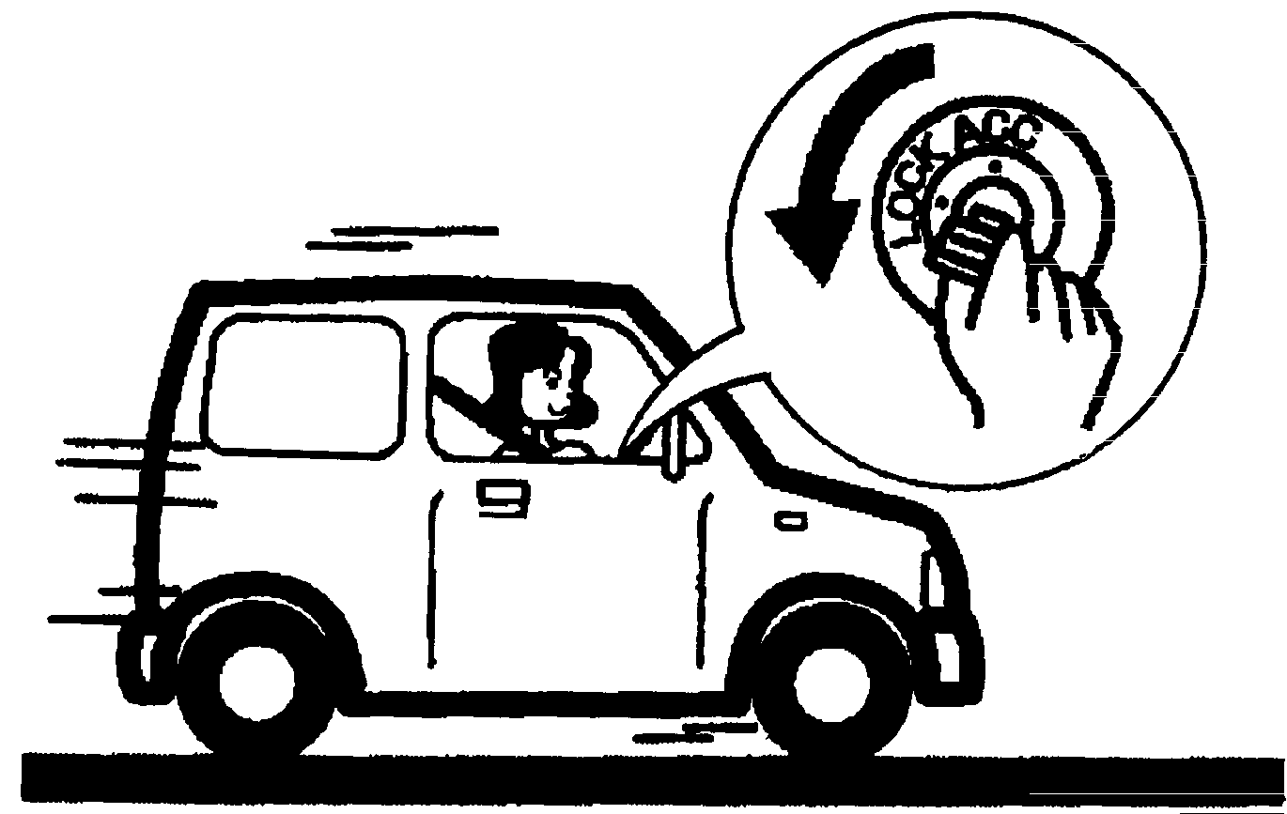

81A297S

* **Never remove the ignition key while the vehicle is moving. The steering wheel will lock and you will not be able to steer the vehicle.**
* **Always remove the ignition key when leaving the vehicle even if only for a short time. Also do not leave children alone in a parked vehicle. Unattended children could cause accidental movement of the vehicle or could tamper with power windows. They also could suffer from heat stroke in warm or hot weather. These could result in severe injury or even death.**

**WARNING**

**EXAMPLE**

* **Do not use the starter motor for more than 15 seconds at a time. If the engine does not start, wait 15 seconds before trying again. If the engine does not start after several attempts, check the fuel and igni- tion systems or consult your MAR- UTI SUZUKI dealer.**
* **Do not leave the ignition switch in the “ON” position if the engine is not running as the battery will dis- charge.**

***NOTICE***

###### ACC

Accessories such as the radio can oper- ate, but the engine is off.

###### ON

This is the normal operating position. All electrical systems are on.

###### START

This is the position for starting the engine using the starter motor. The key should be released from this position as soon as the engine starts.

Ignition key reminder (if equipped)

A buzzer sounds intermittently to remind you to remove the ignition key if it is in the ignition switch when the driver’s door is opened.

### 3-4

**OPERATING YOUR VEHICLE**



**Always set the parking brake fully before leaving your vehicle or it may move, causing injury or damage. When parking, make sure the gear- shift lever is in 1st gear. Remember, even though the transaxle is in gear, you must set the parking brake fully.**

**WARNING**

* **Never drive your vehicle with the parking brake on: rear brake effec- tiveness can be reduced from over- heating, brake life may be shortened, or permanent brake damage may result.**
* **If the parking brake does not hold the vehicle securely or does not fully release, have your vehicle inspected immediately by an autho- rized MARUTI SUZUKI dealer.**

**WARNING**



**When parking the vehicle in extremely cold weather, the following procedure should be used:**

1. **Set the parking brake.**
2. **Manual transmission - turn off the engine, then shift into reverse or first gear, with ignition key “ON” position.**

**Automated manual transaxle - shift into reverse or first gear and check the gear position indicator in the instrument cluster to make sure that the transaxle is engaged in 1st or reverse, then turn the ignition switch “LOCK” position.**

1. **Get out of the vehicle and put chocks under the wheels.**
2. **Release the parking brake.**

**When you return to your vehicle, you must remember to first set the parking brake, then remove the wheel chocks.**

**WARNING**

## Parking Brake Lever

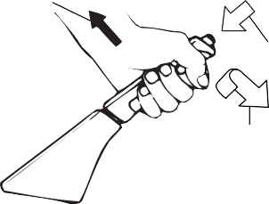

**EXAMPLE**

(1)

(2)

(3)

60MHM03001

* 1. To set
  2. To release
  3. To release

The parking brake lever is located between the front seats. To set the parking brake, hold the brake pedal down and pull the parking brake lever all the way up. To release the parking brake, hold the brake pedal down, pull up slightly on the parking brake lever, push the button on the end of the lever with your thumb, and lower the lever to its original position.

**3-5**

## Pedal

##### Manual Transaxle

##### Clutch Pedal (1)

**(For manual transaxle)**

The clutch pedal is used to disengage the drive to the wheels when starting the engine, stopping, or shifting the gearshift lever. Depressing the pedal disengages the clutch.

**EXAMPLE**

(1) (2)

(3)



**Do not drive with your foot resting on the clutch pedal. It could result in excessive clutch wear, clutch dam- age, or unexpected loss of engine braking.**

**WARNING**

#### OPERATING YOUR VEHICLE

##### Auto Gear Shift



**EXAMPLE**

80J2121

##### Brake Pedal (2)

Your MARUTI SUZUKI vehicle is equipped with front disc brakes and rear drum brakes. Depressing the brake pedal applies both sets of brakes.

You may hear occasional brake squeal when you apply the brakes. This is a nor- mal condition caused by environmental factors such as cold, wet, snow, etc.

##### Accelerator Pedal (3)

This pedal controls the speed of the engine. Depressing the accelerator pedal increases power output and speed.



**Do not “ride” the brakes by applying them continuously or resting your foot on the brake pedal. This will result in overheating of the brakes which could cause unpredictable braking action, longer stopping dis- tances, or permanent brake damage.**

**WARNING**

53M05009



**If brake squeal is excessive and occurs each time the brakes are applied, you should have the brakes checked by your MARUTI SUZUKI dealer.**

**WARNING**

### 3-6

**OPERATING YOUR VEHICLE**

## Starting the Engine

##### Before Starting the Engine

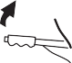

##### Starting a Cold and Warm Engine

With your foot off the accelerator pedal, crank the engine by turning the ignition key to “START”. Release the key when the engine starts.

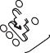

* **Stop turning the starter immedi- ately after the engine has started or the starter system may be dam- aged.**
* **Do not crank the engine for more than 15 seconds at a time. If the engine doesn’t start on the first try, wait about 15 seconds before try- ing again.**

***NOTICE***

## Using the Transaxle

##### Manual Transaxle

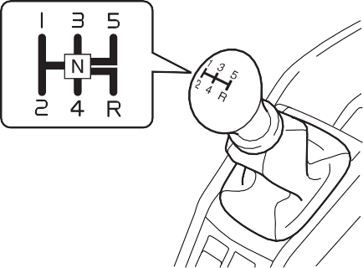

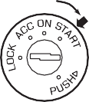

76MH021

1. Make sure the parking brake is set fully.

If the engine does not start after 15 sec-

Starting off

53MH0303

1. Shift into “N” (Neutral) and depress the clutch pedal all the way to the floor. Hold the clutch pedal while starting the engine.

Automated manual transaxle – Shift into “N” (Neutral) and depress the brake pedal. Hold the brake pedal while start- ing the engine.



**Make sure that the parking brake is set fully and the transaxle is in Neu- tral before attempting to start the engine.**

**WARNING**

onds of cranking, wait about 15 seconds, then press down the accelerator pedal to 1/3 of its travel and try cranking the engine again. Release the key and accelerator pedal when the engine starts.

If the engine still does not start, try holding the accelerator pedal all the way to the floor while cranking. This should clear the engine if it is flooded.

To start off, depress the clutch pedal all the way to the floor and shift into 1st gear. After releasing the parking brake, gradually release the clutch. When you hear a change in the engine’s sound, slowly press the accelerator while continuing to gradu- ally release the clutch.

Shifting

All forward gears are synchronized, which provides for quiet and easy shifting. Always push in the clutch pedal fully before shifting gears.

### 3-7

#### OPERATING YOUR VEHICLE

##### Downshifting maximum allowable speeds

For F8D engine



* **Reduce your speed and downshift to a lower gear before going down a long or steep hill. A lower gear will allow the engine to provide braking. Avoid riding the brakes or they may overheat, resulting in brake failure.**
* **When driving on slippery roads, be sure to slow down before down- shifting. Excessive and or sudden changes in engine speed may cause loss of traction, which could cause you to lose control.**

**WARNING**

* **To help avoid clutch damage, do not use the clutch pedal as a foot- rest while driving or use the clutch to keep the vehicle stationary on a slope. Depress the clutch fully when shifting.**
* **When shifting or starting off, do not race the engine. Racing the engine can shorten engine life and affect smooth shifting.**

***NOTICE***

|  |  |
| --- | --- |
| Downshifting | km/h (mph) |
| 2nd to 1st | 35 (22) |
| 3rd to 2nd | 65 (40) |
| 4th to 3rd | 100 (62) |
| 5th to 4th | OK at all |

**For K10B engine**

|  |  |
| --- | --- |
| Downshifting | km/h (mph) |
| 2nd to 1st | 35 (22) |
| 3rd to 2nd | 80 (50) |
| 4th to 3rd | 120 (75) |
| 5th to 4th | OK at all |

**When downshifting to a lower gear, make sure not to downshift at a speed faster than the maximum allowable speeds, or severe engine damage may result.**

***NOTICE***

Keep the engine speed so it does nor get into the red zone of tachometer.

Automated Manual Transaxle

Automated manual transaxle is a 5-speed forward/reverse transaxle. Automated

manual transaxle has the basic features of conventional manual transaxle, but clutch

**Make sure that the vehicle is com- pletely stationary before you shift into reverse.**

***NOTICE***

operation and transaxle gear shifting are controlled electronically. The features are as follows:



**-**

**M**

**+**

**R**

**N D**

76MH0A054

### 3-8

#### OPERATING YOUR VEHICLE

**EXAMPLE**

76MH0A055



**-**

**M**

**+**

**R**

**N D**



**-**

**M**

**+**

**R**

**N D**

##### Depress brake pedal indicator (if equipped)

76MH0A047

This light will come on if you do not depress the brake pedal in the following situations.

* + When starting the engine.
  + When the engine is on and the gearshift lever is shifted from “N” position to “D”, “M” or “R” position.
  + When the ignition switch is in the “ON” position and the engine is off, the gear- shift lever is shifted into any position.

### 3-9

Starting the engine

When starting the engine, always place the gearshift lever in the “N” position and depress the brake pedal firmly. The engine cannot be started unless the gearshift lever is in the “N” position and the brake pedal is depressed.

76MH0A056

Clutch operation

You can select either the Drive (D) mode or the Manual (M) mode. Since this vehicle controls clutch operation electronically in either mode, you do not need to operate the clutch.

Creeping function

This vehicle has a creeping function that helps the vehicle to start smoothly by engaging the clutch. When the gearshift lever is in any of the positions “D”, “M” or “R”, and you release your foot from the brake pedal, the vehicle starts slowly with- out depressing the accelerator pedal. The creeping function is disabled if you depress the brake pedal or pull up the parking brake lever.

*NOTE:*

*If the driver’s door is opened and/or the parking brake lever is engaged with the gear in the “M”, “D” or “R” position, the creeping function will not operate.*

**Parking and Stopping the vehicle** Automated manual transaxle does not have a parking position. The vehicle can be parked with the gearshift lever in any position. When stopping the vehicle, the gear will be shifted to 1st.

**A buzzer will sound continuously if the vehicle is operated with the gear- shift lever in-between of each shift positions. The vehicle will become inoperative if you continue to operate the vehicle with the gearshift lever in between shift positions.**

***NOTICE***

##### Drive (D) mode

When the Drive (D) mode is activated, the most appropriate gear position is automati- cally selected upon operation of the accel- erator pedal and variation of vehicle speed.

Normal driving:

1. Start the engine as instructed in “Start- ing the engine” in this section.
2. With your foot on the brake pedal, shift the gearshift lever to the “D” position. When the gearshift lever is shifted to the “D” position, the gear will be shifted to 1st.

#### OPERATING YOUR VEHICLE



76MH0A057

*NOTE:*



* **While driving the vehicle, do not shift the gearshift lever to the “N” position. The engine brake may not work and you may get involved in an unexpected accident. If you return the gearshift lever from “N” to “D” because of unintended shift- ing, the gear position will be shifted according to the current vehicle speed.**
* **Always keep your foot on the brake pedal while stopped with the engine running. This operation pre- vents the vehicle from moving due to unintended activation of the creeping function.**

**WARNING**

**Do not operate the system as described below. The life cycle of the clutch may be reduced.**

* **Using the accelerator pedal to hold the vehicle on an uphill slope with the gearshift lever in the “D” or “M” position. If you perform this opera- tion for a certain period of time, a warning buzzer will sound.**
* **Shifting the gearshift lever to the “D”, “M” or “R” position while rac- ing the engine.**
* **Driving at low speed using a high gear.**
* **Holding the vehicle on an uphill slope using the creeping function. If you perform this operation for a certain period of time, a warning buzzer will sound.**

***NOTICE***

* + *If 1st gear cannot be engaged even though the gearshift lever has been shifted from the “N” to the “D” position, the system will re-try shifting automati- cally. This will take some time, noise may be heard from the gears, and shift- ing gear shock may occur. However, they do not indicate a malfunction.*
  + *The “N” indicator will flash, the depress brake pedal indicator will come on and a warning buzzer (long pulse sound) will sound if any of the following cases occur;*

**If the gearshift lever cannot shift into any position, or the gear is changed to “N” position automatically when the vehicle speed becomes less than 10 km/h, there may be a system mal- function. In this case, ask your MAR- UTI SUZUKI dealer to inspect the Auto Gear Shift system as soon as possible.**

***NOTICE***

* + - *If you shift the gearshift lever from the “N” to the “D” position without depress- ing the brake pedal*

**Operate your Automated Manual Transaxle vehicle with one foot only. driving your automated manual transaxle vehicle with accelerator and brake pedals depressed together will cause overheating of the clutch.**

***NOTICE***

* + - *If the system is unable to re-try shifting You should depress the brake pedal and shift the gearshift lever to “N” position, then shift to “D” again.*

1. Release the parking brake and brake pedal.
2. Depress the accelerator pedal slowly.

### 3-10

#### OPERATING YOUR VEHICLE

##### Starting off on an uphill/downhill:

Uphill

1. Apply the parking brake firmly so that the vehicle does not roll backwards.
2. Shift the gearshift lever to the “D” posi- tion while depressing the brake pedal. Make sure that the gear position indica- tor in the instrumental cluster displays 1st gear.
3. Release the brake pedal and depress the accelerator pedal gradually, and when the vehicle starts to move, release the parking brake and depress the accel- erator pedal to start off.

**On an uphill slope, never hold the vehicle at a stop using only the accel- erator pedal or the creeping function. If you perform this operation for a certain period of time, a warning buzzer will sound, and in some cases the engine will stall. This can also cause excessive damage to the clutch.**

***NOTICE***

clutch will be engaged when the vehicle speed increases.

##### Using engine braking:

When driving on a downhill slope, down- shifting is recommended. So you can use engine braking.

By placing the gearshift lever in the “M” position, the Manual (M) mode is selected, and you can shift to a lower gear manually. For details of downshift operation, refer to “Upshift and downshift” in the “Manual (M) mode”.

##### Manual (M) mode

The gears are not shifted automatically. To shift the transaxle, the driver must operate

##### Upshift and downshift:

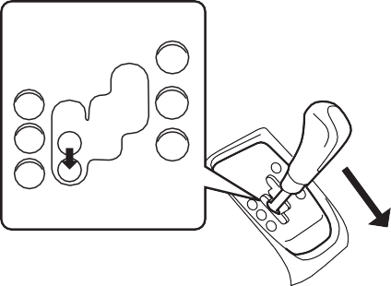Upshifting

**-**

**M**

**+**

**R**

**N D**

76MH0A058

##### Downhill

1. Depress the brake pedal and shift the gearshift lever to the “D” position. Make sure that the gear is in 1st by checking the gear position indicator.
2. Release the brake pedal and depress the accelerator pedal slowly. Even if the accelerator pedal is not depressed, the

the gearshift lever to the “+” or “–” direc- tion. As for conventional manual transaxle vehicles, releasing the accelerator pedal a little may help the transaxle to shift smoothly.

Pull the gearshift lever to the “+” direction and release it. Every time the lever is oper- ated, the transaxle is upshifting 1 step in the order of 1st  2nd  3rd  4th  5th gear.



76MH0A059

### 3-11

#### OPERATING YOUR VEHICLE



* **Be careful when accelerating, upshifting, downshifting or braking on a slippery surface. Sudden acceleration or engine braking could cause the vehicle to spin or skid.**
* **To drive down a long or steep hill, reduce your speed and downshift. Remember, if you ride the brakes excessively, they may overheat and fail.**
* **While driving the vehicle, do not shift the gearshift lever to “N” posi- tion. The engine brake may not work and you may get involved in an unexpected accident. If you return the gearshift lever from “N” to “M” because of unintended shift- ing, the gear position will be shifted according to the current vehicle speed.**
* **Do not apply the parking brake while driving. Otherwise, it could cause a skid and you may get involved in an unexpected acci- dent.**

**WARNING**

Downshifting

76MH0A060

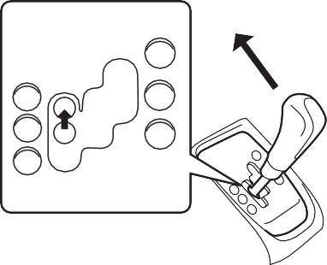

**-**

**M**

**+**

**R**

**N D**

Push the gearshift lever to the “–” direction and release it. Every time the lever is oper- ated, the transaxle is downshifted in the order 5th  4th  3rd  2nd  1st gear.

76MH0A061

The gear position is displayed on the gear position indicator. The gear position indica- tor shows the transaxle gear position. Before starting off, always check the gear position indicator to make sure that the transaxle is engaged in 1st or reverse, then depress the accelerator pedal.



*NOTE:*

* *To downshift smoothly, the engine runs fast in some cases. This is done inten- tionally by the system and is not a mal- function.*
* *When driving down a hill, downshift and use the engine braking appropriately. If necessary, continuous downshifting is possible. However, if downshifting more than 3 steps, gear shifting will take more time.*
* *When the gear is shifting, a noise can be heard in some case. This is not a mal- function.*

### 3-12

#### OPERATING YOUR VEHICLE

* **If the gearshift lever cannot shift into any position, or the gear is changed to “N” position automati- cally when the vehicle speed becomes less than 10 km/, there may be a system malfunction. In this case, ask your MARUTI SUZUKI dealer to inspect the Auto Gear Shift system as soon as possible.**
* **The manual (M) mode does not upshift even if the engine speed reaches the rev-limit.**
* **The system will not allow shifting up or down to a gear that would cause engine over-revving or under-rev- ving.**
* **If frequently driving at low speed using a high gear position, the life cycle of the clutch may be reduced.**
* **Frequent downshifting (more than 3 positions consecutively) causes the reduction of transaxle life.**

***NOTICE***

##### Starting off:

* 1. Start the engine as instructed in “Start- ing the engine” in this section.
  2. With your foot on the brake pedal, shift the gearshift lever to the “M” position. When the gearshift lever is shifted to the “M” position, the gear will be shifted to 1st. Before starting off, always make sure that the intended gear is engaged by checking the gear position indicator, then depress the accelerator pedal.

*NOTE:*

* *If 1st gear cannot be engaged even though the gearshift lever has been shifted from the “N” to the “M” position, the system will re-try shifting automati- cally. This will take some time, noise may be heard from the gears, and shift- ing gear shock may occur. However, they do not indicate a malfunction.*

**Do not operate the system as described below. The life cycle of the clutch may be reduced.**

* **Using the accelerator pedal to hold the vehicle on an uphill slope oper- ation with the gearshift lever in the “M” or “D” position. If you perform this operation for a certain period of time, a warning buzzer will sound.**
* **Shifting the gearshift lever to the “M”, “D” or “R” position while rac- ing the engine.**
* **Driving at low speed using a high gear.**
* **Stopping on a slope using the creeping function. If you perform this operation for a certain period of time, a warning buzzer will sound.**

***NOTICE***

* *The “N” indicator will flash, the depress brake pedal indicator will come on and a warning buzzer (long pulse sound) will sound if any of the following cases occur;*
* *If you shift the gearshift lever from the “N” to the “M” position without depressing the brake pedal*
* *If the system is unable to re-try shifting You should depress the brake pedal and shift the gearshift lever to “N” position, then shift to “M” position again a few seconds later.*

1. Release the parking brake and brake pedal. Depress the accelerator pedal slowly for smooth starting.

**Operate your Automated Manual Transaxle vehicle with one foot only. driving your automated manual transaxle vehicle with accelerator and brake pedals depressed together will cause overheating of the clutch.**

***NOTICE***



**Always keep your foot on the brake pedal or pull up the parking lever while stopped with the engine run- ning. These operations prevent the vehicle from starting due to unin- tended activation of the creeping function.**

**WARNING**

### 3-13

#### OPERATING YOUR VEHICLE

##### Starting off on an uphill/downhill slope:

Uphill

1. Apply the parking brake firmly so that the vehicle does not roll backwards.
2. Shift the gearshift lever to the “M” posi- tion while depressing the brake pedal. Make sure that the gear position indica- tor in the instrumental cluster displays 1st gear.
3. Release the brake pedal and depress the accelerator pedal gradually, and when the vehicle starts to move, release the parking brake and depress the accelerator pedal to start off.

**On an uphill slope, never hold the vehicle at a stop using only the accel- erator pedal or creeping function. If you perform this operation for a cer- tain period of time, a warning buzzer will sound, and in some cases the engine will stall. This can also cause excessive damage to the clutch.**

***NOTICE***

depressed, the clutch will be engaged when the vehicle speed increases.

Backing up

After the vehicle has stopped completely, depress the brake pedal and shift the gear- shift lever to the “R” position. Depress the accelerator pedal slowly as when starting off in 1st gear. Before backing up, make sure that reverse gear is selected by checking the gear position indicator.

76MH0A062

*You should depress the brake pedal and shift the gearshift lever to “N” position, then shift to “R” position again a few sec- onds later.*

* *The system will not allow shifting to the “R” position if the vehicle speed is over about 3 km/h. If the gearshift lever is operated under this condition, the “N” indicator in the instrument cluster will blink. However, when the vehicle speed drops below about 3 km/h, the gear will be shifted to reverse. Make sure that the vehicle has stopped completely before shifting to the “R” position.*

**On a downhill slope, never hold the vehicle at a stop using only the accel- erator pedal or the creeping function. If you perform this operation for a certain period of time, a warning buzzer will sound, and in some cases the engine will stall. This can also cause excessive damage to the clutch.**

***NOTICE***

Downhill

* 1. Depress the brake pedal and shift the gearshift lever to the “M” position. Check the gear position indicator to make sure that the gear is in 1st.
  2. Release the brake pedal and depress the accelerator pedal slowly. Even though the accelerator pedal is not

*NOTE:*

* *If reverse gear cannot be engaged even though the gearshift lever has been shifted from the “N” to the “R” position, the system will re-try shifting automati- cally. This will take some time, noise may be heard from the gears, and shift- ing gear shock may occur. However, they do not indicate a malfunction.*
* *The “N” indicator will flash, the depress brake pedal indicator will come on and a warning buzzer (long pulse sound) will sound if any of the following cases occur;*
* *If you shift the gearshift lever from the “N” to the “R” position without depress- ing the brake pedal*
* *If the system is unable to re-try shifting*

Stopping

The vehicle can be stopped by depressing the brake pedal regardless of the gear position. This is because the clutch is auto- matically disengaged to prevent the engine from stopping.

* If the gearshift lever is in the “D” position, the gear will be downshifted to 1st when the vehicle stops.

### 3-14

#### OPERATING YOUR VEHICLE

* + If the gearshift lever is in the “M” posi- tion, the gear will be downshifted to 1st when the vehicle stops.

3) turn the ignition switch to “LOCK” posi- tion.

*NOTE:*

* **On a slope, never hold the vehicle at a stop using only the accelerator pedal or the creeping function. If you perform this operation for a certain period of time, a warning buzzer will sound, and in some cases the engine will stall. This can also cause excessive damage to the clutch.**
* **If the gearshift lever is operated more than necessary, the system may not allow operation of the gearshift lever for a certain period of time, and the gear may not be shifted appropriately. Therefore, do not operate the gearshift lever if not necessary.**

***NOTICE***

* *After the ignition switch is turn to “ACC” or “LOCK” position is stopped, the gear in the transaxle does not change even if you shift the gearshift lever in any posi- tion. Always shift the gearshift lever before stop the engine.*
* *Check the transaxle gear position by looking at the gear position indicator, then turn the ignition switch off to stop the engine. Release the brake pedal after a few seconds.*

Parking



* **When stopping, for example, at a traffic light, be sure to depress the brake pedal firmly. For your safety, apply the parking brake, too, when stopping on a hill.**
* **When racing the engine, make sure that the gear is in the “N” position by checking the gear position indi- cator. If the accelerator is operated with the gear in any other position, the vehicle may move resulting in an unexpected accident.**
* **Do not leave your vehicle unat- tended while the engine is running.**
* **When leaving the vehicle, stop the engine and park the vehicle with a gear engaged. If you need to leave the vehicle with the engine running, apply the parking brakes firmly, and shift the gearshift lever to the “N” position. Otherwise, the vehi- cle may move unexpectedly and may cause an accident.**

**WARNING**



* **If the gear is not engaged properly and completely before the ignition switch is turned off, the vehicle may not be parked with the gear engaged. Always confirm the gear position by checking the gear posi- tion indicator when parking.**
* **On a downhill slope, the gear should be put in reverse, and in 1st gear on an uphill slope. Otherwise, the vehicle may move, and cause an unexpected accident. If the gear is left in the “N” position, the vehi- cle cannot be parked with a gear engaged.**

**WARNING**

Unlike an automatic transaxle, Automated manual transaxle does not have a parking position. The vehicle can be parked with the gearshift lever in any position.

1. Apply the parking brake firmly and turn the ignition “ON” position.
2. While depressing the brake pedal, shift the gearshift lever to the “R” position on a downhill slope, and to the 1st position in the drive (D) mode or the “M(1)” posi- tion in the manual (M) mode on an uphill slope and confirm the gear posi- tion by checking the gear position indi- cator.

### 3-15

##### Parking cancel

Depress the brake pedal, turn the ignition switch to the “ON” position, and shift the gearshift lever to the “N” position. The gear will be disengaged.

Warning functions

A warning buzzer will sound or the indica- tor will blink under the following conditions.

* The clutch is heated due to excessive load.
* The creeping function is being activated for a long period of time.

**In the above cases, pull over to the side of the road and stop the engine, and then ask your MARUTI SUZUKI dealer to inspect your vehicle. Other- wise, the clutch disc may get dam- aged.**

***NOTICE***

* The ignition switch is turned to the “OFF” position with the gear in 2nd, 3rd, 4th or 5th. In this case, turn the ignition switch to the “ON” position and shift the gear- shift lever in the “N” position, shift it to the “D” or “M” or “R” position, then turn the ignition switch to “OFF”.
* During a stop, the driver’s door is opened with the gearshift lever in the “R”, “D” or “M” position while the engine is running.

“N” indicator blinking

When the gear indicator lamp blinks “N”, you should depress the brake pedal and shift the gearshift lever to “N” position.

“1st” indicator blinking

When the gear indicator lamp blinks “1st”, you should depress the brake pedal and shift the gearshift lever to “N” position, then shift to “D” or “M” position again a few sec- onds later.

“R” indicator blinking

When the gear indicator lamp blinks “R”, you should depress the brake pedal and shift the gearshift lever to “N” position, then shift to “R” position again a few seconds later.

**OPERATING YOUR VEHICLE**

## Braking

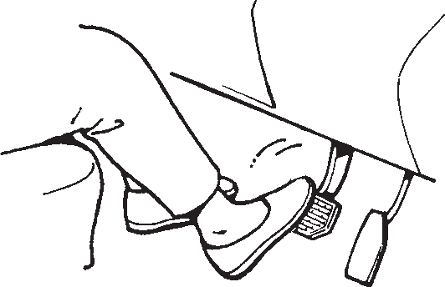

**EXAMPLE**

53M05022

The distance needed to bring any vehicle to a halt increases with the speed of the vehicle. The braking distance needed, for example, at 60 km/h (37 mph) will be approximately 4 times greater than the braking distance needed at 30 km/h (19 mph). Start to brake the vehicle when there is plenty of distance between your vehicle and the stopping point, and slow down gradually.

### 3-16

#### OPERATING YOUR VEHICLE

senses that the wheels are locking up. You may feel the brake pedal moves a little while the ABS is operating.

*NOTE:*



**If water gets into the brake drums, brake performance may become poor and unpredictable.**

**After driving through water or washing the underside of the vehicle, test the brakes while driving at a slow speed to see if they have maintained their normal effectiveness. If the brakes are less effective than normal, dry them by repeatedly applying the brakes while driving slowly until the brakes have regained their normal effective- ness.**

**WARNING**



**Even without reserve power in the brake system, you can still stop the vehicle by pressing the brake pedal harder than normally required. How- ever, the stopping distance may be longer.**

**WARNING**

*The ABS will not work if vehicle speed is under about 10 km/h (6mph).*

##### Power-Assisted Brakes (if equipped)

Your vehicle has power-assisted brakes. If power assistance is lost due to a stalled engine or other failures, the system is still fully operational on reserve power and you can bring the vehicle to a complete stop by pressing the brake pedal once and holding it down. The reserve power is partly used up when you depress the brake pedal and reduces each time the pedal is pressed. Apply smooth and even pressure to the pedal. Do not pump the pedal.

##### Brake Assist System (if equipped)

When you slam the brakes on, the brake assist system judges as an emergency stop and provides more powerful braking for a driver who cannot hold down the brake pedal firmly.



* **On some types of loose surfaces (such as gravel, snow-covered roads, etc.) the stopping distance required for an ABS-equipped vehi- cle may be slightly greater than for a comparable vehicle with a con- ventional brake system. With a con- ventional brake system, skidding tires are able to “plow” the gravel or snow layer, shortening the stop- ping distance. ABS minimizes this resistance effect. Allow for extra stopping distance when driving on loose surfaces.**
* **On regular paved roads, some driv- ers may be able to obtain slightly shorter stopping distances with conventional brake systems than with ABS.**

(Continued)

**WARNING**

*NOTE:*

*If you quickly and forcefully depress the brakes, you may hear a clicking sound in the brake pedal. This is normal and indi- cates that the brake assist system is acti- vated properly.*

##### Anti-Lock Brake System (ABS) (if equipped)

ABS will help you avoid skidding by elec- tronically controlling braking pressure. It will also help you maintain steering control when braking on slippery surfaces or when braking hard.

The ABS works automatically, so you do not need any special braking technique. Just push the brake pedal down without pumping. The ABS will operate whenever it

### 3-17

#### OPERATING YOUR VEHICLE

##### How the ABS Works

A computer continuously monitors wheel speed. The computer compares the changes in wheel speed when braking. If the wheels slow suddenly, indicating a skidding situation, the computer will change braking pressure several times each second to prevent the wheels from locking. When you start your vehicle or when you accelerate after a hard stop, you may hear a momentary motor or clicking noise as the system resets or checks itself.



(Continued)

* **In both of the above conditions, ABS will still offer the advantage of helping you maintain directional control. However, remember that ABS will not compensate for bad road or weather conditions or poor driver judgment. Use good judg- ment and do not drive faster than conditions will safely allow.**

**WARNING**



* **If the ABS warning light (1) on the instrument panel comes on and stays on while driving, there may be a problem with the ABS system. Ask your SUZUKI dealer to inspect the ABS system immediately. If the ABS system becomes inoperative, the brake system will function as an ordinary brake system that has no ABS.**
* **If the ABS warning light (1) and the Brake system warning light (2) on the instrument panel simultane- ously stays on or comes on when driving, both anti-lock function and rear brake force control function (proportioning valve function) of the ABS system may have failed. If so, the rear wheels may easily skid or the vehicle can even spin in the worst case when braking on a slip- pery road or when hard braking even on a dry paved road. Ask your SUZUKI dealer to inspect the ABS system immediately. Drive care- fully, avoiding hard braking as much as possible.**

**WARNING**



**The ABS may not work properly if tires or wheels other than those specified in the owner’s manual are used. This is because the ABS works by comparing changes in wheel speed. When replacing tires or wheels, use only the size and type specified in this owner’s manual.**

**WARNING**

63J081

1. ABS warning light
2. Brake system warning light

**3-18**

# DRIVING TIPS

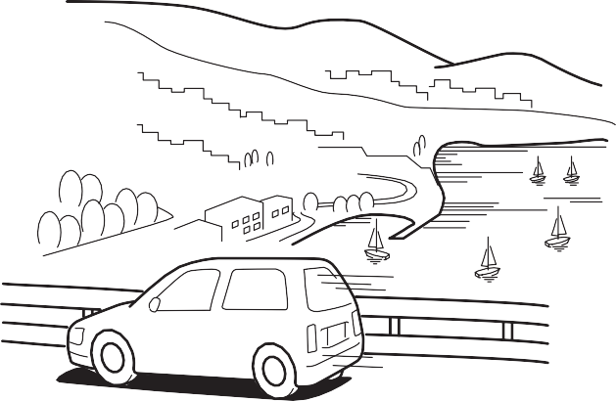

#### DRIVING TIPS

**Running-in 4-1**

**Catalytic Converter 4-1**

**Improving Fuel Economy 4-2**

**Highway Driving 4-3**

**Driving on Hills 4-3**

**Driving on Slippery Roads ................................................. 4-4 4**

**Do’s and Dont’s for Safe Driving 4-4**

**Margin for Safety 4-4**

60G409

#### DRIVING TIPS

## Running-in Catalytic Converter

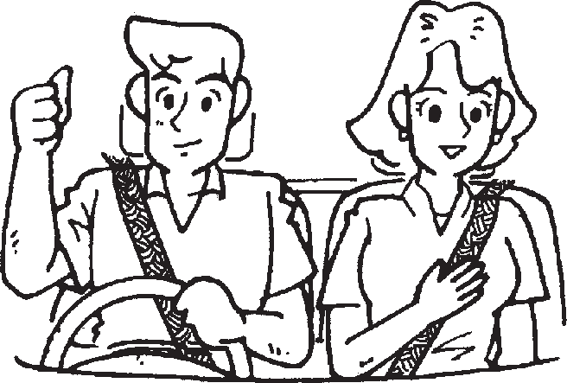

68PHM4001

* **WEAR YOUR SEAT BELTS AT ALL**

**TIMES. Even though air bags may be equipped at the front seating positions, the driver and all pas- sengers should be properly restrained at all times, using the seat belts provided. Refer to the “Seat Belts and Child Restraint Systems” section for instructions on proper use of the seat belts.**

* **Never drive while under the influ- ence of alcohol or other drugs. Alcohol and drugs can seriously impair your ability to drive safely, greatly increasing the risk of injury to yourself and others. You should also avoid driving when you are tired, sick, irritated, or under stress.**

**WARNING**

**The future performance and reliabil- ity of the engine depends on the care and restraint exercised during its early life. It is especially important to observe the following precautions during the initial 960 km of vehicle operation.**

* **After starting, do not race the engine. Warm it up gradually.**
* **Avoid prolonged vehicle operation at a constant speed. Moving parts will break in better if you vary your speed.**
* **Start off from a stop slowly. Avoid full throttle starts.**
* **Avoid hard braking, especially during the first 320 km of driving.**
* **Do not drive slowly with the transaxle in a high gear.**
* **Drive the vehicle at moderate engine speeds.**
* **Do not tow a trailer.**

***NOTICE***



**EXAMPLE**

80G106

The purpose of the catalytic converter is to minimize the amount of harmful pollutants

in your vehicle’s exhaust. Use of leaded fuel in vehicles equipped with catalytic converters is prohibited, because lead deactivates the pollutant-reducing compo- nents of the catalyst system.

The converter is designed to last the life of the vehicle under normal usage and when unleaded fuel is used. No special mainte- nance is required on the converter. How- ever, it is very important to keep the engine properly tuned. Engine misfiring, which can result from an improperly tuned engine, may cause overheating of the cat- alyst. This may result in permanent heat damage to the catalyst and other vehicle components.

### 4-1

**DRIVING TIPS**

## Improving Fuel Economy

The following instructions will help you improve fuel economy.

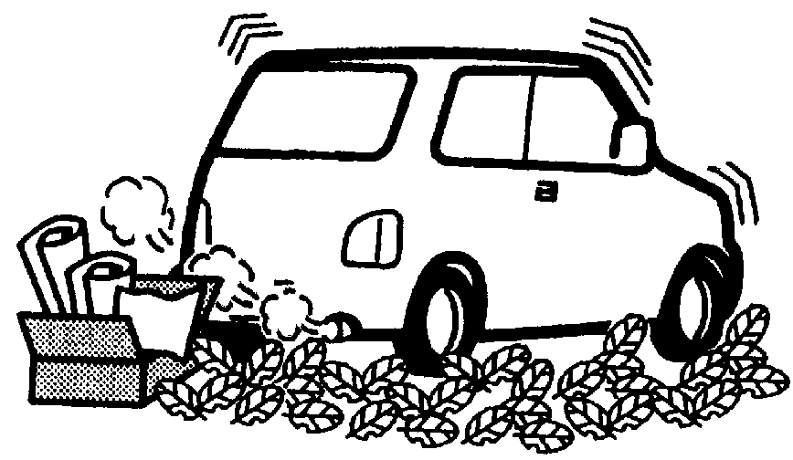

54G584S

**Be careful about where you park and drive; the catalytic converter and other exhaust components can get very hot. As with any vehicle, do not park or operate this vehicle in areas where combustible materials such as dry grass or leaves can come in con- tact with a hot exhaust system.**

**WARNING**

**EXAMPLE**

**To avoid damaging catalyst or other vehicle damage:**

* **Maintain the engine in the proper operating condition.**
* **In the event of an engine malfunc- tion, particularly one involving engine misfiring or other apparent loss of performance, have the vehi- cle serviced promptly.**
* **Do not turn off the engine or inter- rupt the ignition when the transaxle is in gear and the vehicle is in motion.**
* **Do not try to start the engine by pushing or towing the vehicle, or coasting down a hill.**
* **Do not idle the engine with any spark plug wires disconnected or removed, such as during diagnos- tic testing.**
* **Do not idle the vehicle for pro- longed periods if idling seems rough or there are other malfunc- tions.**
* **Do not allow the fuel tank to get near the empty level.**
* **Avoid driving your vehicle at excessively high engine speed.**

***NOTICE***

Avoid excessive idling

If you are to wait for more than a minute while you are parked, stop the engine and start it again later. When warming up a cold engine, do not allow the engine to idle or apply full throttle until the engine has reached operating temperature. Allow the engine to warm up while driving.

Avoid sudden acceleration

Sudden acceleration starting from rest or while driving will consume fuel unneces- sarily and shorten engine life. Start off slowly.

Avoid unnecessary stops

Avoid unnecessary deceleration and stop- ping. Try to maintain a slow, steady speed whenever possible. Slowing down and then accelerating again uses more fuel.

Keep a steady cruising speed

Keep as constant a speed as road and traf- fic conditions will permit.

### 4-2

#### DRIVING TIPS

Keep the air cleaner clean

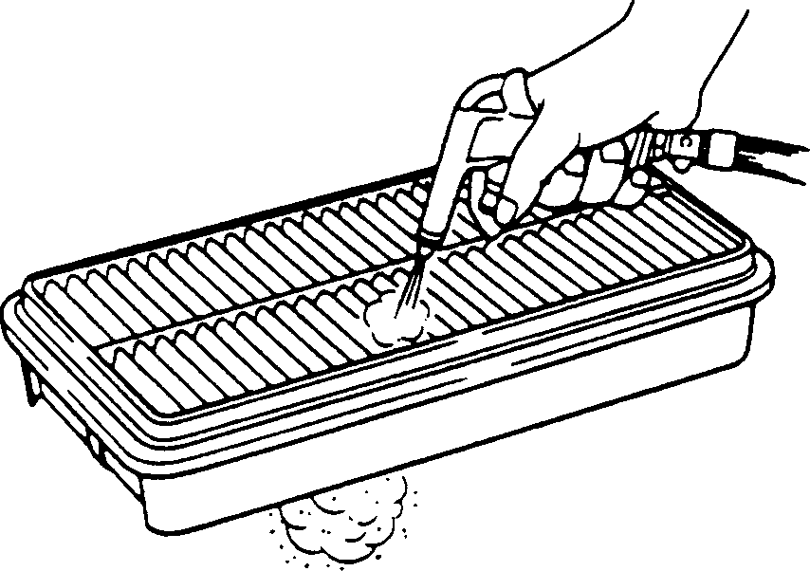

**EXAMPLE**

60A183S

## Highway Driving

When driving at high speeds, pay attention to the following:

* Stopping distance progressively increases with vehicle speed. Apply the brakes far enough ahead of the stopping point to allow for the extra stopping dis- tance.
* On rainy days, hydroplaning can occur. Hydroplaning is the loss of direct contact between the road surface and the vehi- cle’s tires due to a water film forming between them. Steering or braking the vehicle while hydroplaning can be very difficult, and loss of control can occur.

## Driving on Hills

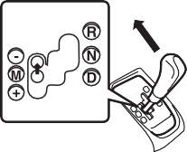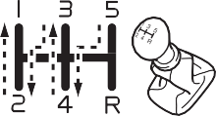

**EXAMPLE**

53M06005

If the air cleaner is clogged with dust, there will be greater intake resistance, resulting in decreased power output and increased fuel consumption.

Keep weight to a minimum

Heavier the load, more fuel the vehicle consumes. Take out any luggage or cargo when it is not necessary.

**Keep tire pressures correct** Underinflation of the tires can waste fuel due to increased running resistance of the tires. Keep your tires inflated to the correct pressure shown on the label on the driver’s side door or the driver’s door lock pillar.

Keep speed down when the road surface is wet.

* At high speeds, the vehicle may be affected by side winds. Therefore, reduce speed and be prepared for unex- pected buffeting, which can occur at the exits of tunnels, when passing by a cut of a hill, or when being overtaken by large vehicles, etc.
* When climbing steep hills, the vehicle may begin to slow down and show a lack

of power. If this happens, you should shift to a lower gear so that the engine will again be operating in its normal power range. Shift rapidly to prevent the vehicle from losing momentum.

* When driving down a hill, the engine should be used for braking by shifting into a lower gear.

**4-3**

## Driving on Slippery Roads



**Try not to hold the brake pedal down too long or too often while going down a steep or long hill. This could cause the brakes to overheat, result- ing in reduced braking efficiency. Failure to take this precaution could result in loss of vehicle control.**

**WARNING**

**Tire Chains**

#### DRIVING TIPS

##### While moving uphill/gradient from a stand still condition

* + Apply the parking brake firmly so that the vehicle does not roll backwards.
  + Depress the Clutch pedal and Shift the gearshift lever to 1st Select position.
  + Do not slip the clutch.
  + When ready to start, press accelerator pedal and slowly release the clutch pedal simultaneously. When the vehicle starts to move, gradually release the parking brake.

**When descending down a hill, NEVER turn the ignition key to the “OFF” position. Emission control system damage may result.**

***NOTICE***

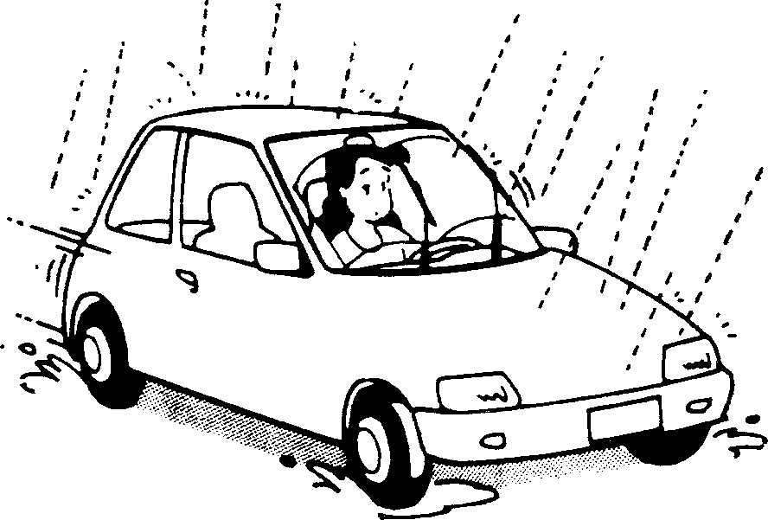

**EXAMPLE**

60G089S

Under wet road conditions you should drive at a lower speed than on dry roads due to possible slippage of tires during braking. When driving on icy, snow-cov- ered, or muddy roads, reduce your speed and avoid sudden acceleration, abrupt braking, or sharp steering movements.

Tire chains should only be used if they are needed to increase traction or are required by law. Make sure that the chains you use are the correct size for your vehicle’s tires. Also make sure that there is enough clear- ance between the fenders and the chains as installed on the tires.

Install the chains on the front tires tightly, according to the chain manufacturer’s instructions. Retighten the chains after driving about 1.0 km (1/2 mile) if neces- sary. With the chains installed, drive slowly.

* **If you hear the chains hitting against the vehicle body while driv- ing, stop and tighten them.**
* **If your vehicle is equipped with full wheel caps, remove the wheel caps before installing the chains or the wheel caps can be damaged by the chain bands.**

***NOTICE***

### 4-4

#### DRIVING TIPS

##### If Your Vehicle Gets Stuck

If your vehicle gets stuck in snow, mud, or sand, follow the directions below:

1. Shift the transaxle back and forth between a forward range (or first gear for manual transaxle) and reverse. This will create a rocking motion which may give you enough momentum to free the vehicle. Press gently on the accelerator to keep wheel spinning to a minimum wheel rpm. Remove your foot from the accelerator while shifting. Do not race the engine. Excessive wheel spin will cause the tires to dig deeper, making it more difficult to free the vehicle.
2. If your vehicle remains stuck after a few minutes of rocking, we recommend you to consult your authorised Maruti Suzuki workshop or a roadside assis- tance service. If a towing service is not available in an emergency, your vehicle may be temporarily towed by a towing cable or chain secured to the towing hook either on the front of the vehicle or on the rear of the vehicle. Refer to “Frame Hooks” in the “OTHER CON- TROLS AND EQUIPMENT” section.

* **When driving on wet roads, avoid driving through large amount of standing water on the road. Large amount of water entering the engine compartment may cause damage to the engine and or elec- trical components.**
* **If stuck in deep water, do not start till water level drops.**
* **Water is incompressible substance, water inside engine is harmful to the engine.**



**Do not allow anyone to stand near the vehicle when you are rocking it, and do not spin the wheels faster than an indicated 40 km/h on the speedometer. Personal injury and/ or vehicle damage may result from spin- ning the wheels too fast.**

**WARNING**

**Do not continue rocking the vehicle for more than a few minutes. Pro- longed rocking can cause engine overheating or transaxle damage.**

***NOTICE***

## Driving On Wet Roads



**CAUTION**

### 4-5



* **In addition to following the driving tips in this section, it is important to observe the following precau- tions.**
* **Make sure your tires are in good condition and always maintain the specified tire pressure. Refer to “Tires” in the “INSPECTION AND MAINTENANCE”**
* **Do not use tires other than those specified by MARUTI SUZUKI. Never use different sizes or types of tires on the front and rear wheels. For information regarding the specified tires, refer to the Tire Information Label located on the driver’s door lock pillar.**
* **Never use oversized tires or spe- cial shock absorbers and springs to raise (jack up) your vehicle. This will change the handling character- istics. Oversized tires may also rub against the vehicle body over bumps, causing vehicle damage or tire failure.**
* **After driving through water, test the brakes while driving at a slow speed to see if they have main- tained their normal effectiveness. If the brakes are less effective than normal, dry them by repeatedly applying the brakes while driving slowly until the brakes have regained their normal effective- ness.**

**WARNING**

#### DRIVING TIPS

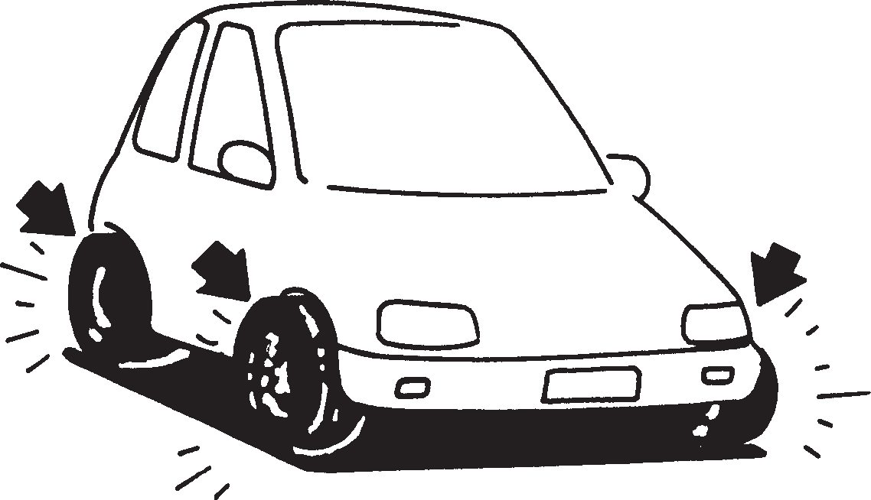 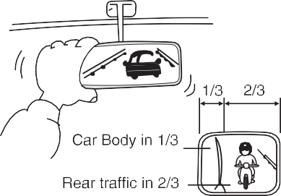

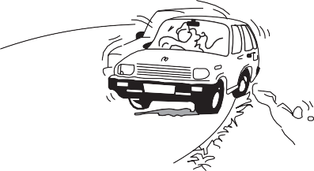

82PHM04001

## Do’s and Dont’s for Safe Driving

Exercise care in handling your vehicle. Be conscious of not only your own safety but also the safety of others on the road, and thus enjoy the best and most comfortable driving experience.

Following are basic rules for safe driving. Read them carefully for good understand- ing of the content so that you can enjoy safe and pleasant driving in your vehicle.

##### Starting

1. Adjust the driver’s seat for the proper driving posture.
2. Adjust the rear view mirror so as to obtain the best possible rear view.

72F08002

1. Before moving, look around your vehi- cle to confirm safety.
2. Don’t accelerate suddenly, since it is dangerous and wastes fuel.

##### General Driving

1. Be sure to stop before a stop light or stop sign. When moving into an inter- section without any traffic lights or signs, drive slowly to confirm safety.
2. Always follow other vehicles at a safe distance in order to prevent a rear-end collision, in case the vehicle ahead makes a sudden stop.

72F08008

1. Turn ON the turn signal at least 30 meters before making a turn or chang- ing the lane so as not to be hit.
2. Before entering a corner, decelerate to a safe speed. Don’t apply brakes during cornering, or skidding may occur.
3. When overtaking other vehicles, watch out for oncoming vehicles and carefully ensure safety.
4. Don’t attempt zigzag driving as it will hinder your control over the vehicle and may cause an accident.
5. Avoid reckless high speed driving and try to drive at a safe speed suitable for the road conditions while maintaining a constant speed.
6. The higher the speed, the narrower the driver’s visual range becomes. In such a state, it is difficult to anticipate any hazard and the driver feels fatigued.

### 4-6

#### DRIVING TIPS

##### Braking

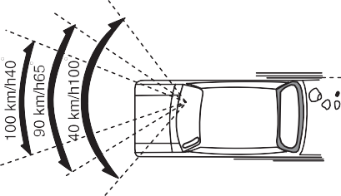



72F08015

1. Do not attempt sharp handling during high speed driving. You may lose your control over your vehicle.
2. When overtaking or changing lanes while driving at a high speed, keep ample vehicle-to-vehicle distance.

Use foot brake in three stages

* 1. Warn the vehicle behind you

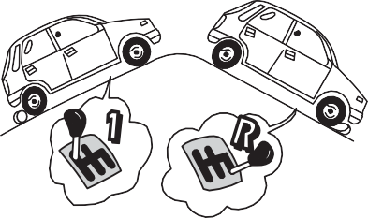

* 1. Gradually apply the brake.
  2. Bring the vehicle to a halt.

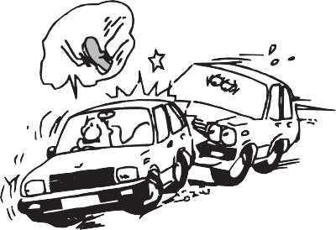72F08012

72F08011

* + 1. Use the parking brake when parking your vehicle and shift the gear shift lever into the first gear or reverse gear position for the sake of safety.
    2. Don’t use hand-braking unless unavoid- able. It causes the vehicle to skid and a collision may occur. It is especially dan- gerous when the tyres are worn out as they skid more.
    3. When driving downhill, try not to apply the brake but use the engine brake effectively. Overuse of the foot-brake may result in reduction of brake effec- tiveness.

##### Long distance driving

1. Be sure to perform safety checks before starting a trip.
2. Take rest at certain intervals to prevent an accident which may occur due to feeling sleepy or tired.

### 4-7

##### Night time driving

1. Don’t use headlights on high beam unless its use is inevitable. It may cause

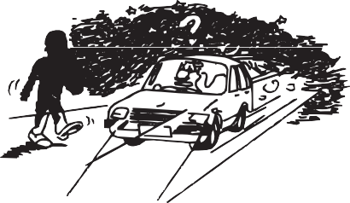

## Margin for Safety

#### DRIVING TIPS

72F08020

1. Drive at lower speeds during the night than in the daytime, as the visual range is restricted at night.
2. Avoid overtaking other vehicles at night. Darkness bothers your sense of speed and hinders your judgment of vehicle- to-vehicle distance.

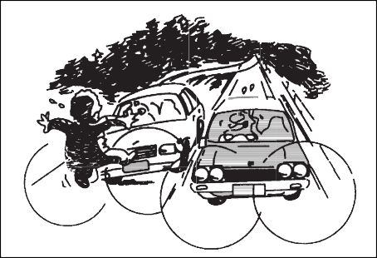

72F08021

visual impairment to the driver of the oncoming vehicle or the vehicle ahead of you, which may cause an accident.

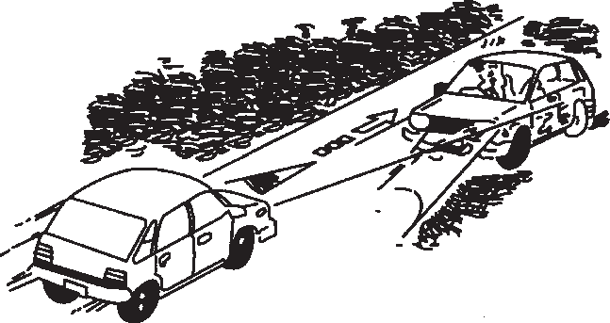

53M06015

* + 1. Always keep the window glasses clean. Don’t operate the windshield wiper when the windshield glass is dry else the wiper blade and glass may get dam- aged.

It is important to allow yourself a margin for safety during driving so that you can cope with erroneous or unexpected driving of other drivers. For that, observe the follow- ing.

* + - * Drive at a safe speed.
      * Maintain a sufficient distance between your vehicle and the vehicle ahead.
      * Don’t force yourself to overtake other vehicles.
      * Don’t accelerate suddenly, steer sharply or stop suddenly.
      * Keep ample gaps between driving schedules.
      * Observe traffic rules and regulations.

##### Conclusion

A perfect driver does not exist. The endeavour of every motorist should be to strive for perfection. Safety consciousness not only ensures your safety and the safety of other road users, it also helps reduce the wear and tear on your vehicle, length- ens its life, gives better fuel efficiency and ensures a comfortable driving experience.

**Follow the do’s and dont’s listed, and driving will never be the same again.**

### 4-8

**OTHER CONTROLS AND EQUIPMENT**

# OTHER CONTROLS AND EQUIPMENT

**Manual Heating and Air Conditioning System**

**(if equipped) 5-1**

**Fuel Filler Cap 5-6**

**Engine Hood 5-7**

**Sun Visor 5-8**

**Interior Light Switch 5-8**

**Accessory Socket (if equipped) ......................................... 5-9 5**

**Assist Grips (if equipped) 5-9**

**Glove Box 5-10**

**Cup Holder and Storage Area 5-10**

**Floor Mats 5-10**

**Shopping Hook (if equipped) ............................................. 5-11**

**Luggage Compartment Cover (if equipped) 5-11**

**Frame Hooks 5-12**

**Front Speaker Provision 5-12**

**Audio System (if equipped) 5-13**

**OTHER CONTROLS AND EQUIPMENT**

## Manual Heating and Air Conditioning System (if equipped)

##### Side outlet

###### ALTO 800

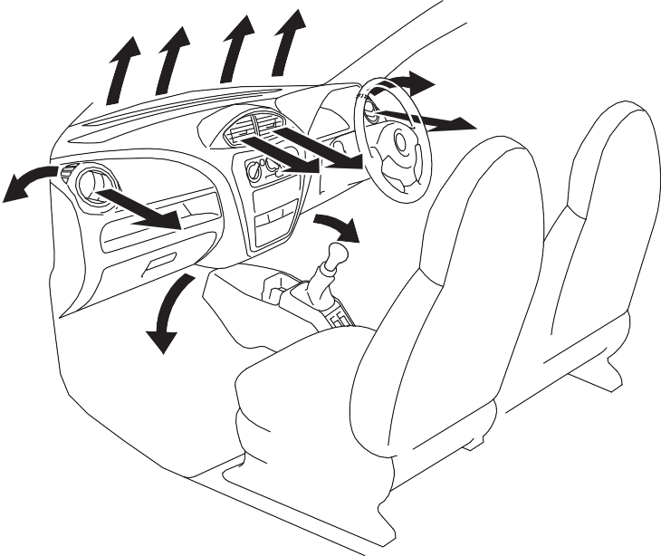

**EXAMPLE**

(1)

(1)

(2)

(3)

(2)

(3)

(4)

(5)

(5)



**EXAMPLE**

53MM05001

###### ALTO K10



**EXAMPLE**

1. Windshield defroster outlet
2. Side defroster outlet
3. Side outlet
4. Center outlet
5. Front floor outlet

53MM05002

53M-07-003

When “Open”, air comes out regardless of the air flow selector position.

### 5-1

#### OTHER CONTROLS AND EQUIPMENT

##### Description of Controls

###### ALTO 800

Temperature selector (1)

This is used to select the temperature by turning the selector.

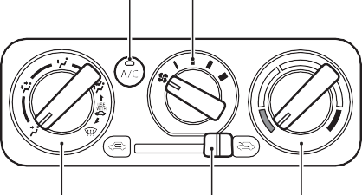

(5) (2)

(3)

(4)

(1)

Blower speed selector (2)

This is used to turn on the blower and to select blower speed by turning the selec- tor.

**Air flow selector (3)**

###### ALTO K10

53M-07-008

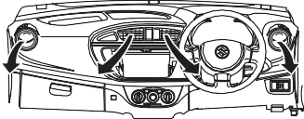

**EXAMPLE**

Temperature-controlled air comes out of the center and side air outlets.

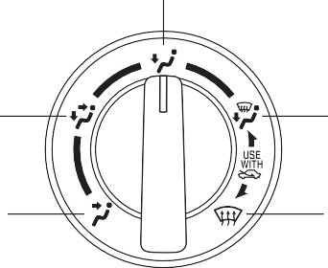

**EXAMPLE**

(c)

(b)

(d)

(a)

(e)

##### BI-LEVEL (b)

###### ALTO 800

53MH0503

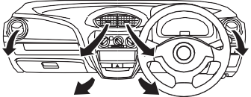

**EXAMPLE**

###### ALTO K10

53MH0504

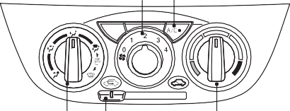

(2) (5)

(3) (4)

(1)

This is used to select one of the functions described below.

##### VENTILATION (a)

###### ALTO 800

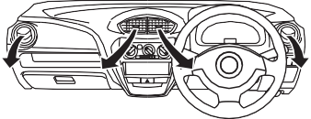

**EXAMPLE**

###### ALTO K10

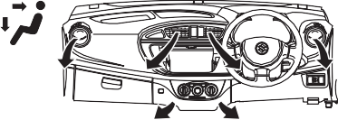

**EXAMPLE**

53MH0506

53M-07-005

53MH0505

53M-07-010

Temperature-controlled air comes out of the floor outlets and cooler air comes out of the center and side outlets. When the temperature selector (1) is in the fully cold position or fully hot position, however, the

### 5-2

#### OTHER CONTROLS AND EQUIPMENT

air from the floor outlets and the air from the center and side outlets will be the same temperature.

##### HEAT (c)

**ALTO 800**

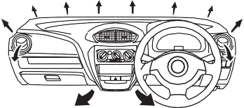

**EXAMPLE**

##### HEAT & DEFROST (d)

**ALTO 800**

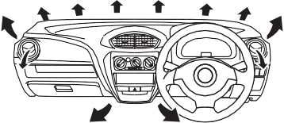

**EXAMPLE**

**ALTO K10**

**ALTO K10**

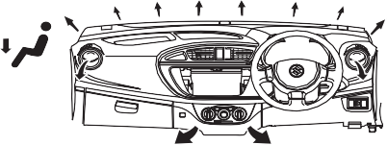

**EXAMPLE**

53MH0507

###### ALTO K10

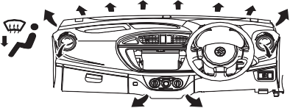

**EXAMPLE**

53MH0508

53M-07-016

Temperature-controlled air comes out of the windshield defroster outlets, the side defroster outlets and the side outlets.

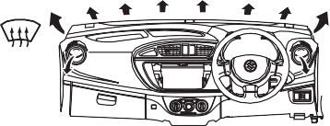

**EXAMPLE**

Air intake selector (4) ALTO 800



(g)

(f)

**EXAMPLE**

53M-07-0012

Temperature-controlled air comes out of the floor outlets and the side outlets, also comes out of the windshield defroster out- lets and also comes slightly out of the side defroster outlets.

53M-07-014

Temperature-controlled air comes out of the floor outlets, the windshield defroster outlets, the side defroster outlets and the side outlets.

##### DEFROST (e)

###### ALTO 800

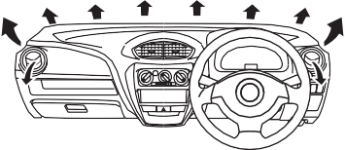

**EXAMPLE**

###### ALTO K10

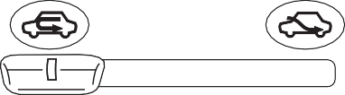

**EXAMPLE**

53MH0510



53MH0509

53m-07-018

This selector is used to select the following modes.

### 5-3

#### OTHER CONTROLS AND EQUIPMENT

##### Fresh Air (f)

When this mode is selected by moving the lever to right, outside air is used.

##### Recirculated Air (g)

When this mode is selected by moving the lever to left, outside air is shut out and inside air is recirculated. This mode is suit- able when driving through dusty or polluted air such as in a tunnel, or when attempting to quickly cool down the interior.

*NOTE:*

*If you select RECIRCULATED AIR for an extended period of time, the air in the vehi- cle can become contaminated. Therefore, you should occasionally select FRESH AIR.*

**Air conditioning switch (5) (if equipped)** To turn on the air conditioning system, set the blower speed selector to a position other than “OFF” and push in the “A/C” switch. With this “A/C” switch operation, a indicator light will come on when the air conditioning system is on. To turn off the air conditioning system, push “A/C” switch again.

During operation of the air conditioner, you may notice slight changes in engine speed. These changes are normal, the system is designed so that the compressor turns on or off to maintain the desired tem- perature.

Less operation of the compressor results in better fuel economy.

##### System Operating Instructions

Natural ventilation

Select VENTILATION and FRESH AIR, the temperature selector to the desired tem- perature position, and the blower speed selector to off. Fresh air will flow through the vehicle during driving.

Forced ventilation

The control settings are the same as for natural ventilation except you set the blower speed selector to a position other than off.

**Normal heating (using outside air)** Select HEAT and FRESH AIR, the tem- perature selector to the desired tempera- ture position and the blower speed selector to the desired blower speed position. Set- ting the blower speed selector to a higher blower speed position increases heating efficiency.

**Quick heating (using recirculated air)** The control settings are the same as for normal heating except you select RECIR- CULATED AIR. If you use this heating method for an extended period of time, the air in the vehicle can become contami- nated and the windows can become misty. Therefore, use this method only for quick heating and change to the normal heating method as soon as possible.

**Head cooled/Feet warmed heating** Select BI-LEVEL and FRESH AIR, the temperature selector to the desired tem- perature position, and the blower speed selector to the desired blower speed posi- tion. Unless the temperature selector is in the fully cold position or fully hot position, the air that comes out of the center and side outlets will be cooler than the air that comes out of the floor outlets.

Normal cooling

Set the air flow selector to VENTILATION, the temperature selector to the desired temperature position and the blower speed selector to the desired blower speed posi- tion, and turn on the “A/C” switch. Setting

the blower speed selector to a higher blower speed position increases cooling

efficiency.

You can switch the air intake selector to either FRESH AIR or RECIRCULATED

AIR as you desire. Choosing RECIRCU- LATED AIR increases cooling efficiency.

**Quick cooling (using recirculated air)** The control settings are the same as for normal cooling except you select RECIR- CULATED AIR and the highest blower speed.

*NOTE:*

* *To turn on the air conditioning system, push in the “A/C” switch and set the blower speed selector to a position other than OFF. With this “A/C” switch opera-*

### 5-4

#### OTHER CONTROLS AND EQUIPMENT

*tion, an indicator light will come on when the air conditioning system is on. To turn off the air conditioning system, push the “A/C” switch again.*

* + *During operation of the air conditioner, you may notice slight changes in engine speed. These changes are normal, the system is designed so that the compres- sor turns on or off to maintain the desired temperature. Less operation of the compressor results in better fuel economy.*

*NOTE:*

* + *If you select RECIRCULATED AIR for an extended period of time, the air in the vehicle can become contaminated. Therefore, you should occasionally select FRESH AIR.*
  + *If your vehicle has been left in the sun with the windows closed, it will cool faster if you open the windows briefly while you operate the air conditioner with the air intake selector at FRESH AIR and the blower at high speed.*

Dehumidifying

Set the air flow selector to a desired air flow selector position, the temperature selector to the desired temperature posi- tion and the blower speed selector to the desired blower speed position. Also select FRESH AIR and turn on the “A/C” switch.

*NOTE:*

*Because the air conditioner dehumidifies the air, turning it on will help keep the win- dows clear, even when blowing heated air using the DEFROST or HEAT & DEFROST functions.*

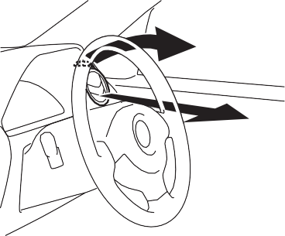

**EXAMPLE**

53MH0511

*NOTE:*

*If you need maximum defrosting:*

* *set the air flow selector to DEFROST,*
* *set the blower speed selector to high,*
* *adjust the temperature selector to the hot end, and*
* *adjust the side outlets so the air blows on the side windows.*

##### Maintenance

If you do not use the air conditioner for a long period, such as during winter, it may not give the best performance when you start using it again. To help maintain opti- mum performance and durability of your air conditioner, it needs to be run periodically. Operate the air conditioner at least once a month for one minute with the engine idling. This circulates the refrigerant and oil and helps protect the internal components.

*NOTE:*

*Your vehicle uses the air conditioning refrigerant HFC-134a, commonly called “R-134a”. R-134a replaced R-12 around*

*1993 for automotive applications. Other refrigerants are available, including recy-*

*cled R-12, but only R-134a should be used in your vehicle.*

**Using the wrong refrigerant may damage your air conditioning sys- tem. Use R-134a only. Do not mix or replace the R-134a with other refrig- erants.**

***NOTICE***

**5-5**

## Fuel Filler Cap

**ALTO 800**

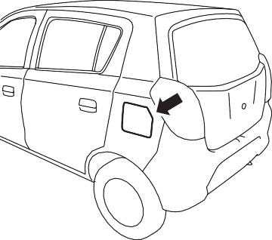

**EXAMPLE**

#### OTHER CONTROLS AND EQUIPMENT

To remove the fuel filler cap:

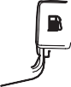

**EXAMPLE**

1. Open the fuel filler door.
2. Remove the cap by turning it counter- clockwise.



**CAUTION**

**Remove the fuel filler cap slowly. The fuel may be under pressure and may spray out, causing injury.**

###### ALTO K10

53MH0512

53MH0513

The fuel filler cap is located on the left rear side of the vehicle. The fuel filler door can be unlocked by pulling up the opener lever located on the outboard side of the driver’s seat and locked by simply closing the door.

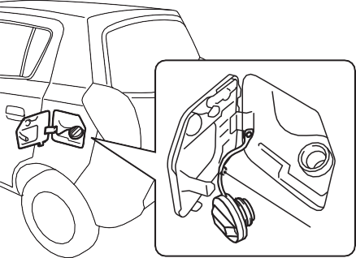

**EXAMPLE**

(1)

53MH0514

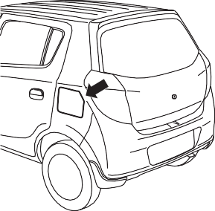

**EXAMPLE**

Open

Close

**EXAMPLE**

*NOTE:*

53M-07-021

68KN048

*If the fuel filler door is equipped with the cap holder (1), then use the cap holder to hold fuel filler cap while refueling.*

To reinstall the fuel filler cap:

1. Turn the cap clockwise until you hear several clicks.
2. Close the fuel filler door.

### 5-6

**OTHER CONTROLS AND EQUIPMENT**

## Engine Hood



**If you need to replace the fuel cap, use a Maruti genuine cap. Use of an improper cap can result in a malfunc- tion of the fuel system or emission control system. It may also result in fuel leakage in the event of an acci- dent.**

**WARNING**

**Fuel is extremely flammable. Do not smoke when refueling, and make sure there are no open flames or sparks in the area.**

**WARNING**



**EXAMPLE**

53MH0515

To open the engine hood:

1. Pull the hood release handle located on the outboard side of the driver’s side. This will disengage the engine hood lock halfway.

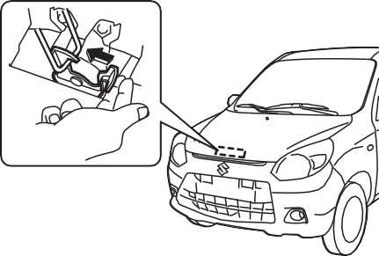

**EXAMPLE**

53MM05009

1. Push the under-hood release lever sideways with your finger, as shown in the illustration. While pushing the lever, lift up the engine hood.

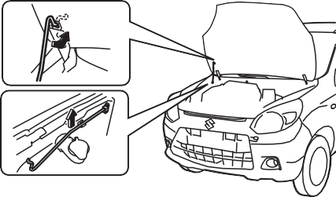

**EXAMPLE**

53MM05010

1. Continue to lift up the hood until it is high enough to support with the prop rod.

To close the engine hood:

1. Lift the hood up slightly and remove the prop rod from the hole. Put the prop rod back to the holding clip.
2. Lower the hood close to the bumper, then let it drop down. Make sure the hood is securely latched after closing.



**Make sure the hood is fully closed and latched before driving. If it is not, it can fly up unexpectedly during driving, obstructing your view and resulting in an accident.**

**WARNING**

**5-7**

## Sun Visor



**EXAMPLE**

## Interior Light Switch

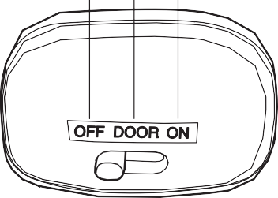

**EXAMPLE**

(3) (2) (1)

#### OTHER CONTROLS AND EQUIPMENT

79J161

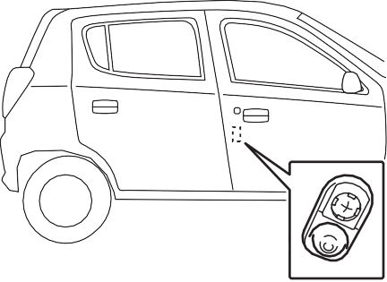

**EXAMPLE**

82JN065

*NOTE:*

53MH0519

The sun visors can be pulled down to block glare coming through the windshield, or they can be unhooked and turned to the side to block glare coming through the side window.

**When unhooking and hooking a sun visor, be sure to handle it by side of the sun visor as shown in the figure else sun visor may get damaged.**

***NOTICE***

This light switch has three positions which function as described below:

* 1. The light comes on and stays on regardless of whether the door is open or closed.
  2. The light comes on when the door is opened.
  3. The light remains off even when the door is opened.

*The number of doors involved in the light- ing operation of the interior light depends*

*on the vehicle specification. If there is a switch (rubber projection) at the door opening as shown, the door is involved in the lighting operation. The tailgate is also involved in this operation even without the rubber projection.*

### 5-8

**OTHER CONTROLS AND EQUIPMENT**

## Accessory Socket (if equipped)

###### ALTO 800

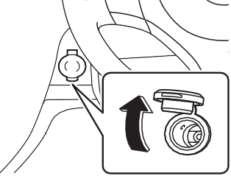

**EXAMPLE**

**Automated Manual Transaxle**

## Assist Grips (if equipped)

###### ALTO K10

Manual Transaxle

53M-07-032

53M-07-034

The accessory socket will work when the ignition switch is in the “ACC” or “ON” posi- tion. This socket can be used to provide 12volt/120 watt power for electrical acces- sories. Check that the cap remains on the socket when socket is not in use.

53MH0518

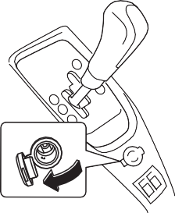

**EXAMPLE**

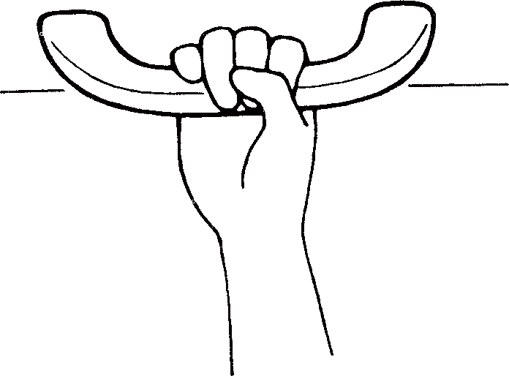

**EXAMPLE**

Assist grips are provided for convenience.

**To avoid damaging the assist grip and the molded headlining, do not hang down the assist grip.**

***NOTICE***

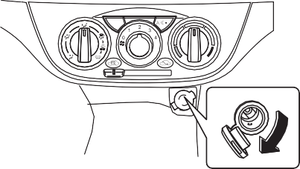

**EXAMPLE**

**Use of inappropriate electrical acces- sories can cause damage to your vehicle’s electrical system. Make sure that any electrical accessories you use are designed to plug into this type of socket.**

***NOTICE***

53M-07-033

**5-9**

## Glove Box

**OTHER CONTROLS AND EQUIPMENT**

## Cup Holder and Storage Area



(Continued)

* **Do not use the cup holders to hold sharp-edged, hard, or breakable objects. Objects in the cup holders may be thrown about during a sud- den stop or impact, and could cause personal injury.**
* **Be careful not to spill liquid or insert any foreign materials into the moving part of the gearshift lever, or any electrical components. Liq- uid or foreign materials may dam- age these parts.**

**WARNING**



**EXAMPLE**

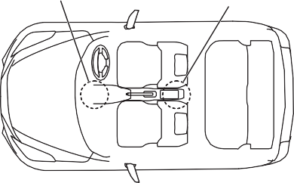

(1)

**EXAMPLE**

(2)

53MH0520

To open the glove box, pull the latch lever. To close it, push the lid until it latches securely.



**Never drive with the glove box lid open. It could cause injury if an acci- dent occurs.**

**WARNING**

53MM05008

1. Front cup holder and bottle holder (if equipped)
2. Rear bottle holder (if equipped)

**Front Cup Holder & Bottle Holder (1) (if equipped) / Rear Bottle Holder (2) (if equipped)**



**Failure to take the precautions listed below could cause personal injury or vehicle damage.**

* **Be careful when you are using the cup holders to hold a cup contain- ing hot liquid. Spilling out hot liq- uid can cause burn injury.**

(Continued)

**WARNING**

## Floor Mats

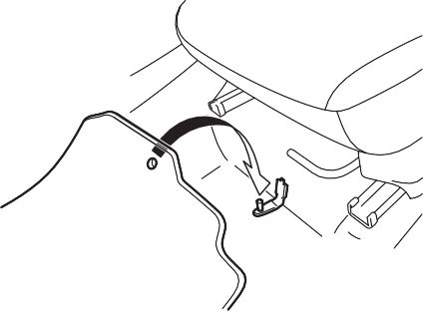

**EXAMPLE**

53MH0522

To prevent the driver’s side floor mat from sliding forward and possibly interfering with

### 5-10

#### OTHER CONTROLS AND EQUIPMENT

the operation of the pedals, MARUTI GEN- UINE floor mats are recommended.

Whenever you put the driver’s side floor mat back in the vehicle after it has been removed, be sure to hook (if equipped) the floor mat grommet(s) to the fastener(s) and position the floor mat properly in the foot- well.

When you replace the floor mats in your vehicle with a different type such as all- weather floor mats, we highly recommend using MARUTI GENUINE floor mats for proper fitting.



**Failure to take the following precau- tions may result in the driver’s side floor mat interfering with the pedals and causing a loss of vehicle control or an accident.**

* **Make sure that the floor mat grom- met(s) is(are) hooked to the fas- tener(s).**
* **Never place additional floor mats on top of the existing floor mats.**

**WARNING**

## Shopping hook (if equipped)

You can hang the shopping bag or other suitable objects on the hook located on the dashboard. This hook is not designed for large or heavy items.



**CAUTION**

**To avoid breaking the hook, do not hang items heavier than 2 kg (4.4 ibs).**



**EXAMPLE**

53M-07-039

## Luggage Compartment Cover (if equipped)

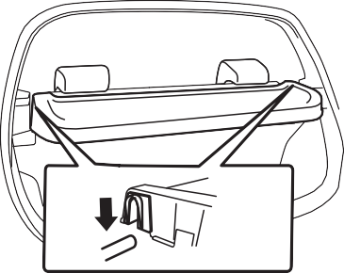

**EXAMPLE**

53M-07-040

Luggage or other cargo placed in the lug- gage compartment is hidden from view by a luggage compartment cover.



**Do not carry items on top of the lug- gage compartment cover, even if they are small and light. Objects on top of the cover could be thrown about in an accident, causing injury, or could obstruct the driver’s rear view.**

**WARNING**

### 5-11

**OTHER CONTROLS AND EQUIPMENT**

## Frame Hooks

Front

To tow your vehicle on the road or highway, follow the instruction of “Towing” in “EMER- GENCY SERVICE” or “VEHICLE LOAD-

ING AND TOWING” section.



**EXAMPLE**

##### Front Speakers Provision (if equipped)

###### ALTO 800

53M-07-043



**Do not use the frame hooks to tow another vehicle or to have your vehi- cle towed on the road or highway. The hooks (1) is designed for use in emergency situations only, such as if your vehicle or another vehicle gets stuck in deep mud or snow.**

**The hook (2) is provided for trailer/ train shipping purposes.**

**WARNING**



**EXAMPLE**

Rear

53M-07-045

###### ALTO K10

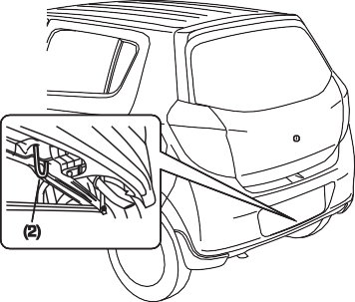

**EXAMPLE**



**EXAMPLE**

**When you use the towing hook (1), avoid the driving that gives signifi- cant physical shock on hook. Such operation can damage the hook, or the vehicle body.**

**Do not sudden accelerate.**

***NOTICE***

53M-07-044

The frame hooks are provided on the front (1), rear (2) of the vehicle. The hooks (1) is used for emergency situations. The hooks

(1) and (2) are used for trailer/train ship- ping purpose.

53M-07-046

Space for fitment of front speaker is pro- vided on the front doors.

### 5-12

**OTHER CONTROLS AND EQUIPMENT**

## Audio System (if equipped)

**If you pay extended attention to oper- ating the audio system or viewing the audio system display while driving, an accident can occur. If you set the sound volume too loud, it could pre- vent you from being aware of road and traffic conditions.**

* **Keep your eyes on the road and your mind on the drive. Avoid pay- ing extended attention to operating the audio system or viewing the audio system display.**
* **Familiarize yourself with the audio system controls and operation of the audio system before driving.**
* **Preset your favorite radio stations before driving so that you can quickly tune to them using the pre- sets.**
* **Set the sound volume to a level that will allow you to continue to be aware of road and traffic conditions while driving.**

###### ALTO 800

Refer supplementary manual for audio system (if equipped), provided along with the vehicle.

###### ALTO K10

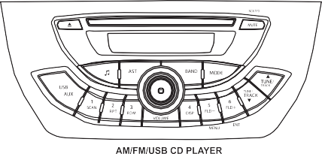

**EXAMPLE**

53M-07-047

about one hour. This will allow the con- densation to disappear normally.

* Driving on extremely bumpy roads which cause severe vibrations may cause sound to skip.
* This unit uses a precision mechanism. Even in the event that trouble arises, never open the case, disassemble the unit, or lubricate the rotating parts. Please bring the unit to an authorized MARUTI SUZUKI dealer.

Cautions on Handling



53M-07-048

This unit has been designed specifically for playback of compact discs bearing mark

(A) shown above.

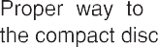

### 5-13

##### Notes on Discs

Precautions

* When the inside of the vehicle is very cold and the player is used soon after switching on the heater, condensation may form on the disc or the optical parts of the player and proper playback may not be possible. If condensation forms on the disc, wipe it off with a soft cloth. If condensation forms on the optical parts of the player, do not use the player for

53M-07-049

To remove the compact disc from its stor- age case, press down on the center of the

#### OTHER CONTROLS AND EQUIPMENT

case and lift the disc out, holding it care- fully by the edges.

Always handle the compact disc by the edges.

Never touch the surface.

Use of such discs will cause damage or prevent the system from operating prop- erly.

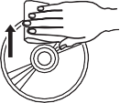

53M-07-050

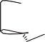

To remove fingermarks and dust, use a soft cloth, and wipe in a straight line from the center of the compact disc to the cir- cumference.

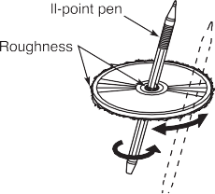

53M-07-051

New discs may have some roughness around the edges. The unit may not work or the sound may skip if such discs are used. Use a ball-point pen etc. to remove the roughness from the edges of the disc.

53M-07-052

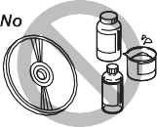Never stick labels on the surface of the compact disc or write on the surface with a pencil or pen.

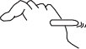

53M-07-053

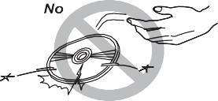Do not use any solvents such as commer- cially available cleaners, anti-static spray, or thinner to clean compact discs.

53M-07-054

Do not use compact discs that have large scratches, are misshaped, or cracked, etc.

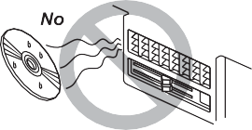53M-07-055

Do not expose compact discs to direct sun- light or any heat source.

*NOTE:*

* *Do not use commercially available CD*

*protection sheets or discs equipped with stabilizers, etc.*

*These may get caught in the internal mechanism and damage the disc.*

* *It may be impossible to play CD-R discs with this unit due to the recording condi- tions.*
* *CD-RW discs cannot be played with this unit.*



**This is a class I laser product. Use of controls or adjustments or perfor- mance of procedures other than those specified herein may result in hazard- ous radiation exposure.**

**Do not open covers and do not attempt to repair this unit by yourself. Refer servicing to qualified personnel.**

**WARNING**

### 5-14

**OTHER CONTROLS AND EQUIPMENT**

## Basic Operations

1. VOL PUSH POWER knob
2. SOUND button
3. MUTE button

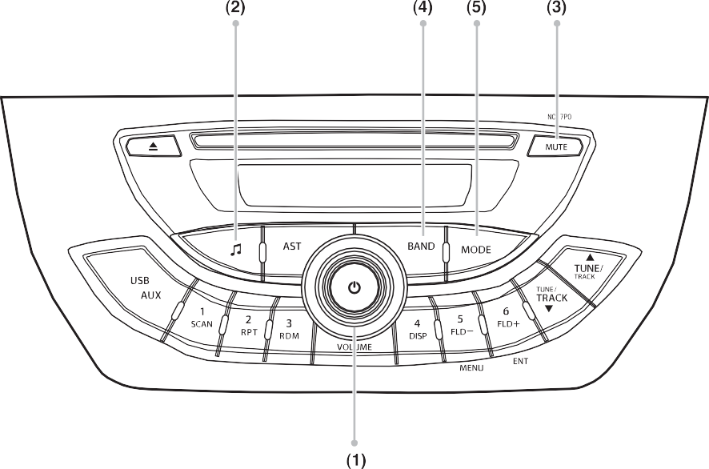

**EXAMPLE**

1. BAND button
2. MODE button

53M-07-056

### 5-15

#### OTHER CONTROLS AND EQUIPMENT

##### Turning power on/off

Press the VOL PUSH POWER knob (1). The unit starts in the function mode it was in when the power was turned off last.

**You can also turn the power on by pressing the desired source button**

RADIO mode

: Press the BAND button (4)

Last accessed media mode : Press the MODE

button (5)

Adjusting the volume

Turning it clockwise increases the volume; turning it counterclockwise decreases the volume.

Mute

Press the MUTE button (3) to mute the sound. To cancel the mute, press the MUTE button (3) again.

##### Adjusting bass/treble/balance / fader

1. Press the SOUND button (2).

Each time the knob is pressed, sound adjustment will change as follows:

Preset-EQ **(FLAT)**

Bass adjustment **(BAS 0)** Treble adjustment **(TRE 0)** Balance adjustment **(BAL 0)**

Fader adjustment **(FAD 0)**

1. Turn the VOL PUSH POWER knob (1) to adjust the sound.

Beep tone

Each time SOUND button (2) is pressed (more than 1 second) beep tone mode switches as follows.

##### Preset-EQ

Preset-EQ calls up various sound types in accordance with the listening music type.

1. Press the SOUND button (2) several times until “FLAT” appears.
2. Turn the VOL PUSH POWER knob (2). Each time the knob is turned, preset EQ mode will change as follows:

*NOTE:*

*Once the set is switched off and switched on, the setting on EQ will be remained the previous setting.*

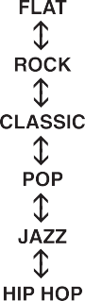

53M-07-058

### 5-16

**OTHER CONTROLS AND EQUIPMENT**

## Listening to Radio

Display

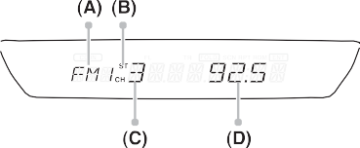

* 1. BAND button

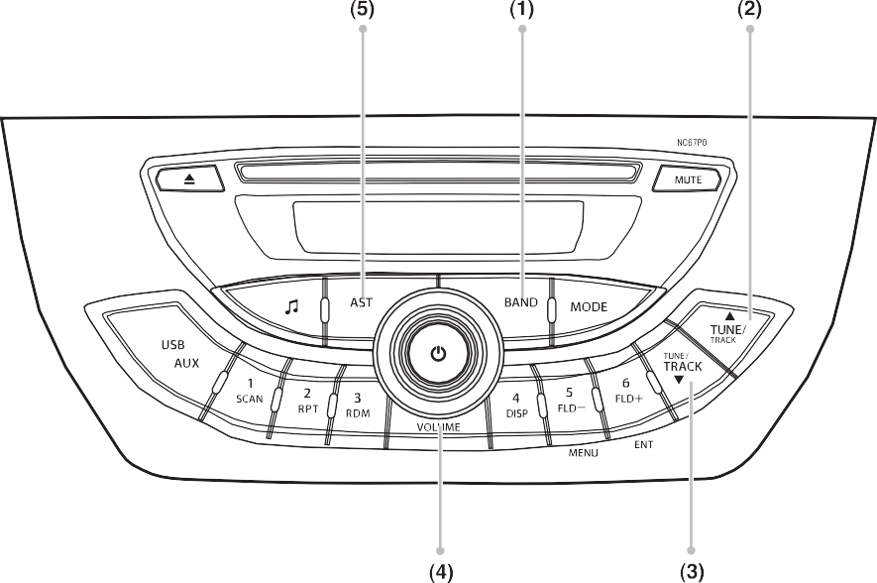

**EXAMPLE**

* 1. Up button
  2. Down button
  3. Preset buttons ([1] to [6])
  4. AST button
     1. Band
     2. Stereo
     3. preset Channel Number
     4. Frequency

53M-07-060

53M-07-059

### 5-17

#### OTHER CONTROLS AND EQUIPMENT

##### Selecting the reception BAND

Press the BAND button (1). Each time the button is pressed, the reception band will change as follows:



53M-07-061

Seek tuning

Hold down the seek Up button (2) or the seek Down button (3) for 1 second or lon- ger.

The unit stops searching for a station at a frequency where a broadcast station is available.

Manual tuning

Press seek Up button (2) or the seek Down button (3).

The frequency being received is displayed. Which receiving FM stereo broadcasting. ST lights up.

##### Preset memory

1. Select the desired station.
2. Hold down a desired button ([1] to [6]) of the Preset buttons (4) to which you want to store the station for 2 seconds or longer.

Auto store

Hold down the AST button (5) for 1 second or longer. Six stations in good reception will automatically be stored to the Preset buttons (4) in order, starting from a station whose frequency is the lowest.

*NOTE:*

* + *Auto store can be released by pressing AS button (5) while auto store is under way.*
  + *When the auto store is performed, the station previously stored in the memory at the position is over written.*
  + *When there are fewer than 6 stations that can be stored even if 2 rounds of auto store operation is performed, no station will be stored at the remaining Preset buttons (4).*
  + *6 stations can be preset for FM1, FM2 and FM3 in common, and 6 stations for AM in auto store mode.*

##### Radio Reception

Radio reception can be affected by envi- ronment, atmospheric conditions, or radio signal’s power and distance from the sta- tion. Nearby mountains and buildings may interfere or deflect radio reception, causing poor reception. Poor reception or radio static can also be caused by electric cur- rent from overhead wires or high voltage power lines.

### 5-18

**OTHER CONTROLS AND EQUIPMENT**

## Listening to a CD

Display



1. Eject button

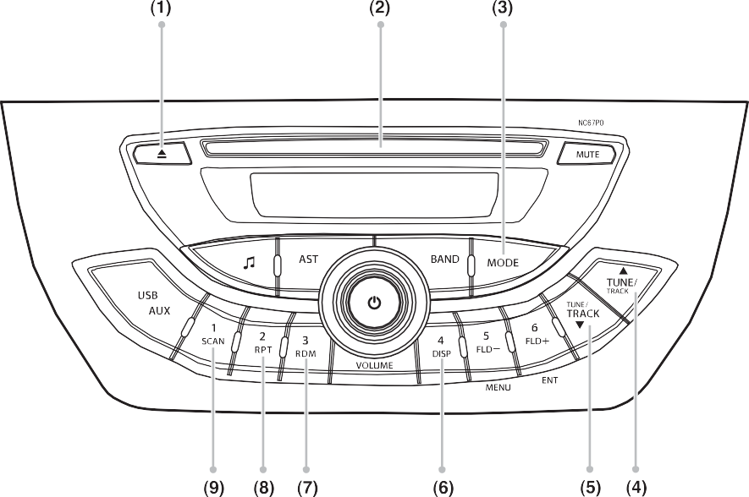

**EXAMPLE**

1. Insertion slot
2. Media Source Mode button
3. Up button
4. Down button
5. DIPS button
6. RDM button
7. RPT button
8. SCAN button
   1. Track number
   2. Play time

*NOTE:*

53MM05011

*This product does not support 8 cm CD (sometimes called as “mini single CD”, “3- inch CD”, “CD3” etc.).*

53M-07-062

### 5-19

#### OTHER CONTROLS AND EQUIPMENT



53M-07-064

* + - CDs or CD-ROM carrying no mark (A) cannot be used.
    - Some discs recorded in CD-R/CD-RW format may sometimes be impossible to use.

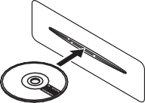

53M-07-065

* + - A CD is to be inserted with its label side up.
    - When there is a CD already in the unit, it is impossible to insert another CD with- out ejecting the CD in the unit. Do not use force to insert a CD into the CD insertion slot.
* **Never insert your finger or hand into the CD insertion slot. Never insert foreign objects.**
* **Never insert a CD with glue coming out from adhesive tape or a rental CD label or with a trace indicating that adhesive tape or a rental CD label has been removed. This may cause the CD not to eject or result in a malfunction.**

Loading a CD

Insert a CD in the Insertion slot (2). With the printed side up.

When a CD is loaded, play starts.

Ejecting a CD

Press the Eject button (1). (After ejecting, the unit returns to the Radio mode.)



**CAUTION**

*NOTE:*

* + *If a disc is inserted after the previous disc is removed from the unit, the unit starts playback from the beginning of the first track.*



**CAUTION**

* + *If you turn OFF the ACC and within few second so of turning ON the ACC, the unit starts playback from the position from where it has accepted.*
  + *If you press the EJECT button, and leave the disc for roughly 15 seconds, the disc is automatically reinserted into the unit to protect the disc. In this case, the unit doesn’t start playback automati- cally.*

Selecting a CD mode

Press the Media Source Mode button (3). Each time the button is pressed, the mode

will change as follows.

**If you forcefully try to push an ejected CD inside the unit before auto reloading, the disc surface might be scratched.**

* **When reloading a CD, remove it from the unit completely before reloading.**

53M-07066

### 5-20

#### OTHER CONTROLS AND EQUIPMENT

##### Listening to a CD

When a CD is inserted, playback will auto- matically start.

When a CD is already inside the unit, press the Media Source Mode button (3) to select CD mode and to start playback.

##### Selecting a track

Press the Up button (4) to listen to the next track.

Press the Down button (5) twice to listen to the previous track. When the Down button

(5) is pressed once, the track currently being played will start from the beginning again.

##### Fast forwarding/Rewinding a track

* + - Hold down the Up button (4) to fast for- ward the track.
    - Hold down the Down button (5) to fast rewind the track.

##### Track scan play

Press the SCAN button (9). The first 10 seconds of each track in the disc is played in sequence.

*NOTE:*

*To cancel the scan play, press the SCAN button (9) again or switch to another mode or turn the power off, or eject the disc.*

##### Random playback

Track Random

Press the RDM button (7). Each time the button is pressed, the mode will change as follows:



53M-07-067

The random indicator “RDM” will light.

The tracks in the loaded disc will be played in random order.

*NOTE:*

* + *To cancel random playback, press the RDM button (7) again or eject the disc.*

##### Repeat playback

Track Repeat

Press the RPT button (8).

Each time the button is pressed, the mode will change as follows:



53M07068

The repeat indicator “RPT” will light.

The track currently being played will be played repeatedly.

*NOTE:*

* + *To cancel repeat playback, press the RPT button (8) again or eject the disc.*

##### Display change

Press the DISP button (8).

Each time the button is pressed, display will change as follows:



53M-07-069

##### Press the DISP (6) for 1 second or longer.

Each time this button is pressed, the dis- play switches as follows.

First 8 character next 8 characters.

##### A total of 16 characters can be dis- played.

* it the number of character is 8 or less, display doesn’t switch.
* If the disc/track name is not recorded on the disc, “NO TITLE” will be displayed.

**5-21**

## Listening to an MP3/WMA/AAC Disc

#### OTHER CONTROLS AND EQUIPMENT

Display

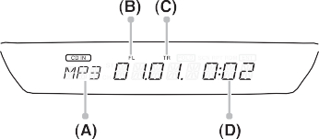

1. SCAN button

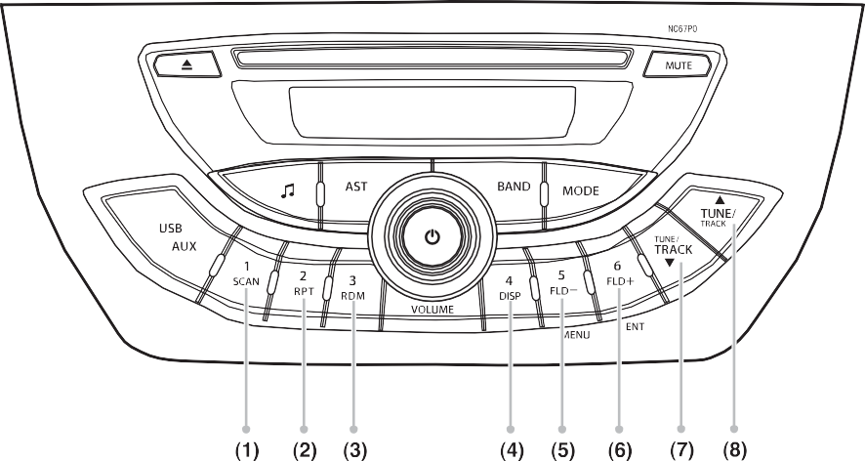

**EXAMPLE**

1. RPT button
2. RDM button
3. DISP button (1 to 6)
4. FLD - button
5. FLD + button
6. TRACK DOWN button
7. TRACK UP button
   1. Disc type
   2. Folder number
   3. Track time
   4. Play type

53-07-071

53M-07-070

### 5-22

#### OTHER CONTROLS AND EQUIPMENT

##### Selecting a folder

* + Press the Folder Up button (6) to select next folder.
  + Press the Folder Down button (5) select previous folder.

Selecting a track

* + Press the Up button (8) to listen to the next track.
  + Press the Down button (7) twice to listen to the previous track. When the Down button (7) is pressed once, the track cur- rently being played will start from the beginning again.

Fast forwarding/Rewinding a track

* + Hold down the Up button (2) to fast for- ward the track.
  + Hold down the Down button (3) to fast rewind the track.
  + If you keep pressing the UP (8)/DOWN button(7) until the beginning or ending of the disc, the unit release the fast-for- ward/rewind operation and plays the first track.

##### Scan play

File scan

Press the SCAN button (1). The first 10 seconds of each file is sequence.

Folder scan

press the SCAN button (1) for 1 second or longer. The first 10 seconds of the first file in each folder stored in the disc is played in sequence.

*NOTE:*

*To cancel the scan play, press the SCAN button (1) again or switch to another mode or turn the power off, or eject the disc.*

##### Random playback

Track random

Press the RDM button (5).

the random indicator “RDM” will light. The tracks in the loaded disc will be played in random order.

Folder random

Press the RDM button (3) for 1 second or longer.

The random indicator “RDM and FOLD.” will light. The tracks in the current folder will be played in random order.

*NOTE:*

*To cancel random playback, press the RDM button (3) again or eject the disc.*

##### Repeat playback

Track repeat

Press the RPT button (4).

The repeat indicator “RPT” will light. The track currently being played will be played repeatedly.

Folder repeat

press the RPT button (2) for 1 second or longer.

The repeat indicator “RPT and FOLD.” will light. All tracks in the currently selected folder will be played repeatedly.

*NOTE:*

*To cancel the repeat playback, press the RPT button (2) again or eject the disc.*

Display change

Press the DISP button (6).

Each time the button is pressed, display will change as follows:

### 5-23

#### OTHER CONTROLS AND EQUIPMENT

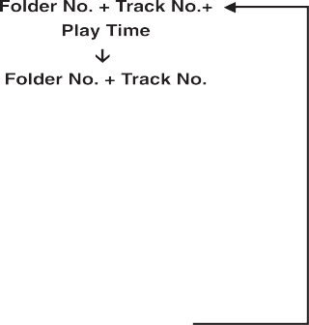

53M-07-072

##### Press the DISP (4) for 1 second or longer.

Each time this button is pressed, title dis lay switches as follows.

First 8 characters Next 8 characters.

A total of 16 characters can be dis- played.

* + If the number of character is 8 or less, display doesn’t switch.
  + If the ID3 tag/tag info is not available on the track, “NO TITLE” will be displayed.

**WMA**

* Supports only v7/8/9, DRM/Professional/ Loseless/Voice are not supported
* Bit rate:48, 64, 80, 96, 128, 160, 192

kbps

* Sampling frequency:8, 16, 22.05, 32,

44.1 kHz

##### AAC

* MPEG4 AAC (Compliant with ISO/IEC 14496-12:2003 + iTunes Meta-data Specification)
* Bit rate:up to 320kbps
* Sampling frequency:8/11.025/ 12/16/ 22.05/24/32/44.1/48 kHz
* Apple loseless is not supported.

**Supported file systems**

**ISO 9660 Level 1/Level 2, Joliet, Romeo**

**Maximum number of files/folders**

* Maximum number of files: 512 (files + folders)
* Maximum number of files in a folder: 256
* Maximum depth of tree structure: 8
* Maximum number of folders: 255 (Root folder is included.)

##### Playing limitations

* The number of tracks and folders that can be played on one disc is as follows:
* The total number of folders + total tracks=512.
* However, maximum number of folder is 255.
* Also, maximum number of the folder level is 8.
* The compression bit rate of MP3 files that can be played with the unit is from 32 kbps to 320 kbps. However, for file capacity and sound quality, 128 kbps and above is recommended. When a file compressed at 128 kbps or less is played, sound quality may be inconsis- tent Compatible sampling rates are as follows:
* MPEG 1 48k 44.1k 32k
* MPEG2 24k 22.05k 16k
* MPEG2.5 12k 8k
* When both music CD data (CD-DA) and MP3/WMA/AAC file data exist on one disc, only the music data (CD-DA) is played. Do not write a file other than MP3/WMA/AAC or needless folder in the disc.
* The unit is compatible with files com- pressed with VBR (Variable Bit Rate), however, the playback time may not be displayed correctly during fast-forward/ rewind.
* The unit may not play MP3/WMA/AAC files in the order of recording.

### 5-24

#### OTHER CONTROLS AND EQUIPMENT

* + As the number of folders recorded on the disc increases, the time to read the disc information also increases.

##### Limitations of displayed information



**CAUTION**

* **The playback order may differ depending on the writing software.**
* **Make sure to finalize the disc before using on the unit.**
* **When naming an MP3/WMA/AAC file, make sure to attach the exten- sion “.mp3/.wma/.m4a” to the file name.**
* **Do not attach the extension “.mp3/**

**.wma/.m4a” to files other than MP3/ WMA/AAC files. If a disc with such a file is played, it will be mistakenly recognized and it may cause excessive noise to be emitted, damaging the speaker.**

* **The unit may not be able to play certain discs depending on disc conditions, recording software or the recorder used for writing the data. In such cases, refer to the instruction manual of the equip- ment used.**
* **The unit is compatible with multi- session recorded discs. However, be sure to properly close the ses- sion. Disc with a session that has not been closed cannot be played properly. When a disc is initially inserted, some time will be required for reading the data before play can begin.**
  + The unit only displays the folder and file
  + name.
  + Only one-byte alphanumeric characters and symbols can be displayed. If 2-byte characters can be displayed, they will display as 1 character. If 2-byte charac- ter display is not possible, a “*” will be displayed.
  + When playing MP3/WMA/AAC file, the playback time may not be displayed properly.

**5-25**

## Listening to files stored in a USB device

#### OTHER CONTROLS AND EQUIPMENT

Display

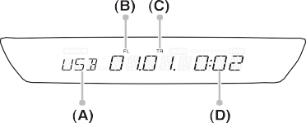

1. Media Source Mode button

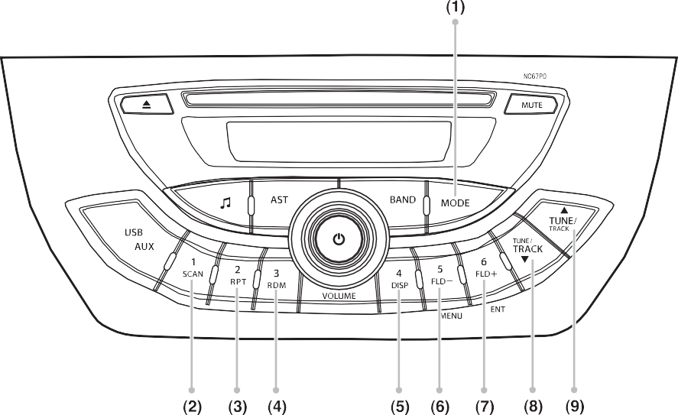

**EXAMPLE**

1. SCAN button
2. RPT button
3. RDM button
4. DISP button
5. FLD - button
6. FLD + button
7. TRACK DOWN button
   1. USB indicator
   2. Folder number
   3. Track number
   4. Play time

53M-07-074

53M-07-073

### 5-26

#### OTHER CONTROLS AND EQUIPMENT

Fast forwarding/Rewinding a track

**Do not connect any USB device other than a USB memory or a USB audio player. Do not connect multiple USB devices to the USB connector using a USB hub, etc. Supplying power to multiple USB devices from the con- nector could cause overheating and smoking.**

***NOTICE***

* + - Hold down the Up button (9) to fast for- ward the track.
    - Hold down the Down button (8) to fast rewind the track.
    - If you keep pressing the UP (9)/DOWN button(8) until the beginning or ending of the disc, the unit release the fast-for- ward/rewind operation and plays the first track.

##### Scan play

## Random playback

Track random

Press the RDM button (4). the random indi- cator “RDM” will light. The tracks in the loaded USB device will be played in ran- dom order.

Folder random

Press the RDM button (4) for 1 second or longer. The random indicator “RDM and FOLD.” will light. The tracks in the current

##### Selecting a USB device mode

Press the Media Source Mode button to select USB mode (1).

53M-07-075

Selecting a folder

Press the Folder Up button (7) to select next folder. Press the Folder Down button

(6) select previous folder.

Selecting a track

* Press the Up button (9) to listen to the next track.
* Press the Down button (8) twice to listen to the previous track. When the Down button (8) is pressed once, the track cur- rently being played will start from the beginning again.

File Scan

Press the SCAN button (2). The first 10 seconds of each file is play in sequence.

Folder Scan

press the SCAN button (2) for 1 second or longer. The first 10 seconds of the first file in each folder stored in the USB is played in sequence.

*NOTE:*

*To cancel the scan play, press the SCAN button (2) again or eject the USB.*

folder will be played in random order.

*NOTE:*

*To cancel random playback, press the RDM button (4) again or eject the USB.*

**5-27**

## Repeat playback

File repeat

Press the RPT button (3). The repeat indi- cator “RPT” will light. The track currently being played will be played repeatedly.



Folder Repeat



press the RPT button (3) for 1 second or longer. The repeat indicator “RPT and FOLD.” will light. All tracks in the currently selected folder will be played repeatedly.



*NOTE:*

*To cancel the repeat playback, press the RPT button (3) again or eject the USB.*





**Display change**



#### OTHER CONTROLS AND EQUIPMENT

Press the DISP (6) for 1 second or lon- ger.



Each time this button is pressed, the dis- play switches as follows. First 8 character next 8 characters.

A total of 16 characters can be dis- played.

If the number of character is 8or less, dis- play doesn’t switch. If the ID3 tag/tag info is not available on the track, “NO TITLE” will be displayed.

## Notes on USB device

Compatible USB devices

* + USB Mass Storage Class

Press the DISP button (7).

Each time the button is pressed, display will change as follows:

53M-07-076

* For details as to whether your USB memory/USB Audio is compatible with USB Mass Storage Class, please con- tact the USB memory/USB Audio manu- facturer.
* USB Standard Compatibility 1.1/2.0 Full Speed
* File System FAT16/32
* Maximum current less than 1 A
* Capacity less than 32 GB (1 partition)

### 5-28

**OTHER CONTROLS AND EQUIPMENT**

## USB device connection

* + When connecting a USB device, make sure that the connector is pushed all the way into the port.
  + Do not leave the USB device for long periods of time in places inside the vehi- cle where the temperature can rise too high.
  + Back up any important data beforehand. We cannot accept responsibility for any lost data.
  + It is recommended not to connect a USB device that contains data files other than MP3/WMA/AAC format.
  + We recommend against use of USB devices that are non-standard shape such as key chains, mobile phone accessories, etc. which may damage or stress the connection between USB device and Socket terminal.
  + Always close the USB socket terminal when not in use, since entry of foreign material, dust, water, conductive liquids may damage the audio system or USB device.
  + Device such as MP3 player/Mobile phone/digital camera may not be rec- ognized by the audio system for playing music.

## Recording MP3/WMA/AAC files on a USB device

* Playback or display may not be possible depending on the type of USB device in use or the condition of the recording.
* Depending on the connected USB mem- ory, the files may be played in different order from the order that the files were stored.
* During initialization, the reading time of USB device may vary depending upon factors such as file structure, size and contents other than music files.
* When files recorded contains VBR (vari- able bit rate), during playback, fast-for- ward or reverse operation are done.
* The sound quality of MP3/WMA/AAC files generally improves with higher bit rate in order to achieve good sound qual- ity recording with CBR 9continuous bit rate) of at least 128kbps is recom- mended.

##### Compression formats

###### MP3

* MPEG 1,2 and 2.5 layer III
* Bit rate:

– MPEG-1: 32, 44.1, 48 kHz

– MPEG-2: 16, 22.05, 24 kHz

– MPEG-2.5: 8, 12 kHz

– VBR

* Sampling frequency:

– MPEG-1: 32, 44.1, 48 kHz

– MPEG-2: 16, 22.05, 24 kHz

– MPEG-2.5: 8, 12 kHz

**WMA**

* Supports only v7/8/9, DRM/Professional/ Loseless/Voice are not supported
* Bit rate:48, 64, 80, 96, 128, 160, 192

kbps

* Sampling frequency:8, 16, 22.05, 32,

44.1 kHz

###### AAC

* MPEG AAC (Compliant with ISO/ IEC14496-12:2003 + iTunes Meta-data Specification)
* Bit rate: up to 320kbps
* Sampling frequency:8/11.025/12/16/ 22.05/24/32/44.1/48 kHz
* Sampling frequency:8/11.025/12/16/ 22.05/24/32/44.1/48 kHz

##### Maximum number of files/folders

* Maximum number of files: 65280 (files + folders)
* Maximum number of files in a folder: 256
* Maximum depth of tree structure: 8
* Maximum number of folders: 255 (Root folder is included.)

**5-29**

## Listening to an iPod®

#### OTHER CONTROLS AND EQUIPMENT

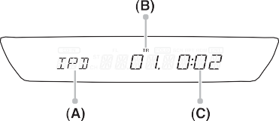Display

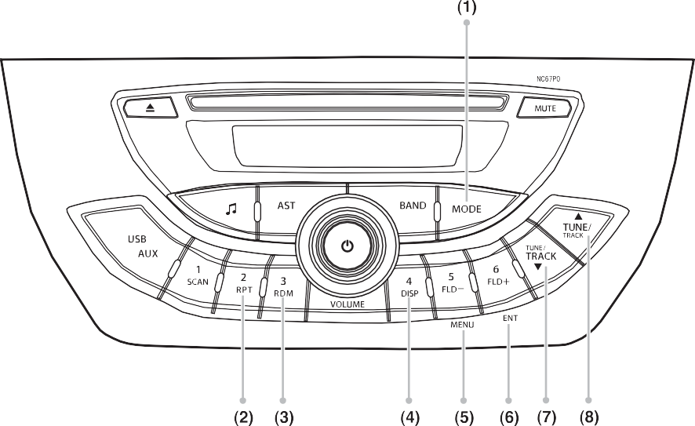

**EXAMPLE**

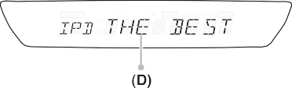

53M-07-078

53M-07-077

1. Media Source Mode button
2. RPT button
3. RDM button
4. DISP button
5. iPod MENU button
6. ENTER button
7. Up button
8. Down button
   1. iPod indicator
   2. Track number
   3. Play time number
   4. Title information

### 5-30

#### OTHER CONTROLS AND EQUIPMENT

##### Selecting an iPod® mode

Press the Media Source Mode button (1) to select USB (iPod) mode.

53M-07-079

##### Selecting a track

* Press the Up button (8) to listen to the next track.
* Press the Down button (7) twice to listen to the previous track. When the Down button (7) is pressed once, the track cur- rently being played will start from the beginning again.

##### Fast forwarding/Rewinding a track

* Hold down the Up button (8) to fast for- ward the track.
* Hold down the Down button (7) to fast rewind the track.

##### Random playback

Track random

* Press the RDM button (3).
* The random indicator “RDM” will light. Track random is the same behavior as album shuffle of iPod.

Folder random

* Press the RDM button (3) for 1 second or longer.

### 5-31

* The random indicator “FOLD.” and “RDM” will light. The folder random is the same as song shuffle or iPod.

*NOTE:*

*To cancel random playback, press the RDM button (3) again or eject the iPod.*

##### Repeat playback

Track repeat

* Press the RPT button (2).
* The repeat indicator “RPT” will light. The track. Repeat is the same behavior as one track repeat of the iPod.

*NOTE:*

* *To cancel repeat playback, press the RPT button (2) again or eject the iPod.*
* *The unit will always trigger Repeat mode (No indication will be displayed on unit) in iPod automatically when iPod is con- nected.*
* *when repeat mode is triggered, the unit will play all the songs in the category repeatedly. Repeat mode will not be turned off unless 1-track repeat is trig- gered.*
* *Turning off 1-track repeat will re-enable Repeat mode again.*

##### Display change

Press the DISP button (4).

Each time the button is pressed, display will change as follow:

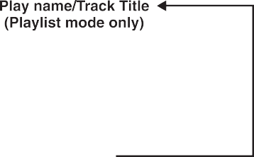

53M-07-080

##### Press the DISP (4) for 1 second or longer.

Each time this button is pressed, title dis- play switches as follow. Fist 8 characters Next 8 characters.

##### A total of 16 characters can be dis- played.

* If the number of character is 8 or less, display doesn’t switch.
* Text display in iPod menu mode is allowed to switch but it is invalid for first category of iPod menu mode.
* If no data is stored in the particular cate- gory, “NO DATA” will be displayed.
* If the file/artist/album title is not recorded on the iPod, “NO TITLE” will be dis- played.

#### OTHER CONTROLS AND EQUIPMENT

##### iPod® menu mode

* 1. Press the MENU button (5).
  2. Press the Up button (8) or Down button

(7) to select the category as follow:

* 1. Press the ENTER button (6) to select the category.
  2. repeat the step 2 and 3 again to select the desired.



53M-07-081

##### About resume play

When connecting iPod to car stereo, iPod will start playing the song which played before connecting (resume play). When browse items or lists are changed from resume play, selected song of playlist starts to play and list title also can be dis- played.

*NOTE:*

*After entering iPod menu mode, the mode has 30 seconds timeout.*

##### About iPod

Before using iPod

* iPod is only private usage and may not be used without authorities. Copyright privacy is against the law.
* Operating may be different for each iPod software version.

How to connect iPod

* Connect the iPod cable into USB inser- tion slot.

##### Caution for connecting iPod

* When iPod EQ setting is ON, sound may be distorted.
* Before or after connecting, setting (such as shuffle, repeat and etc.) may be changed.
* Remove all equipments, (headphone etc.) when connecting.
* *iPod may have difficulty of operation.
* Do not leave iPod inside vehicle. Direct sunlight and high temperature may cau se damage to iPod.
* Fix iPod at specified way when using the adapter. Removing iPod may interfere with your driving, so accident may occur.
* Read iPod manual for iPod operation.
* When connecting iPod (video), play music once, turn the power off and con-

nect. If video is playing before connec- tion, it may take some time.

### 5-32

#### OTHER CONTROLS AND EQUIPMENT

**Supported iPod** “Made for iPod,” and “Made for iPhone,” mean that an electronic accessory has been designed to connect specifically to iPod, or iPhone, respectively, and has been certified by the developer to meet Apple performance standards. Apple is not responsible for the operation of this

device or its compliance with safety and regulatory standards. Please note that the use of this accessory with iPod, or iPhone may affect wireless performance.

|  |  |
| --- | --- |
| **iPod/ iPhone models** | **Software Version** |
| iPhone® 5S | 7.1.1 |
| iPhone® 5C | 7.1.1 |
| iPhone® 5 | 7.1.1 |
| iPhone® 4S | 7.1.1 |
| iPhone® 4 | 7.1.1 |
| iPod® touch (5th generation) | 7.1.1 |
| iPod® touch (4th generation) | 6.1.6 |
| iPod® nano (7th generation) | 1.0.3 |
| iPod® nano (6th generation) | 1.2 |
| iPod® classic | 2.0.5 |

iPhone®, iPod®, iPod® classic, iPod® nano, and iPod® touch are trademarks of Apple Inc., registered in the U.S. and other countries.

**5-33**

## AUX Function

#### OTHER CONTROLS AND EQUIPMENT

##### AUX connection

To listen to auxiliary audio sources (sold separately) through the unit, follow the instruction below. 1) Press the Media Source Mode button (1). 2) Connect the auxiliary audio source to the AUX socket with an AUX cable.

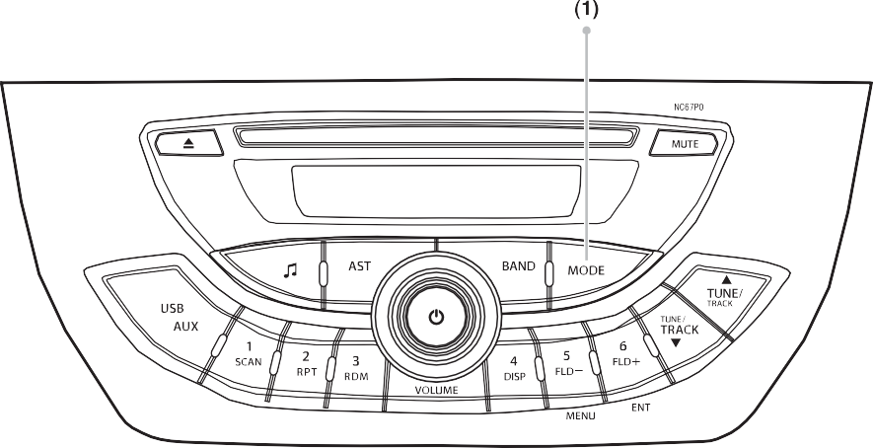

**EXAMPLE**



**CAUTION**

* **Before connection, set the volume for the unit to 0 (When AUX mode is selected) and also keep the volume of the auxiliary audio source within a range that will not cause distortion.**
* **When the audio source is turned off, noise may be emitted. Be sure to turn off the unit or switch to another mode before turning off the audio source**

53M-07-082

*NOTE*

* *Please consult your place of purchase for details about whether a given auxil- iary audio source can be connected and the proper auxiliary cord to use.*
* *The volume and tone controls of the auxiliary audio source can be adjusted on the unit.*

### 5-34

**OTHER CONTROLS AND EQUIPMENT**

## Troubleshooting

**FM/AM**

|  |  |  |
| --- | --- | --- |
| **SYMPTOM** | **CAUSE** | **REMEDY** |
| **The station cannot be received.** | The connection of the car antenna has not been made correctly. | Check the connection of the car antenna. |
| **Automatic tuning is not possible.** | The broadcast signal is too weak. | Perform manual setting. |
| **The radio sensitivity is poor.** | Car antenna is not extended fully or inclining. | Check the car antenna. |
| **No sound is coming out from front speaker or rear speaker.** | Adjustment of the front and rear speakers tilts towards either of the side. | According to “Adjusting the audio”, adjust the FAD level.  For the 2 speakers, adjust the FAD level  to “0”. |

### 5-35

**OTHER CONTROLS AND EQUIPMENT**

## Troubleshooting

**USB**

|  |  |  |
| --- | --- | --- |
| **SYMPTOM** | **CAUSE** | **REMEDY** |
| **NO Device** | USB device is not connected | Connect USB memory device properly. Also check if USB connector area is clean. |
| **No File** | There is no playable music files | Check data stored in USB memory device is in supported format |
| **Unsupported (Check 04)** | The USB device is not supported | Check if data stored in USB memory device is in supported format |
| **Read Error (Check 04)** | Cannot read the file which is trying to play by some reason. (File system, Com- pressed setting, data format, file name expanding, data damaged, file recorded by others may not be supported.) | Check USB memory device if connected properly. If it's not connected properly, reconnect, and select the file which player is able to read and check the data stored in USB memory. You must format the USB memory if necessary. |
| **Operation Error** | Cannot be controlled by some reason. | Switch POWER or ACC ON/OFF. If still not recovered, remove the USB memory device and reconnect. |
| **Over Current (Check 05)** | The USB device is over the current. | Use other USB memory device whose current consumption is 1A or below. Also check if USB connector area is clean. |
| **Audio will be muted and skip to next track.** | The file is protected with copyright (DRM). | The file protected with copyright cannot be played. Select the playable file. |

### 5-36

#### OTHER CONTROLS AND EQUIPMENT

**IPod/Phone**

|  |  |  |
| --- | --- | --- |
| **SYMPTOM** | **CAUSE** | **REMEDY** |
| **NO Device** | iPod is not connected | It may take some time to recognize iPod. Check iPod or cable to be connected properly. Or check if iPod connector area is clean. |
| **No File** | There is no playable music files | Check if data stored in iPod is in sup- ported format |

## Error Display Messages

The following messages appear during operation to give you hints about how to use the unit properly.

**CD**

|  |  |  |
| --- | --- | --- |
| **SYMPTOM** | **CAUSE** | **REMEDY** |
| **CHECK 01** | A disc is loaded upside-down inside the CD deck and does not play.  An unsupported disc/format is being used. | Eject the disc then reinsert correctly with the printed side upwards.  Use supported disc/format only. |
| **CHECK 02** | A disc is caught inside the CD deck and is not ejected. | Make sure there is no blockage at the CD slot.  If problem persists, turn off the unit and contact your Nippon Service Centre. |
| **CHECK 03** | A disc cannot be played due to scratches. | Clean the disc surface.  If problem persists, replace with a non- scratched, non-warped disc. |
| **NO DISC** | The disc is not inserted. | Insert CD disc into the unit. |

### 5-37

**OTHER CONTROLS AND EQUIPMENT**

## Error Display Messages

**USB/IPod**

|  |  |  |
| --- | --- | --- |
| **SYMPTOM** | **CAUSE** | **REMEDY** |
| **CHECK 04** | The connected USB device is not sup- ported.  The USB device cannot be read. | Use supported USB device with properly encoded audio files.  Check USB memory device if connected properly. If it's not connected properly, reconnect, and select the file which player is able to read and check the data stored in USB memory. You must format the USB memory if necessary. |
| **CHECK 05** | Over-current is detected. | Use other USB memory device whose current consumption is 1A or below. Also check if USB connector area is clean. |
| **NO DEV** | The USB device/iPod is not connected. | Connect USB memory device/iPod prop- erly. Also check if USB connector area is clean. |
| **NO MUSIC** | There is no playable music file. | Check data stored in USB memory device/iPod is in supported format. |

### 5-38

**VEHICLE LOADING AND TOWING**

# VEHICLE LOADING AND TOWING

Vehicle Loading 6-1

Trailer Towing 6-1

Towing Your Vehicle 6-2

**6**

**VEHICLE LOADING AND TOWING**

## Vehicle Loading

Your vehicle was designed for specific weight capacities. The weight capacities of your vehicle are indicated by the Gross Vehicle Weight Rating (GVWR) and the Permissible maximum Axle Weight (PAW, front and rear). The GVWR and PAW (front and rear) are listed in the “SPECIFICA- TIONS” section.

GVWR – Maximum permissible overall weight of the fully loaded vehicle (including all the occupants, accessories and cargo plus the trailer nose weight if towing a trailer).

PAW – (Front and Rear) Maximum permis- sible weight on an individual axle.

Actual weight of the loaded vehicle and actual loads at the front and rear axles can only be determined by weighing the vehi- cle.

Compare these weights to the GVWR and PAW (front and rear). If the gross vehicle weight or the load on either axle exceeds these ratings, you must remove enough weight to bring the load down to the rated capacity.

## Trailer Towing

Your MARUTI SUZUKI was originally designed to carry people and a normal amount of cargo, not to tow a trailer. MAR- UTI SUZUKI does not recommend you use your vehicle to tow a trailer. Towing a trailer can adversely affect handling, durability, and fuel economy.



**Always distribute cargo evenly. To avoid personal injury or damage to your vehicle, always secure cargo to prevent it from shifting if the vehicle moves suddenly. Place heavier objects on the floor and as far for- ward in the cargo area as possible. Never pile cargo higher than the top of the seat backs.**

**WARNING**

**Never overload your vehicle. The gross vehicle weight (sum of the weights of the vehicle, all the occu- pants, accessories, cargo plus trailer nose weight if towing a trailer) must never exceed the Gross Vehicle Weight Rating (GVWR). In addition, never distribute a load so that the weight on either the front or rear axle exceeds the Permissible maximum Axle Weight (PAW).**

**WARNING**

**6-1**

## Towing Your Vehicle

Your vehicle may be towed behind another vehicle (such as a motorhome), provided your vehicle is 2 wheel drive (2WD) and you use the proper towing method speci- fied for your vehicle. The towing method you must use depends on the specifica- tions of your vehicle: whether it is a manual transaxle vehicle or an automated manual transaxle vehicle.

Use the towing instruction table to select the proper towing method for your vehicle, and carefully follow the corresponding instructions. Be sure to use proper towing equipment designed for recreational tow- ing and make sure that towing speed does not exceed 90 km/h (55 mph).



**A safety chain should always be used when you tow your vehicle.**

**WARNING**

**When you tow your vehicle, follow the instructions below to avoid acci- dents and damage to your vehicle. In addition, be sure to observe govern- ment and local requirements regard- ing vehicle lighting and trailer hitches or tow bars.**

**WARNING**

##### TOWING INSTRUCTION TABLE

|  |  |  |
| --- | --- | --- |
| **DRIVE TRAIN** | **TRANS MISSION** | **TOWING METHOD** |
| 2WD | M/T | **A,B** |
| 2WD | Automated Manual Transaxle | **A,B** |

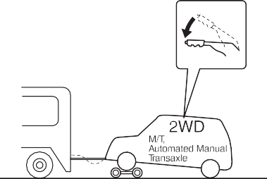

**EXAMPLE**

53M-08-001

#### VEHICLE LOADING AND TOWING

###### A: 2WD VEHICLES WITH MANUAL TRANSAXLE OR AUTOMATED MAN- UAL TRANSAXLE

1. Secure the front wheels on a towing dolly according to the instructions pro- vided by the dolly manufacturer.
2. Release the parking brake.

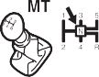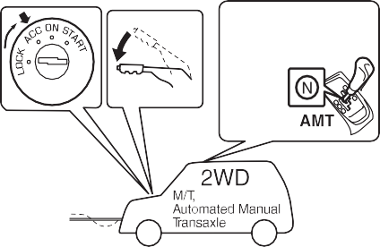

**EXAMPLE**

53M-08-002

### 6-2

#### VEHICLE LOADING AND TOWING

###### B: 2WD VEHICLES WITH MANUAL TRANSAXLE OR AUTO GEAR SHIFT

* 1. Shift the gearshift lever into neutral.
  2. Turn the ignition key to the “ACC” posi- tion to unlock the steering wheel.
  3. Release the parking brake.

**After shifting the auto gear shift gear- shift lever to the “N” position, always check the gear position indicator in the instrument cluster shows the “N” position to make sure that the transaxle is disengaged.**

**If the transaxle cannot be put in neutral, turn the key from the “OFF” to the “ON” position, and move the auto gear shift lever from “N” to “D”, “M” or “R”, then back to “N” again. Then turn the key from the “ON” to the “OFF” posi- tion.**

**These procedures may help put the transaxle in neutral. If the transaxle still cannot be put in neutral, you can- not tow the vehicle without using a towing dolly.**

***NOTICE***

**The steering column is not strong enough to withstand shocks trans- mitted from the front wheels during towing. Always unlock the steering wheel before towing.**

***NOTICE***

### 6-3

**INSPECTION AND MAINTENANCE**

# INSPECTION AND MAINTENANCE

**Maintenance Schedule 7-2**

**Periodic Maintenance Schedule 7-2**

**Drive Belt 7-10**

**Engine Oil and Filter 7-10**

**Engine Coolant 7-13**

**Air Cleaner 7-15**

**Spark Plugs 7-15**

**Gear Oil 7-16**

**Clutch Pedal 7-17**

**Fuel Filter 7-17**

**Brakes .................................................................................. 7-18 7**

**Steering ................................................................................ 7-20**

**Tires 7-20**

**Battery 7-22**

**Fuses 7-23**

**Bulb Replacement 7-27**

**Wiper Blades 7-29**

**Windshield Washer Fluid 7-31**

**Air Conditioning System 7-31**

**INSPECTION AND MAINTENANCE**



60A187S

**You should take extreme care when working on your vehicle to prevent accidental injury. Here are a few pre- cautions that you should be espe- cially careful to observe:**

(Continued)

**WARNING**



(Continued)

* **To prevent damage or unintended activation of the air bag system or seat belt pretensioner system, be sure the battery is disconnected and the ignition switch has been in the “LOCK” position for at least 90 seconds before performing any electrical service work on your vehicle. Do not touch air bag sys- tem components, seat belt preten- sioner system components or wires.**

**The wires are wrapped with yellow tape or yellow tubing, and the cou- plers are yellow for easy identifica- tion.**

* **Do not leave the engine running in garages or other confined areas.**
* **When the engine is running, keep hands, clothing, tools, and other objects away from the fan and drive belt. Even though the fan may not be moving, it can automatically turn on without warning.**

(Continued)

**WARNING**



(Continued)

* **When it is necessary to do service work with the engine running, make sure that the parking brake is set fully and the transaxle is in Neutral.**
* **Do not touch ignition wires or other ignition system parts when start- ing the engine or when the engine is running, or you could receive an electric shock.**
* **Be careful not to touch a hot engine, exhaust manifold and pipes, muffler, radiator and water hoses.**
* **Do not allow smoking, sparks, or flames around fuel or the battery. Flammable fumes are present.**
* **Do not get under your vehicle if it is supported only with the portable jack provided in your vehicle.**
* **Be careful not to cause accidental short circuits between the positive and negative battery terminals.**
* **Keep used oil, coolant, and other fluids away from children and pets. Dispose of used fluids properly; never pour them on the ground, into sewers, etc.**

**WARNING**

**7-1**

## Maintenance Schedule

The following table shows when regular maintenance on your vehicle is required, this table shows in kilometers and months when inspections, adjustments, lubrication and other services should be performed.



**MARUTI SUZUKI recommends that maintenance on your MARUTI SUZUKI vehicle be performed by MARUTI SUZUKI Authorised Dealer/ Service Station.**

**WARNING**

**INSPECTION AND MAINTENANCE**

## Periodic Maintenance Schedule



**CAUTION**

**Whenever it becomes necessary to replace parts on your vehicle, it is recommended that you use MARUTI GENUINE PARTS (MGP).**

##### ALTO 800

**“A”: Adjust “C”: Clean**

**“R”: Replace or Change**

**“I” : Inspect, clean, adjust, lubricate or replace as necessary**

**“L” : Lubricate**

**“T” : Tighten to Specified Torque “O”: Rotate**

*NOTE:*

*This table includes services as scheduled up to 80,000 km mileage. Beyond 80,000 km, carry out the same services at the same intervals respectively.*

### 7-2

**INSPECTION AND MAINTENANCE**

|  |  |  |  |  |  |  |  |  |  |  |  |  |
| --- | --- | --- | --- | --- | --- | --- | --- | --- | --- | --- | --- | --- |
| **\*Interval: This interval should be judged by odometer reading or months, whichever comes first.** | | **km (x 1,000) months** | **FREE INSPECTIONS** | | | **PERIODIC MAINTENANCE SERVICE AT COST** | | | | | | |
| **1** | **5** | **10** | **20** | **30** | **40** | **50** | **60** | **70** | **80** |
| **1** | **6** | **12** | **24** | **36** | **48** | **60** | **72** | **84** | **96** |
| **ENGINE** | | | | | | | | | | | | |
| 1. | Water pump drive belt (Tension, Wear) | | A | I | I | I | I | I | I | R | A | I |
| 2. | Engine Coolant (Level, Leakage) | | I | I | I | R | I | R | I | R | I | R |
| 3. | Engine oil and Oil filter | | R | I | R | R | R | R | R | R | R | R |
| 4. | Cooling system hoses and connections (Leakage, Damage) | | I | I | I | I | I | I | I | I | I | I |
| 5. | Engine bolts (All cylinder head and manifold fixings) | | – | – | T | – | T | – | T | – | T | – |
| 6. | Engine mounting (Loose, Damage) | | – | – | T | – | T | – | T | – | T | – |
| 7. | Valve Clearance | | – | A | – | A | – | A | – | A | – | A |
| 8. | Camshaft timing belt (Damage, Wear) | | – | – | – | I | – | I | – | I | – | I |
| Replace Every 1,00,000 km | | | | | | | | | |
| 9. | Exhaust system (Noise, Leakage etc.) | | – | I | – | I | – | I | – | I | – | I |
| 10. | Positive crankcase ventilation System (Hoses, Connections and Valve) | | – | I | – | I | – | I | – | I | – | I |
| **IGNITION** | | | | | | | | | | | | |
| 1. | Ignition wiring (Damage, Deterioration) | | – | – | – | I | – | I | – | I | – | I |
| 2. | Spark plugs (Clean and Adjust the gap) | | – | – | I | R | I | R | I | R | I | R |
| **FUEL** | | | | | | | | | | | | |
| 1. | Air cleaner | Paved-road | Clean every 5,000 km. Replace after every 40,000 km. | | | | | | | | | |
| Dusty condition | Clean every 2,500 km or as required. Replace after every 40,000 km. More frequent replacement if dust condition is severe. | | | | | | | | | |
| 2. | Fuel tank cap, fuel lines and connections (Leakage, Damage) | | – | I | – | – | – | I | – | – | – | I |
| 3. | Fuel filter (Leakage) | | I | I | I | I | I | R | I | I | I | R |
| **CLUTCH AND TRANMISSION** | | | | | | | | | | | | |
| 1. | Clutch pedal (Play) | | I | I | I | I | I | I | I | I | I | I |
| 2. | Clutch slipping (Dragging or Excessive damage) | | I | I | I | I | I | I | I | I | I | I |
| 3. | Manual Transmission Oil (Level, Leakage) | | I | I | I | I | I | I | I | I | I | I |
| Replace every 1,60,000 kms or 10 years, which ever comes earlier | | | | | | | | | |
| **DRIVE SHAFTS** | | | | | | | | | | | | |
| 1. | Drive shafts boot (Boot cut / Damage) | | – | I | I | I | I | I | I | I | I | I |
| 2. | Drive Shaft Noise | | I | I | I | I | I | I | I | I | I | I |

### 7-3

**INSPECTION AND MAINTENANCE**

|  |  |  |  |  |  |  |  |  |  |  |  |  |
| --- | --- | --- | --- | --- | --- | --- | --- | --- | --- | --- | --- | --- |
| **\*Interval: This interval should be judged by odometer reading or months, whichever comes first.** | | **km (x 1,000) months** | **FREE INSPECTIONS** | | | **PERIODIC MAINTENANCE SERVICE AT COST** | | | | | | |
| **1** | **5** | **10** | **20** | **30** | **40** | **50** | **60** | **70** | **80** |
| **1** | **6** | **12** | **24** | **36** | **48** | **60** | **72** | **84** | **96** |
| **BRAKE** | | | | | | | | | | | | |
| 1. | Brake fluid (Level, Leakage) | | I | I | I | R | I | R | I | R | I | R |
| 2. | Brake pedal (Pedal-to-wall clearance) | | I | I | I | I | I | I | I | I | I | I |
| 3. | Parking brake lever and cable (Play, Damage) | | I | I | I | I | I | I | I | I | I | I |
| 4. | a. Brake discs and pads (Wear) | | – | I | I | I | I | I | I | I | I | I |
| b. Brake drums & shoes (Wear) | | – | – | I | I | I | I | I | I | I | I |
| 5. | Master cylinder, wheel cylinder, caliper piston (Fluid leakage, Boot/Seal Damage) | | I | I | I | I | I | I | I | I | I | I |
| 6. | Brake hoses and pipes (Fluid leakage, Damage) | | I | I | I | I | I | I | I | I | I | I |
| **WHEEL** | | | | | | | | | | | | |
| 1. | Tyres (Air pressure, Abnormal wear, Crack, Rotation) | | I | I&O | I&O | I&O | I&O | I&O | I&O | I&O | I&O | I&O |
| 2. | Wheels (Damage) | | I | I | I | I | I | I | I | I | I | I |
| 3. | Front/Rear wheel bearings (Loose, Damage) | | – | I | I | I | I | I | I | I | I | I |
| **FRONT AND REAR SUSPENSION** | | | | | | | | | | | | |
| 1. | Suspension strut (Oil leakage, Damage) | | I | I | I | I | I | I | I | I | I | I |
| 2. | Suspension arms/knuckle support (Loose, Damage) | | – | I | I | I | I | I | I | I | I | I |
| 3. | Rear spring (Damage) | | – | I | I | I | I | I | I | I | I | I |
| 4. | Shock absorbers (Oil leakage, Damage) | | I | I | I | I | I | I | I | I | I | I |
| 5. | All bolts and nuts (Loose) | | – | T | T | T | T | T | T | T | T | T |
| 6. | Suspension arms and Tension rods | | – | I | I | I | I | I | I | I | I | I |
| **STEERING** | | | | | | | | | | | | |
| 1. | Steering wheel (Play, Loose) | | I | I | I | I | I | I | I | I | I | I |
| 2. | All rods and arms (Loose, Damage, Wear) | | I | I | I | I | I | I | I | I | I | I |
| **ELECTRICAL** | | | | | | | | | | | | |
| 1. | Battery electrolyte (Level, leakage) | | I | I | I | I | I | I | I | I | I | I |
| 2. | Wiring harness connection (Loose, Damage) | | – | I | I | I | I | I | I | I | I | I |
| 3. | Lighting system (Operation, Stains, Damage) | | I | I | I | I | I | I | I | I | I | I |
| 4. | Horn (Operation) | | I | I | I | I | I | I | I | I | I | I |
| 5. | System voltage | | I | I | I | I | I | I | I | I | I | I |
| **BODY** | | | | | | | | | | | | |
| 1. | All chassis bolts and nuts (Tighten) | | – | I | I | T | T | T | T | T | T | T |
| 2. | All latches, hinges and locks (Function) | | I | I&L | I&L | I&L | I&L | I&L | I&L | I&L | I&L | I&L |

### 7-4

**INSPECTION AND MAINTENANCE**

|  |  |  |  |  |  |  |  |  |  |  |  |  |
| --- | --- | --- | --- | --- | --- | --- | --- | --- | --- | --- | --- | --- |
| **\*Interval: This interval should be judged by odometer reading or months, whichever comes first.** | | **km (x 1,000) months** | **FREE INSPECTIONS** | | | **PERIODIC MAINTENANCE SERVICE AT COST** | | | | | | |
| **1** | **5** | **10** | **20** | **30** | **40** | **50** | **60** | **70** | **80** |
| **1** | **6** | **12** | **24** | **36** | **48** | **60** | **72** | **84** | **96** |
| **ROAD TEST** | | | | | | | | | | | | |
| 1. | Operation of Brakes, Gear shifting and speedometer | | I | I | I | I | I | I | I | I | I | I |
| 2. | Body and Chassis noise | | I | I | I | I | I | I | I | I | I | I |
| **AIR CONDITIONER (if equipped)** | | | | | | | | | | | | |
| 1. | Check belt tension | | I | I | I | I | I | I | I | I | I | I |
| 3. | Tighten compressor mounting bolts | | – | T | T | T | T | T | T | T | T | T |
| 2. | All hose joints (Check, Tighten) | | I | I | I | I | I | I | I | I | I | I |
| 4. | Check functioning of Recirculating flap | | I | I | I | I | I | I | I | I | I | I |
| 5. | Clean condenser with low pressure water | | – | C | C | C | C | C | C | C | C | C |
| 6. | Check belt for frayed edges, change if necessary | | – | I | I | I | I | I | I | I | I | I |
| 7. | Check all mounting bolts | | – | I | I | I | I | I | I | I | I | I |

### 7-5

**INSPECTION AND MAINTENANCE**

## Periodic Maintenance Schedule

##### ALTO K10

**“A”: Adjust “C”: Clean**

**“R”: Replace or Change**

**“I” : Inspect, clean, adjust, lubricate or replace as necessary**

**“L” : Lubricate**

**“T” : Tighten to Specified Torque “O”: Rotate**

*NOTE:*

*This table includes services as scheduled up to 80,000 km mileage. Beyond 80,000 km, carry out the same services at the same intervals respectively.*

### 7-6

**INSPECTION AND MAINTENANCE**

|  |  |  |  |  |  |  |  |  |  |  |  |  |
| --- | --- | --- | --- | --- | --- | --- | --- | --- | --- | --- | --- | --- |
| **\*Interval: This interval should be judged by odometer reading or months, whichever comes first.** | | **km (x 1,000) months** | **FREE INSPECTIONS** | | | **PERIODIC MAINTENANCE SERVICE AT COST** | | | | | | |
| **1** | **5** | **10** | **20** | **30** | **40** | **50** | **60** | **70** | **80** |
| **1** | **6** | **12** | **24** | **36** | **48** | **60** | **72** | **84** | **96** |
| **ENGINE** | | | | | | | | | | | | |
| 1. | Water pump drive belt (Tension, Wear) | | – | – | – | – | – | I | – | – | – | I |
| 2. | Engine Coolant (Level, Leakage) | | I | I | I | R | I | R | I | R | I | R |
| 3. | Engine oil and Oil filter | | – | – | R | R | R | R | R | R | R | R |
| 4. | Cooling system hoses and connections (Leakage, Damage) | | I | I | I | I | I | I | I | I | I | I |
| 5. | Engine bolts (All cylinder head and manifold fixings) | | – | – | T | – | T | – | T | – | T | – |
| 6. | Engine Mounting (Loose, Damage) | | – | – | T | – | T | – | T | – | T | – |
| 7. | Valve Clearance | | – | – | – | – | I | – | – | I | – | – |
| 8. | Exhaust System (Noise, Leakage etc.) | | – | I | – | I | – | I | – | I | – | I |
| 9. | Positive crankcase ventilation System (Hoses, Connections and Valve) | | – | I | – | I | – | I | – | I | – | I |
| **IGNITION** | | | | | | | | | | | | |
| 1. | Ignition wiring (Damage, Deterioration) | | – | – | – | I | – | I | – | I | – | I |
| 2. | Spark plugs | | – | – | – | – | – | R | – | – | – | R |
| **FUEL** | | | | | | | | | | | | |
| 1. | Air cleaner | Paved-road | Clean every 5,000 km. Replace after every 40,000 km. | | | | | | | | | |
| Dusty condition | Clean every 2,500 km or as required. Replace after every 40,000 km. More frequent replacement if dust condition is severe. | | | | | | | | | |
| 2. | Fuel tank cap, fuel lines and connections (Leakage, Damage) | | – | I | – | – | – | I | – | – | – | I |
| 3. | Fuel filter (Leakage) | | – | I | I | I | I | R | I | I | I | R |
| **CLUTCH AND TRANMISSION** | | | | | | | | | | | | |
| 1. | Clutch pedal (Play) | | I | I | I | I | I | I | I | I | I | I |
| 2. | Clutch slipping (Dragging or Excessive damage) | | I | I | I | I | I | I | I | I | I | I |
| 3. | Manual Transmission Oil (Level, Leakage) | | I | I | I | I | I | I | I | I | I | I |
| Replace every 1,60,000 kms or 10 years whichever comes first | | | | | | | | | |
| **DRIVE SHAFTS** | | | | | | | | | | | | |
| 1. | Drive shaft boots (Boot cut / Damage) | | I | I | I | I | I | I | I | I | I | I |
| 2. | Drive Shaft Noise | | I | I | I | I | I | I | I | I | I | I |
| **BRAKE** | | | | | | | | | | | | |
| 1. | Brake fluid (Level, Leakage) | | I | I | I | R | I | R | I | R | I | R |
| 2. | Brake pedal (Pedal-to-wall clearance) | | I | I | I | I | I | I | I | I | I | I |

### 7-7

**INSPECTION AND MAINTENANCE**

|  |  |  |  |  |  |  |  |  |  |  |  |  |
| --- | --- | --- | --- | --- | --- | --- | --- | --- | --- | --- | --- | --- |
| **\*Interval: This interval should be judged by odometer reading or months, whichever comes first.** | | **km (x 1,000) months** | **FREE INSPECTIONS** | | | **PERIODIC MAINTENANCE SERVICE AT COST** | | | | | | |
| **1** | **5** | **10** | **20** | **30** | **40** | **50** | **60** | **70** | **80** |
| **1** | **6** | **12** | **24** | **36** | **48** | **60** | **72** | **84** | **96** |
| 3. | Parking brake level and cable (Play, Damage) | | I | I | I | I | I | I | I | I | I | I |
| 4. | a. Brake discs and pads (Wear) | | – | I | I | I | I | I | I | I | I | I |
| b. Brake drums & shoes (Wear) | | – | – | I | I | I | I | I | I | I | I |
| 5. | Master cylinder, wheel cylinder, caliper piston (Fluid leakage, Boot/Seal Damage) | | I | I | I | I | I | I | I | I | I | I |
| 6. | Brake hoses and pipes (Fluid leakage, Damage) | | I | I | I | I | I | I | I | I | I | I |
| **WHEEL** | | | | | | | | | | | | |
| 1. | Tyres (Air pressure, Abnormal wear, Crack and Rotation) | | I | I&O | I&O | I&O | I&O | I&O | I&O | I&O | I&O | I&O |
| 2. | Wheels (Damage) | | I | I | I | I | I | I | I | I | I | I |
| 3. | Front/Rear wheel bearing (Loose, Damage) | | – | I | I | I | I | I | I | I | I | I |
| **FRONT AND REAR SUSPENSION** | | | | | | | | | | | | |
| 1. | Suspension strut (Oil leakage, Damage) | | I | I | I | I | I | I | I | I | I | I |
| 2. | Suspension arms/knuckle support (Loose, Damage) | | – | I | I | I | I | I | I | I | I | I |
| 3. | Rear spring (Damage) | | – | I | I | I | I | I | I | I | I | I |
| 4. | Shock absorbers (Oil leakage, Damage) | | I | I | I | I | I | I | I | I | I | I |
| 5. | All bolts and nuts (Loose) | | – | T | T | T | T | T | T | T | T | T |
| 6. | Suspension arms and Tension rods | | – | I | I | I | I | I | I | I | I | I |
| **STEERING** | | | | | | | | | | | | |
| 1. | Steering wheel (Play, Loose) | | I | I | I | I | I | I | I | I | I | I |
| 2. | All rods and arms (Loose, Damage, Wear) | | I | I | I | I | I | I | I | I | I | I |
| **ELECTRICAL** | | | | | | | | | | | | |
| 1. | Battery electrolyte (Level, Leakage) | | I | I | I | I | I | I | I | I | I | I |
| 2. | Wiring harness connection (Loose, Damage) | | – | I | I | I | I | I | I | I | I | I |
| 3. | Lighting system (Operation, Stains, Damage) | | I | I | I | I | I | I | I | I | I | I |
| 4. | Horn (Operation) | | I | I | I | I | I | I | I | I | I | I |
| 5. | System voltage | | I | I | I | I | I | I | I | I | I | I |
| **BODY** | | | | | | | | | | | | |
| 1. | All chassis bolts and nuts (Tighten) | | – | I | T | T | T | T | T | T | T | T |
| 2. | All latches, hinges and locks (Function) | | I | I&L | I&L | I&L | I&L | I&L | I&L | I&L | I&L | I&L |
| **ROAD TEST** | | | | | | | | | | | | |
| 1. | Operation of Brakes, Gear shifting and speedometer | | I | I | I | I | I | I | I | I | I | I |
| 2. | Body and Chassis noise | | I | I | I | I | I | I | I | I | I | I |

### 7-8

**INSPECTION AND MAINTENANCE**

|  |  |  |  |  |  |  |  |  |  |  |  |  |
| --- | --- | --- | --- | --- | --- | --- | --- | --- | --- | --- | --- | --- |
| **\*Interval: This interval should be judged by odometer reading or months, whichever comes first.** | | **km (x 1,000) months** | **FREE INSPECTIONS** | | | **PERIODIC MAINTENANCE SERVICE AT COST** | | | | | | |
| **1** | **5** | **10** | **20** | **30** | **40** | **50** | **60** | **70** | **80** |
| **1** | **6** | **12** | **24** | **36** | **48** | **60** | **72** | **84** | **96** |
| **AIR CONDITIONER (if equipped)** | | | | | | | | | | | | |
| 1. | Check belt tension | | I | I | I | I | I | I | I | I | I | I |
| 3. | Tighten compressor mounting bolts | | – | T | T | T | T | T | T | T | T | T |
| 2. | Check all hose joints (Check, Tighten) | | I | I | I | I | I | I | I | I | I | I |
| 4. | Check functioning of Recirculating flap | | I | I | I | I | I | I | I | I | I | I |
| 5. | Clean condenser with low pressure water | | – | C | C | C | C | C | C | C | C | C |
| 6. | Check belt for frayed edges, change if necessary | | – | I | I | I | I | I | I | I | I | I |
| 7. | Check all mounting bolts | | – | I | I | I | I | I | I | I | I | I |

**7-9**

## Drive Belt



**When the engine is running, keep hands, hair, clothing, tools, etc. away from the moving fan and drive belts.**

**WARNING**

**F8D**

**INSPECTION AND MAINTENANCE**

## Engine Oil and Filter

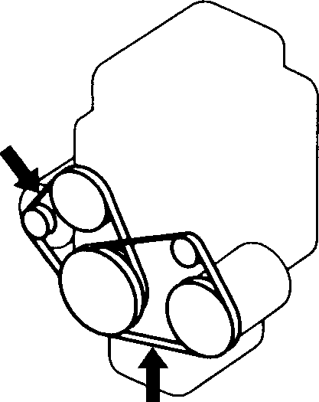

DEF: 6 – 7 mm

(0.24 – 0.28 in.)

**EXAMPLE**

GE

AC

DEF: 7 – 8 mm

(0.28 – 0.31 in.)

: 100 N (10 kg, 22 lbs) press GE: Generator

DEF: Deflection

AC: Air conditioner compressor

##### Specified Oil (ALTO 800)

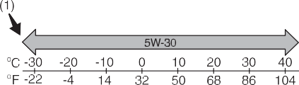

Make sure the drive belt tension is correct. If the belt is too loose, insufficient battery charging, engine overheating, poor power steering, poor air conditioning, or exces- sive belt wear can result. When you press

(1) Preferred

53M-09-004

the belt with your thumb midway between the pulleys, there should be a deflection according to the following chart.

The belts should also be examined to ensure that they are not damaged.

If you need to replace or adjust the belt have it done by your MARUTI SUZUKI dealer.

###### K10B

51KM036

Be sure that the engine oil you use comes under the quality classification of SG+, SL, SM and SN. Select the appropriate oil vis-

cosity according to the above chart.

**SAE 5W-30** (1) is the best choice for good fuel economy, and good starting in cold weather.

Specified Oil (ALTO K10)

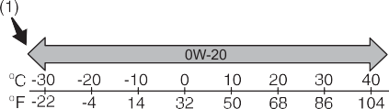

53M-09-005

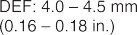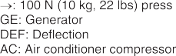

**EXAMPLE**

(1) Preferred

53M-09-003

Be sure that the engine oil you use comes under the quality classification of SL, SM and SN. Select the appropriate oil viscosity according to the above chart.

### 7-10

#### INSPECTION AND MAINTENANCE

**SAE 0W-20** (1) is the best choice for good fuel economy, and good starting in cold weather.

##### Oil Level Check



**EXAMPLE**

68KH066

It is important to keep the engine oil at the correct level for proper lubrication of your vehicle’s engine. Check the oil level with the vehicle on a level surface. The oil level indication may be inaccurate if the vehicle is on a slope. The oil level should be checked either before starting the engine or at least 5 minutes after stopping the engine.

Pull out the oil dipstick, wipe oil off with a clean cloth, insert the dipstick all the way into the engine, then remove it again. The oil on the stick should be between the upper and lower limits shown on the stick. If the oil level indication is near the lower

limit, add enough oil to raise the level to the upper limit.

**Failure to check the oil level regularly could lead to serious engine trouble due to insufficient oil.**

***NOTICE***

##### Refilling

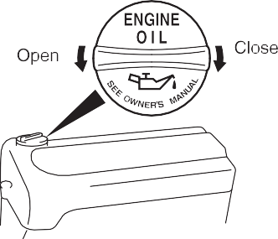

**EXAMPLE**

53M-09-007

Remove the oil filler cap and pour oil slowly through the filler hole to bring the oil level to the upper limit on the dipstick. Be careful not to overfill. Too much oil is almost as bad as too little oil. After refilling, start the engine and allow it to idle for about a min- ute. Stop the engine, wait about 5 minutes and check the oil level again.

##### Changing Engine Oil and Filter

Drain the engine oil while the engine is still warm.

1. Remove the oil filler cap.
2. Place a drain pan under the drain plug.
3. Using a wrench, remove the drain plug and drain out the engine oil.



**CAUTION**

**The engine oil temperature may be high enough to burn your fingers when the drain plug is loosened. Wait until the drain plug is cool enough to touch with your bare hands.**

###### ALTO 800

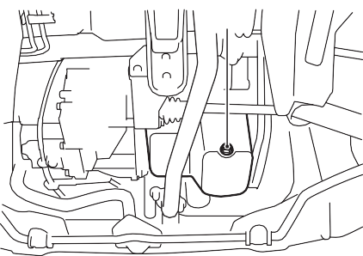

**EXAMPLE**

(1)

53MH0701

**Tightening torque for drain plug (1): 49 Nm (4.9 kg-m, 36.0 lb-ft)**

### 7-11

#### INSPECTION AND MAINTENANCE

###### ALTO K10

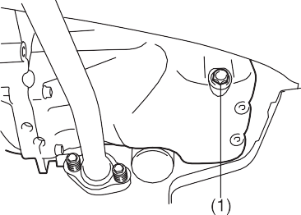

**EXAMPLE**

53M-09-009

1. Reinstall the drain plug and new gas- ket. Tighten the plug with a wrench to the specified torque.

##### Replace the Oil Filter

1. Using an oil filter wrench, turn the oil fil- ter counterclockwise and remove it.
2. Using a clean rag, wipe off the mount- ing surface on the engine where the new filter will be seated.
3. Smear a little engine oil around the rub- ber gasket of the new oil filter.
4. Screw on the new filter by hand until the

Tightening (viewed from filter top)

**EXAMPLE**

(2)

(1)

**Tightening torque for drain plug (1): 35 Nm (3.6 kg-m, 25.8 lb-ft)**

filter gasket contacts the mounting sur- face.

* 1. Oil filter
  2. 1 turn

82JN146

**To tighten the oil filter properly, it is important to accurately identify the position at which the filter gasket first contacts the mounting surface.**

***NOTICE***

* + 1. Loosen



**New and used oil can be hazardous. Children and pets may be harmed by swallowing new or used oil. Keep new and used oil and used oil filters away from children and pets.**

**Continuous contact with used engine oil may cause skin cancer laboratory animals.Brief contact with used oil may irritate skin.**

**To minimize your exposure to used oil, wear a long-sleeve shirt and moistureproof gloves (such as dish- washing gloves) when changing oil. If oil contacts your skin, wash thor- oughly with soap and water.**

**Launder any clothing or rags if wet with oil.Recycle or properly dispose of used oil and filters.**

**WARNING**

* + 1. Tighten

54G092

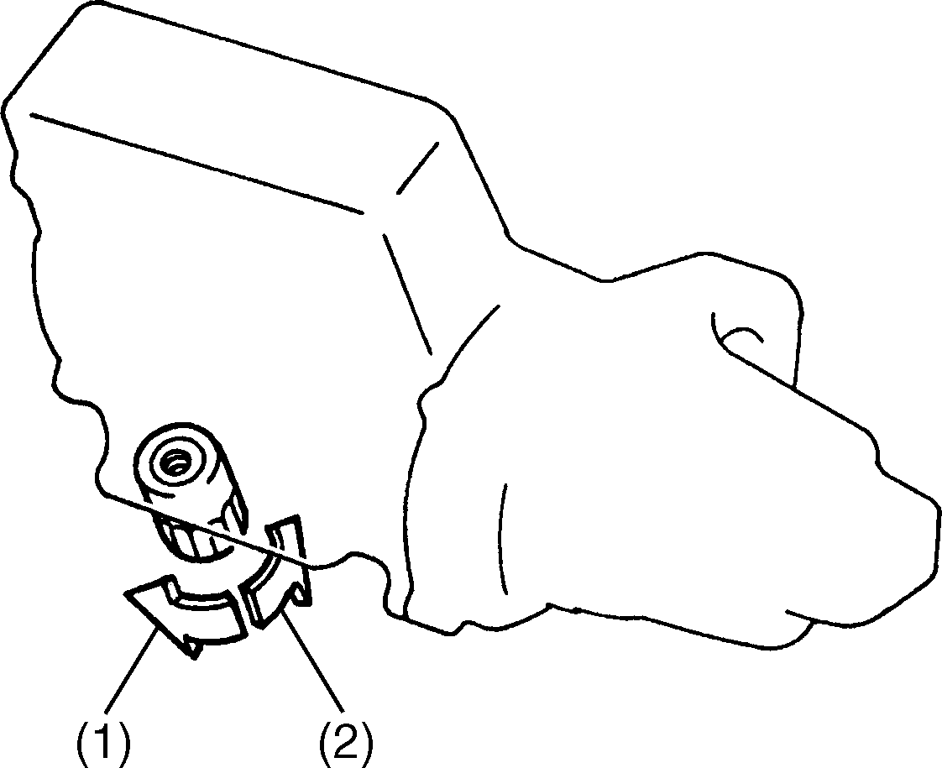

**EXAMPLE**

1. Tighten the filter specified turn from the point of contact with the mounting sur- face (or to the specified torque) using an oil filter wrench.

**Tightening torque for oil filter**

**1 turn or 14 Nm (1.4 kg-m, 10.1 lb-ft)**

**To prevent oil leakage, make sure that the oil filter is tight, but do not over-tighten it.**

***NOTICE***

### 7-12

#### INSPECTION AND MAINTENANCE

##### Refill with Oil and Check for Leaks

1. Pour oil through the filler hole and install the filler cap.

For the approximate capacity of the oil, refer to the “Capacities” item in the “SPECIFICATIONS” section.

1. Start the engine and look carefully for leaks at the oil filter and drain plug. Run the engine at various speeds for at least 5 minutes.
2. Stop the engine and wait about 5 min- utes. Check the oil level again and add oil if necessary. Check for leaks again.

## Engine Coolant

##### Selection of Coolant

**To avoid damaging your cooling sys- tem:**

* **Always use a high quality eth- yleneglycol base non-silicate type coolant diluted with distilled water at the correct mixture concentra- tion.**
* **Make sure that the proper mix is 30/ 70 coolant to distilled water and in no case higher than 70/30. Concen- trations greater than 70/30 coolant to distilled water will cause over- heating conditions.**
* **Do not use straight coolant nor plain water.**
* **Do not add extra inhibitors or addi- tives. They may not be compatible with your cooling system.**
* **Do not mix different types of base coolants. Doing so may result in accelerated seal wear and/or the possibility of severe overheating and extensive engine damage.**

***NOTICE***

To maintain optimum performance and durability of your engine, use MARUTI Genuine Coolant or equivalent.

This type of coolant is best for your cooling system as it:

* Helps maintain proper engine tempera- ture.
* Gives proper protection against freezing and boiling.
* Gives proper protection against corro- sion and rust.

Failure to use the proper coolant can dam- age your cooling system. Your authorized MARUTI SUZUKI dealer can help you select the proper coolant.

##### Coolant Level Check

* **When replacing the oil filter, it is rec- ommended that you use a genuine MARUTI SUZUKI replacement filter. If you use an aftermarket filter, make sure it is of equivalent quality and follow the manufacturer’s instruc- tions.**
* **Oil leaks from around the oil filter or drain plug indicate incorrect installation or gasket damage. If you find any leaks or are not sure that the filter has been properly tightened, have the vehicle inspected by your MARUTI SUZUKI dealer.**

***NOTICE***

Check the coolant level at the reservoir tank, not at the radiator. With the engine cool, the coolant level should be between the “FULL” and “LOW” marks.

### 7-13

#### INSPECTION AND MAINTENANCE

##### Adding Coolant

**ALTO 800**

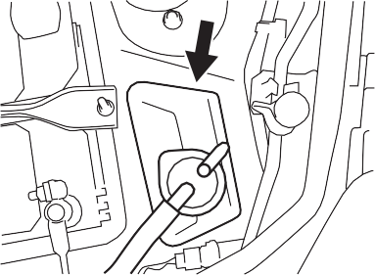

**EXAMPLE**

**ALTO K10**

**ALTO 800**

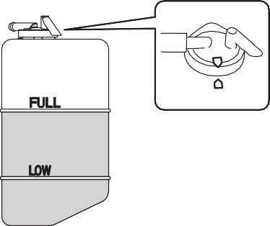

**EXAMPLE**

53MH0702

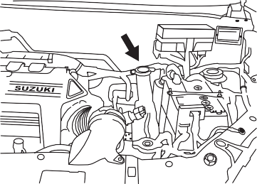

**EXAMPLE**



**Engine coolant is harmful or fatal if swallowed or inhaled. Do not drink antifreeze or coolant solution. If swal- lowed, do not induce vomiting. Imme- diately contact a poison control center or a physician. Avoid inhaling mist or hot vapors; if inhaled, remove to fresh air. If coolant gets in eyes, flush eyes with water and seek medi- cal attention. Wash thoroughly after handling. Solution can be poisonous to animals. Keep out of the reach of children and animals.**

**WARNING**

###### ALTO K10



**EXAMPLE**

* **The mixture you use should con- tain 50% concentration of anti- freeze.**
* **If the lowest ambient temperature in your area is expected to be – 35°C (–31°F) or below, use higher concentrations up to 60% following the instructions on the antifreeze container.**

***NOTICE***

53MM07009

53MH0703

53M-09-015

If the coolant level is below the “LOW” mark, more coolant should be added. Remove the reservoir tank cap and add coolant until the reservoir tank level reaches the “FULL” mark. Never fill the res- ervoir tank above the “FULL” mark.

**When putting the cap on the reser- voir tank, line up the mark on the cap and the mark on the tank. Failure to follow this can result in coolant leak- age.**

***NOTICE***

### 7-14

#### INSPECTION AND MAINTENANCE

##### Coolant Replacement

Since special procedures are required, we recommend you take your vehicle to your MARUTI SUZUKI dealer for coolant replacement.

## Air Cleaner

###### ALTO 800

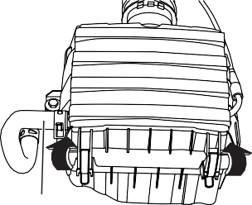

**EXAMPLE**

(1)

Unclamp/Unscrew the side clamps/screws, and remove the element from the air cleaner case. If it appears to be dirty, replace it with a new one.

## Spark Plugs

You should inspect spark plugs periodically for carbon deposits. When carbon accu- mulates on a spark plug, a strong spark may not be produced. Remove carbon deposits with a wire or pin and adjust the spark plug gap.

*NOTE:*

*For ALTO K10: Unclamp the air filter bolt and then remove the air cleaner case.*

###### ALTO K10

1. Pullout the ignition coil (3) and remove the spark plug.

*NOTE:*

*When installation, make sure the wires, couplers, sealing rubber of top cover and washers, are correctly returned in place.*

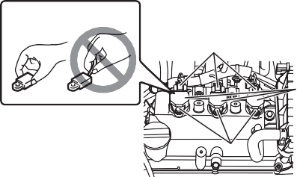

**EXAMPLE**

Right Wrong

(1)

(3)

(2)

*NOTE:*

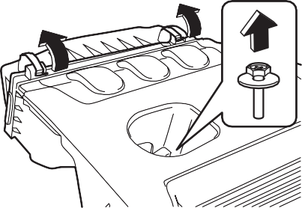

**EXAMPLE**

* **When pulling the ignition coils out, do not pull on the cable. Pulling on the cable can damage it.**
* **When servicing the iridium/plati- num spark plugs (slender center electrode type plugs), do not touch the center electrode, as it is easy to damage.**

***NOTICE***

53MM07007

53MM07008

*Remove hose (1) from air cleaner case before unclamping.*

###### ALTO K10

53M-09-019

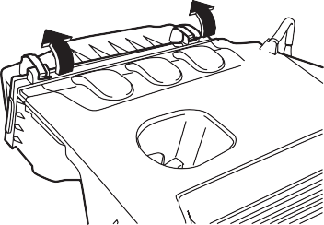

**EXAMPLE**

To access the spark plugs:

### 7-15

53M-09-017

1. If necessary, disconnect the coupler (1) while pushing the release lever.
2. Remove the ignition coil bolts (2).

#### INSPECTION AND MAINTENANCE

###### ALTO 800

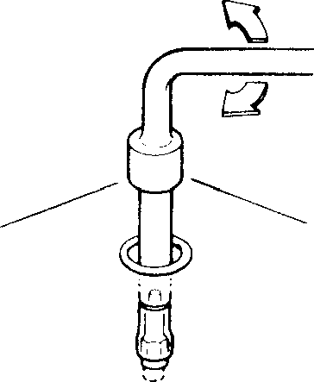

**EXAMPLE**

**NGK DCPR7E, BOSCH YR7DC**

**0.8 - 0.9 mm (0.031 - 0.035 in.)**

###### ALTO K10 NGK KR6A-10:

**0.95 - 1.05 mm (0.037 - 0.041 in.)**

##### Gear Oil Level Check

60G160S

* **When installing the spark plugs, screw them in with your fingers to avoid stripping the threads. Tighten with a torque wrench to 25 Nm (2.5 kg-m, 18.0 lb-ft). Do not allow contaminants to enter the engine through the spark plug holes when the plugs are removed.**
* **Never use spark plugs with the wrong thread size.**

***NOTICE***

(1) Oil filler and level plug

**When replacing spark plugs, you should use the brand and type speci- fied for your vehicle. For the speci- fied spark plugs, refer to the “SPECIFICATIONS” section at the end of this book.**

***NOTICE***

68KH073



**EXAMPLE**

(1)

Spark plug gap “a”

53MM07010

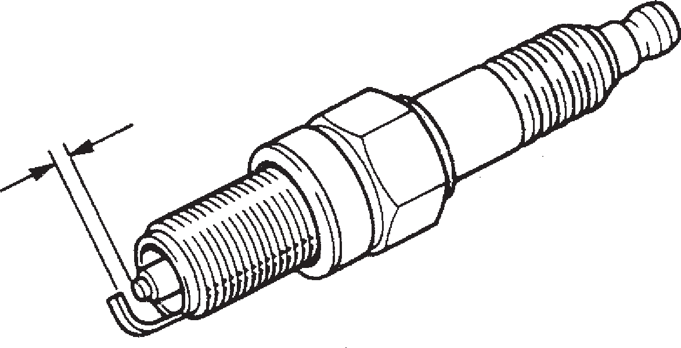

**EXAMPLE**

“a”

## Gear Oil

##### Manual Transaxle Oil

When adding gear oil, use gear oil with the appropriate viscosity and grade.

We highly recommend you use: “MARUTI Genuine GEAR OIL 75W-80” for manual transaxle gear oil or automated manual transaxle oil.

Manual transaxle oil (API GL-4)



53M-09-023

To check the gear oil level, use the follow- ing procedure:

1. Park the vehicle on a level surface with the parking brake applied. Then, stop the engine.
2. Remove the oil filler plug (1) or (2).
3. Check the inside of the hole with your finger. If the oil level comes up to the bottom of the plug hole, the oil level is correct. If so, reinstall the plug.
4. If the oil level is low, add gear oil through the oil filler plug hole (1) or (2) until the oil level reaches the bottom of the filler hole, then reinstall the plug.

**Tightening torque (1):**

**21 Nm (2.1 kg-m, 15.5 lb-ft)**

### 7-16

#### INSPECTION AND MAINTENANCE



**CAUTION**

## Clutch Pedal

##### Cable control clutch

**After driving the vehicle, the transaxle oil temperature may be high enough to burn your skin. Wait until the oil filler plug is cool enough to touch with your bare hands before inspecting transaxle oil.**

**(For Manual Transaxle Model)**

## Fuel Filter

The fuel filter is located on the way of the fuel hose line under the vehicle body.

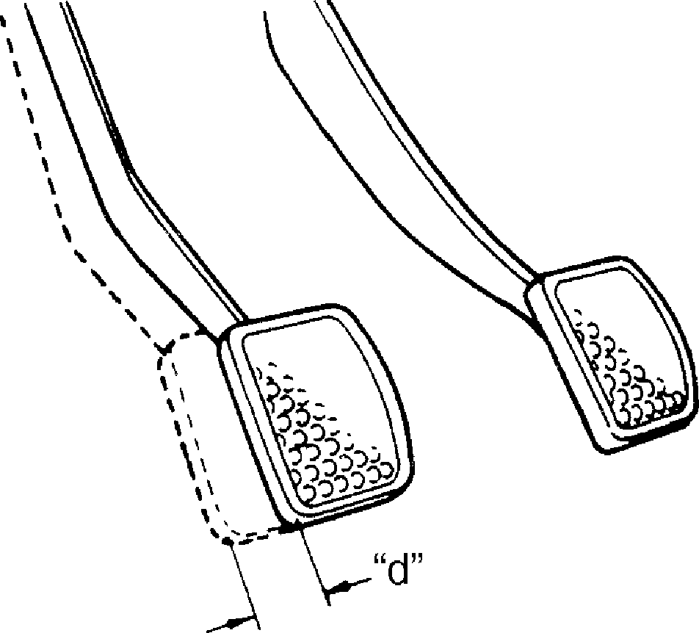

**EXAMPLE**

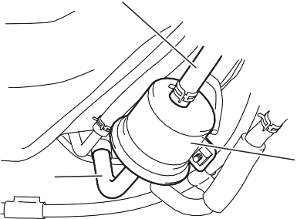

**EXAMPLE** (3)

(1)

(2)

##### Gear Oil Change

Clutch pedal play “d”: 10 - 15 mm (0.4 - 0.6 in.)

54G274

* 1. Fuel filter
  2. Fuel inlet hose

**When tightening the plug, apply the following sealing compound or equivalent to the plug threads to pre- vent oil leakage.**

**Manual transaxle sealant:**

**MARUTI SUZUKI Bond No. “1216E” or “1217G”**

***NOTICE***

53MM07011

Since special procedures, materials and tools are required, it is recommended that you trust this job to your authorized MARUTI SUZUKI dealer.

Measure the clutch pedal play by moving the clutch pedal with your hand and mea- suring the distance it moves until you feel slight resistance. The play in the clutch pedal should be between the specified val- ues. If the play is more or less than the above, or clutch dragging is felt with the pedal fully depressed, have the clutch inspected by your MARUTI SUZUKI dealer.

* 1. Fuel outlet hose

##### Replace the Fuel Filter

Since special procedures are required, we recommend you take your vehicle to your MARUTI SUZUKI dealer for fuel filter replacement.

**7-17**

## Brakes

##### Brake Fluid

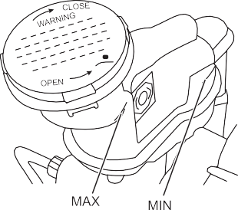

**EXAMPLE**

53M-09-028

Check the brake fluid level by looking at the reservoir in the engine compartment. Check that the fluid level is between the “MAX” and “MIN” lines. If the brake fluid level is near the “MIN” line, fill it up to the “MAX” line with MARUTI GENUINE BRAKE FLUID (MGBF).

#### INSPECTION AND MAINTENANCE



**Brake fluid is harmful or fatal if swal- lowed, and harmful if it comes in con- tact with skin or eyes. If swallowed, do not induce vomiting. Immediately contact a poison control center or a physician. If brake fluid gets in eyes, flush eyes with water and seek medi- cal attention. Wash thoroughly after handling. Solution can be poisonous to animals. Keep out of the reach of children and animals.**

**WARNING**

*NOTE:*

*With disc brakes, the fluid level can be*



**Failure to follow the guidelines below can result in personal injury or seri- ous damage to the brake system.**

* **If the brake fluid in the reservoir drops below a certain level, the brake warning light on the instru- ment panel will come on (the engine must be running with the parking brake fully disengaged). Should the light come on, immedi- ately ask your MARUTI SUZUKI dealer to inspect the brake system.**
* **A rapid fluid loss indicates a leak in the brake system which should be inspected by your MARUTI SUZUKI dealer immediately.**
* **Do not use any fluid other than MARUTI GENUINE BRAKE FLUID**

**(MGBF) brake fluid. Do not use reclaimed fluid or fluid that has been stored in old or open contain- ers. It is essential that foreign parti- cles and other liquids are kept out of the brake fluid reservoir.**

**WARNING**

*expected to gradually fall as the brake pads wear.*

##### Brake Pedal

Check if the brake pedal stops at the regu- lar height without “spongy” feeling when you depress it. If not, have the brake sys- tem inspected by your MARUTI SUZUKI dealer. If you doubt the brake pedal for the regular height, check it as follows:



**CAUTION**

**Brake fluid can harm your eyes and damage painted surfaces. Use cau- tion when refilling the reservoir.**

### 7-18

#### INSPECTION AND MAINTENANCE

##### Parking Brake

53M-09-029

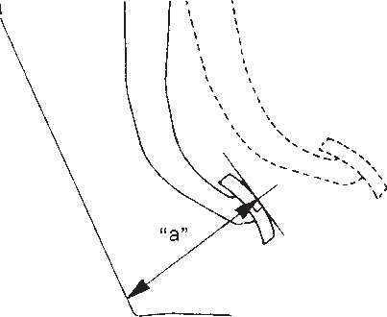

**EXAMPLE**

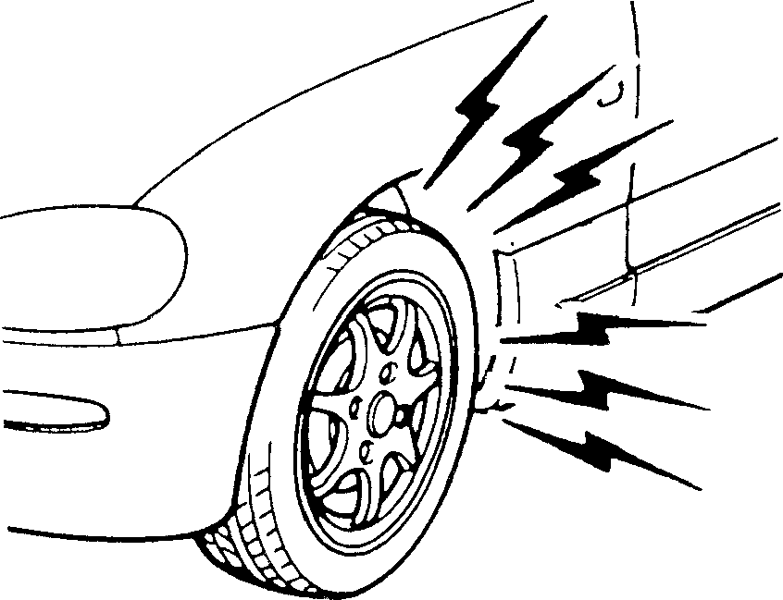

60G104S

**If you experience any of the following problems with your vehicle’s brake system, have the vehicle inspected immediately by your MARUTI SUZUKI dealer.**

* **Poor braking performance**
* **Uneven braking (brakes not work- ing uniformly on all wheels).**
* **Excessive pedal travel**
* **Brake dragging**
* **Excessive noise**
* **Pedal pulsation (pedal pulsates when depressed).**

**WARNING**

**EXAMPLE**

**Pedal to floor carpet minimum dis- tance “a”:**

**ALTO 800: 72 mm (2.8 in.)**

**ALTO K10: 79 mm (3.1 in.)**

With the engine running, measure the dis- tance between the brake pedal and floor carpet when the pedal is depressed with approximately 30 kg (66 lbs) of force. The minimum distance required is as specified. Since your vehicle’s brake system is self- adjusting, there is no need for pedal adjustment.

If the pedal to floor carpet distance as measured above is less than the minimum distance required, have your vehicle inspected by your MARUTI SUZUKI dealer.

*NOTE:*

*When measuring the distance between the brake pedal and floor wall, be sure not to include any accessory floor mat or rubber mat on the floor carpet in your measure- ment.*

54G109

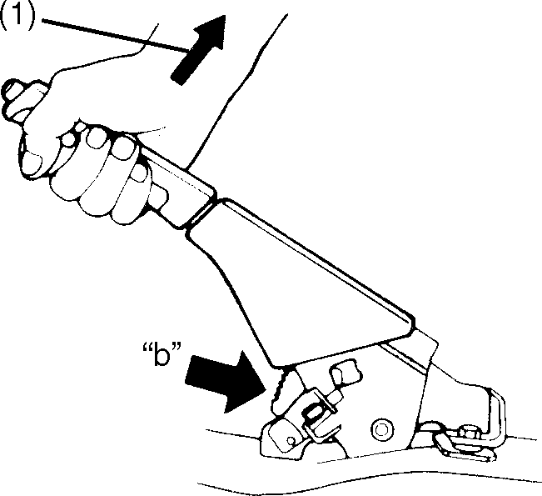

**EXAMPLE**

**Ratchet tooth specification “b”: 4th – 9th**

**Lever pull force (1):**

**200 N (20 kg, 44 lbs)**

Check the parking brake for proper adjust- ment by counting the number of clicks made by the ratchet teeth as you slowly pull up on the parking brake lever to the point of full engagement. The parking brake lever should stop between the speci- fied ratchet teeth and the rear wheels should be securely locked. If the parking brake is not properly adjusted or the brakes drag after the lever has been fully released, have the parking brake inspected and/or adjusted by your MARUTI SUZUKI dealer.

**7-19**

## Steering



**EXAMPLE**

Steering wheel play “c”: 0 – 30 mm (0.0 – 1.2 in.)

53M-09-032

## Tires



**EXAMPLE**

53M-09-033

The front and rear tire pressure specifica- tions for your vehicle are listed on the Tire Information Label. Both the front and rear



* **Air pressures should be checked when the tires are cold or you may get inaccurate readings.**
* **Check the inflation pressure from time to time while inflating the tire gradually, until the specified pres- sure is obtained.**
* **Never underinflate or overinflate the tires.**

**Underinflation can cause unusual handling characteristics or can cause the rim to slip on the tire bead, resulting in an accident or damage to the tire or rim.**

**Overinflation can cause the tire to burst, resulting in personal injury. Overinflation can also cause unusual handling characteristics which may result in an accident.**

**WARNING**

#### INSPECTION AND MAINTENANCE

Check the play of the steering wheel by gently turning it from left to right and mea- suring the distance that it moves before you feel slight resistance. The play should be between the specified values.

Check that the steering wheel turns easily and smoothly without rattling by turning it all the way to the right and to the left while driving very slowly in an open area. If the amount of free play is outside the specifi- cation or you find anything else to be wrong, an inspection must be performed by your MARUTI SUZUKI dealer.

tires should have the specified tire pres- sure.

##### Tire Inspection

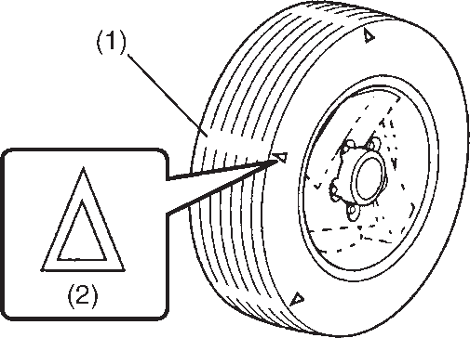

**EXAMPLE**

Inspect your vehicle’s tires at least once a month by performing the following checks:

1. Measure the air pressure with a tire gauge. Adjust the pressure if neces- sary. Remember to check the spare tire, too.

53M-09-034

### 7-20

#### INSPECTION AND MAINTENANCE



* **Your MARUTI SUZUKI is equipped with tires which are all the same type and size. This is important to ensure proper steering and han- dling of the vehicle. Never mix tires of different size or type on the four wheels of your vehicle. The size and type of tires used should be only those approved by MARUTI SUZUKI as standard or optional equipment for your vehicle.**
* **Replacing the wheels and tires equipped on your vehicle with cer- tain combinations of aftermarket wheels and tires can significantly change the steering and handling characteristics of your vehicle.**
* **Therefore, use only those wheel and tire combinations approved by MARUTI SUZUKI as standard or optional equipment for your vehi- cle.**

**WARNING**

* 1. Tread wear indicator
  2. Indicator location mark

1. Check that the depth of the tread groove is more than 1.6 mm (0.06 in.). To help you check this, the tires have molded-in tread wear indicators in the grooves. When the indicators appear on the tread surface, the remaining depth of the tread is 1.6 mm (0.06 in.) or less and the tire should be replaced.
2. Check for abnormal wear, cracks and damage. Any tires with cracks or other damage should be replaced. If any tires show abnormal wear, have them inspected by your MARUTI SUZUKI

##### Tire Rotation

53M-09-035



dealer.



**CAUTION**

**Hitting curbs and running over rocks can damage tires and affect wheel alignment. Be sure to have tires and wheel alignment checked periodi- cally by your MARUTI SUZUKI dealer.**

1. Check for loose wheel nuts.
2. Check that there are no nails, stones or other objects sticking into the tires.

To avoid uneven wear of your tires and to prolong their life, rotate the tires as illus-

trated. Tires should be rotated as men- tioned in periodic maintenance schedule. After rotation, adjust front and rear tire pressures to the specification listed on your vehicle’s Tire Information Label.

Wheel Balancing

If the vehicle vibrates abnormally on smooth road, have the wheel balanced at Maruti Suzuki Authorized Workshop.

**Replacing the original tires with tires of a different size may result in false speedometer or odometer readings. Check with your SUZUKI dealer before purchasing replacement tires that differ in size from the original tires.**

***NOTICE***

Wheel Alignment

In case of abnormal tire wear or pulling towards one side, have the wheel aligned at Maruti Suzuki Authorized Workshop.

### 7-21

Tubeless Tires (If equipped)

The vehicle is equipped with Tubeless Tires. In tubeless tire, a thin layer of butyl rubber is used for lining the inside of the tubeless tire. This layer is to prevent air loss and fulfilling the purpose of tube. The air pressure is maintained by the sealing between tire bead and wheel rim. Tubeless tires are having advantage of slow air loss and preventing sudden deflation while driv- ing.

Care and maintenance tips for tubeless tires

1. Always maintain recommended inflation pressure. Driving continuously at low inflation pressure can lead to tire dam- age.
2. In case any leakage is found, check for any nail penetration/valve core dam- age or rim bent. Damaged wheel must not be used.
3. In case tire has run at low pressure, it must be inspected for any defect.
4. Whenever new tire is fitted, replace the valve.
5. If continuous high speed driving is required, increase tires pressure by 5 psi over recommended inflation pres- sure.
6. Never run the tire beyond TWI (Tread Wear Indicator). The tire is recom- mended to be replaced when the remaining tread has worn to this point. The indicators are spaced across the

tread around the tire marked by a trian- gular symbol (TWI).

1. Always prefer tubeless tire mounting machine. In case of manual mounting- tire/wheel rim damage may occur.
2. In case of any problem, please get in touch with Maruti Suzuki Authorized Workshop.

**INSPECTION AND MAINTENANCE**

## Battery



* **Batteries produce flammable hydrogen gas. Keep flames and sparks away from the battery or an explosion may occur. Never smoke when working in the vicinity of the battery.**
* **When checking or servicing the battery, disconnect the negative cable. Be careful not to cause a short circuit by allowing metal objects to contact the battery posts and the vehicle at the same time.**
* **To avoid harm to yourself or dam- age to your vehicle or battery, fol- low the jump starting instructions in the “EMERGENCY SERVICE”**

**section of this manual if it is neces- sary to jump start your vehicle.**

* **Diluted sulfuric acid spilled from battery can cause blindness or severe burns. Use proper eye pro- tection and gloves. Flush eyes or body with ample water and get medical care immediately if suf- fered.**
* **Keep batteries out of the reach of children.**

**WARNING**

### 7-22

#### INSPECTION AND MAINTENANCE

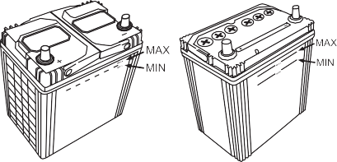

**EXAMPLE**

53m-09-036

The level of the battery solution must be kept between the “MAX” and the “MIN” level lines at all times. If the level is found to be below the “MIN” level line, add dis-

Replacement of the battery

To remove the battery:

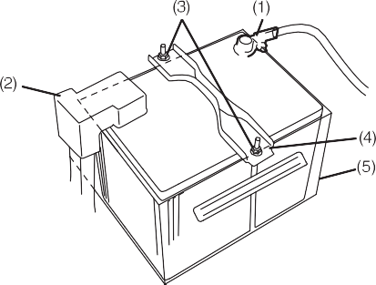

**EXAMPLE**

53M-09-037

To install the battery:

1. Install the battery in the reverse order of removal.
2. Tighten the retainer nuts and battery cables securely.

*NOTE:*

*When the battery is disconnected, some of the vehicle’s function will be initialized and/ or deactivated.*

*These function are required to reset after the battery is reconnected.*

## Fuses

Your vehicle has three types of fuses, as described below:

Main fuse

The main fuse takes current directly from the battery.

tilled water to bring level between “MAX”

and “MIN”. You should, however, periodi- cally check the battery, battery terminals, and battery holddown bracket for corro- sion. Remove corrosion using a stiff brush and ammonia mixed with water, or baking soda mixed with water. After removing cor- rosion, rinse with clean water.

If your vehicle is not going to be driven for a month or longer, disconnect the cable from the negative terminal of the battery to help prevent discharge.



**CAUTION**

1. Disconnect the negative cable (1).
2. Disconnect the positive cable (2).
3. Remove the retainer bolts (3) and remove the retainer (4).
4. Remove the battery along with cover assembly (5) (if equipped).

* **Ensure that battery should not be removed without cover assembly.**
* **When the battery is reassembled into the vehicle, kindly ensure that battery cover is also installed along with battery.**

***NOTICE***

Primary fuses

These fuses are between the main fuse and individual fuses, and are for electrical load groups.

Individual fuses

These fuses are for individual electrical cir- cuits. To remove a fuse, use the fuse puller provided in the fuse box.

**Do not overfill the battery with dis- tilled water in order to avoid spillage.**

### 7-23

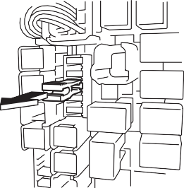53M-09-038

##### Fuses in the Engine Compartment

###### ALTO 800

53M-09-039

|  |  |  |
| --- | --- | --- |
| **MAIN FUSE / PRIMARY FUSE** | | |
| (1) | – | Blank |
| (2) | – | Blank |
| (3) | – | Blank |
| (4) | – | Blank |
| (5) | 50A | Ignition switch fuse |

#### INSPECTION AND MAINTENANCE

##### Fuses in the Engine Compartment

|  |  |  |
| --- | --- | --- |
| (6) | 50A | Battery1 |
| (7) | 15A | Headlight (left) fuse |
| (8) | 15A | Headlight (right) fuse |
| (9) | – | Blank |
| (10) | – | Radiator fan relay |
| (11) | – | Blank |
| (12) | – | Blank |
| (13) | – | Blank |
| (14) | 80A | All electric load |
| (15) | – | Blank |
| (16) | – | Main relay |
| (17) | 30A | Radiator fan fuse |
| (18) | 15A | Fuel injection fuse |
| (19) | 10A | A/c compressor fuse |
| (20) | – | Fuel pump relay |
| (21) | – | Blank |
| (22) | – | Blank |
| (23) | 30A | Battery 2 fuse |

###### ALTO K10

53M-09-040

|  |  |  |
| --- | --- | --- |
| **MAIN FUSE / PRIMARY FUSE** | | |
| (1) | — | Blank |
| (2) | — | Blank |
| (3) | 10A | Font fog light |
| (4) | — | A/c compressor relay |
| (5) | 50A | Ignition switch fuse |
| (6) | 50A | Battery1 |
| (7) | 15A | Headlight (left) fuse |
| (8) | 15A | Headlight (right) fuse |
| (9) | — | Blank |
| (10) | — | Radiator fan relay |
| (11) | — | Blank |
| (12) | — | Blank |
| (13) | — | Blank |

### 7-24

#### INSPECTION AND MAINTENANCE

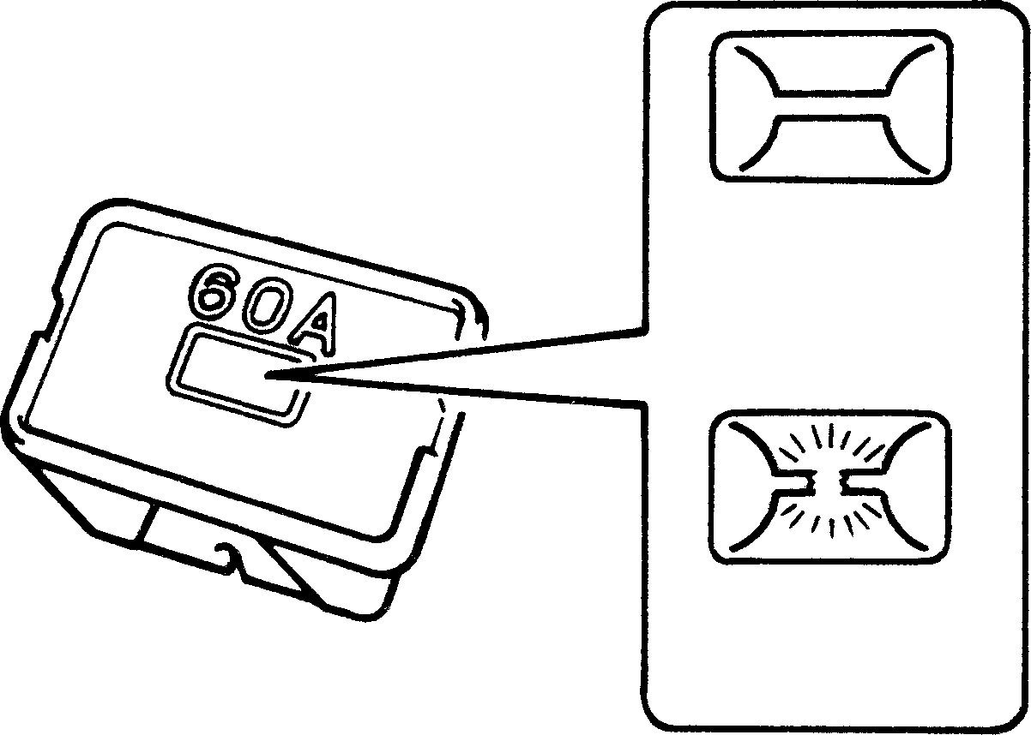

60G111

**If the main fuse or a primary fuse blows, be sure to have your vehicle inspected by an authorized MARUTI SUZUKI dealer. Always use a genuine MARUTI replacement. Never use a substitute such as a wire even for a temporary repair, or extensive electri- cal damage and a fire can result.**

**WARNING**

**EXAMPLE**

**OK**

**BLOWN**

|  |  |  |
| --- | --- | --- |
| (14) | 80A | All electric load |
| (15) | — | Blank |
| (16) | — | Main relay |
| (17) | 30A | Radiator fan fuse |
| (18) | 15A | Fuel injection fuse |
| (19) | 10A | Air compressor fuse |
| (20) | — | Fuel pump relay |
| (21) | 7.5A | Automated Manual Tran- saxle (if equipped) |
| (22) | 40A | Automated Manual Tran- saxle pump (if equipped) |
| (23) | 30A | Battery 2 |

##### Fuses under the Dash Board

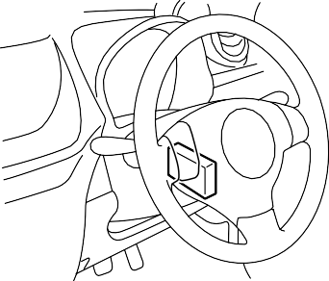

**EXAMPLE**

The main fuse, primary fuses and some of the individual fuses are located in the engine compartment. If the main fuse blows, no electrical component will func- tion. If a primary fuse blows, no electrical component in the corresponding load group will function. When replacing the main fuse, a primary fuse or an individual fuse, use a Maruti Genuine replacement. To remove a fuse, use the fuse puller pro- vided in the fuse box. The amperage of each fuse is shown in side the fuse box cover.

*NOTE:*

*Make sure that the fuse box always carries spare fuses and fuse puller.*

###### ALTO 800

68KH078

53M-09-043

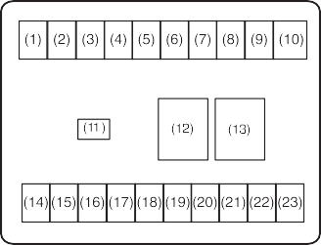

### 7-25

###### ALTO K10

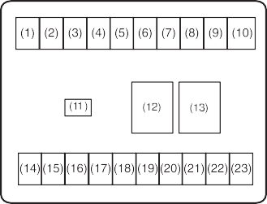

|  |  |  |
| --- | --- | --- |
| **SECONDARY FUSE** | | |
| (1) | 10A | IG2 SIG |
| (2) | 15A | Wiper |
| (3) | – | Blank |
| (4) | – | Blank |
| (5) | 30A | Blower motor |
| (6) | 10A | Stop light |
| (7) | 10A | Tail light |
| (8) | 15A | Audio |
| (9) | 20A | Door lock |
| (10) | – | Blank |
| (11) | 15A | Accessory |
| (12) | – | Blank |
| (13) | 30A | Power window |
| (14) | 15A | Ignition switch |
| (15) | 10A | Turn signal light |
| (16) | 10A | Meter |
| (17) | 7.5A | Air bag |
| (18) | – | Blank |
| (19) | – | Blank |
| (20) | – | Blank |
| (21) | 30A | Power steering |
| (22) | 30A | ST SIG |
| (23) | 15A | Horn/Hazard |

53M-09-044

#### INSPECTION AND MAINTENANCE

|  |  |  |
| --- | --- | --- |
| (15) | 10A | Turn signal light |
| (16) | 10A | Meter |
| (17) | 7.5A | Air bag |
| (18) | 7.5A | IG1 SIG |
| (19) | – | Blank |
| (20) | – | Blank |
| (21) | 30A | Power steering |
| (22) | 30A | ST SIG |
| (23) | 15A | Horn/Hazard |

|  |  |  |
| --- | --- | --- |
| **SECONDARY FUSE** | | |
| (1) | 10A | IG2 SIG |
| (2) | 15A | Wiper |
| (3) | – | Blank |
| (4) | 7.5A | Automated Manual Tran- saxle 2 (if equipped) |
| (5) | 30A | Blower motor |
| (6) | 10A | Stop light |
| (7) | 10A | Tail light |
| (8) | 15A | Audio |
| (9) | 20A | Door lock |
| (10) | – | Blank |
| (11) | 15A | Accessory |
| (12) | – | Blank |
| (13) | 30A | Power window |
| (14) | 15A | Ignition switch |



53M-09-045

**Always be sure to replace a blown fuse with a fuse of the correct amper- age. Never use a substitute such as aluminum foil or wire to replace a blown fuse. If you replace a fuse and the new one blows in a short period of time, you may have a major electri- cal problem. Have your vehicle inspected immediately by your MARUTI SUZUKI dealer.**

**WARNING**

**EXAMPLE**

### 7-26

#### INSPECTION AND MAINTENANCE

**Bulb Replacement Interior Light**

* **Light bulbs can be hot enough to burn your finger right after being turned off. This is true especially for halogen headlight bulbs. Replace the bulbs after they become cool enough.**
* **The headlight bulbs are filled with pressurized halogen gas. They can burst and injure you if they are hit or dropped. Handle them carefully.**



**CAUTION**

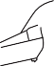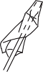

**EXAMPLE**

53M-09-046

Pull down the lens by using a flat blade screwdriver covered with a soft cloth as shown. To install it, simply push it back in. The bulb can be removed by simply pulling it out. When replacing the bulb, make sure that the contact springs are holding the bulb securely.

**Frequent replacement of a bulb indi- cates the need for an inspection of the electrical system. This should be carried out by your MARUTI SUZUKI dealer.**

***NOTICE***

**The oils from your skin may cause a halogen bulb to overheat and burst when the lights are on. Grasp a new bulb with a clean cloth.**

***NOTICE***

##### Headlight

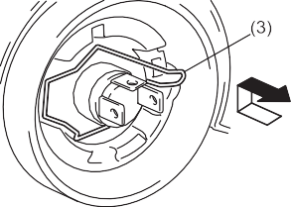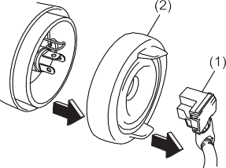

**EXAMPLE**

53M-09-049

Disconnect the coupler (1). Remove the sealing rubber (2). Push the retaining spring (3) forward and unhook it. Then remove the bulb. Install a new bulb in the reverse order.

### 7-27

#### INSPECTION AND MAINTENANCE

##### Side Turn Signal Light

* 1. Removal
  2. Installation



**EXAMPLE**

To remove a bulb holder from a light hous- ing, turn the holder counterclockwise and pull it out. To install the holder, push the holder in and turn it clockwise.

**Bulb**

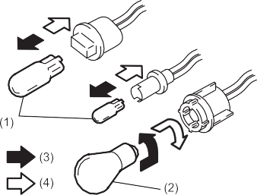

**EXAMPLE**

##### Front turn signal light (1) Front position light (2)

###### ALTO 800



**EXAMPLE**

(2)

(1)

53M-09-050

Pull down the lens by using a flat blade screwdriver covered with a soft cloth as shown. The bulb can be removed by sim- ply pulling it out. Then remove the bulb. Install a new bulb in the reverse order.

##### Other General Lights

Bulb holder

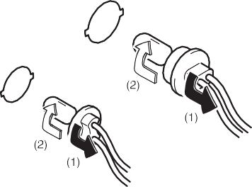

**EXAMPLE**

* 1. Removal
  2. Installation

53M-09-052

###### ALTO K10

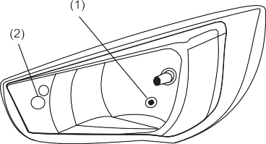

**EXAMPLE**

53MM07001

53M-09-051

There are two types of bulb, “Full glass type” (1) and “Glass/metal type” (2).

To remove and install a full glass type bulb (1), simply pull out or push in the bulb.

To remove a glass metal type bulb (2) from a bulb holder, push in the bulb and turn it counterclockwise. To install a new bulb, push it in and turn it clockwise.

You can access the individual bulb or bulb holders as follows.

53M-09-054

### 7-28

#### INSPECTION AND MAINTENANCE

##### Rear combination light

###### ALTO 800

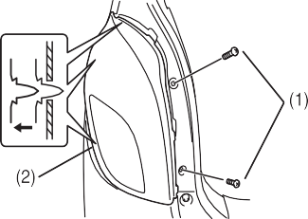

**EXAMPLE**

##### License plate light

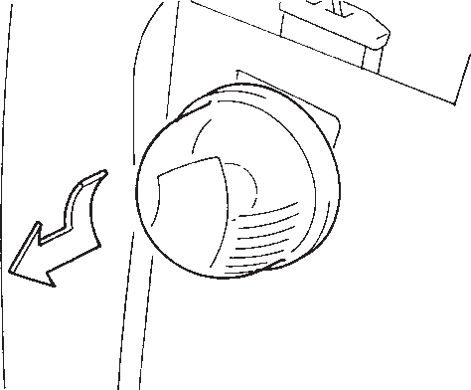

**EXAMPLE**

## Wiper Blades

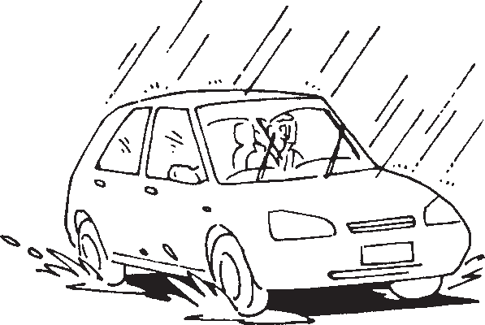

**EXAMPLE**

###### ALTO K10

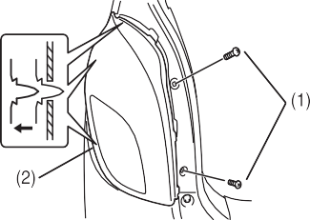

**EXAMPLE**

53M-09-055

##### High-mount stop light



**EXAMPLE**

53M-09-057

53M-09-059

If the wiper blades become brittle or dam- aged, or make streaks when wiping,

replace the wiper blades.

To install new wiper blades, follow the pro- cedures below.

**To avoid scratching or breaking the window, do not let the wiper arm strike the window while replacing the wiper blade.**

***NOTICE***

53M-09-056

Remove the screw (1). Remove the combi- nation light (2) by pulling it outside.

53M-09-058

*NOTE:*

*Some wiper blades may be different from the ones described here depending on vehicle specifications. If so, consult your MARUTI SUZUKI dealer for proper replacement method.*

### 7-29

#### INSPECTION AND MAINTENANCE

For windshield wipers:

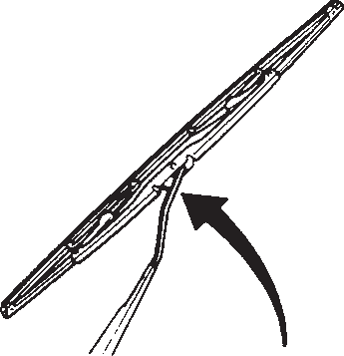

**EXAMPLE**

53M-09-060

* + 1. Hold the wiper arm away from the win- dow
    2. Squeeze lock (1) towards wiper arm (2) and remove the wiper frame from the arm as shown.
    3. Unlock the lock end of the wiper blade and slide the blade out as shown.

Removal

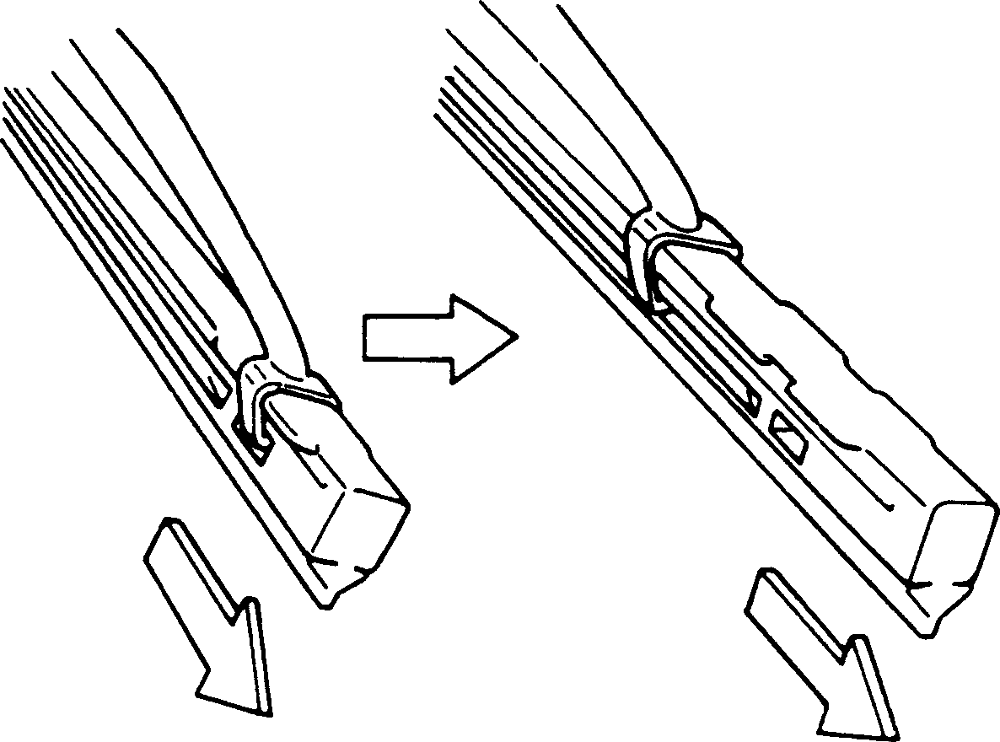

**EXAMPLE**

* + 1. If the new blade is provided without the two metal retainers, move them from the old blade to the new one.

.

*NOTE:*

*When raising both of the front wiper arms, pull the driver’s side wiper arm up first. When returning the wiper arms, lower the passenger’s side wiper arm first. Other- wise, the wiper arms may interfere with each other.*

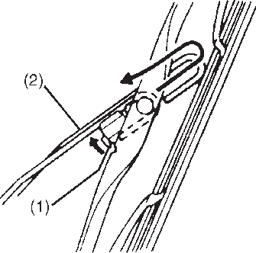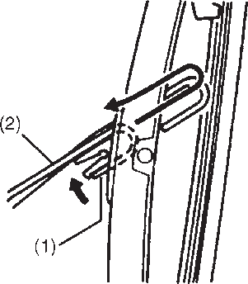

**EXAMPLE**

Installation

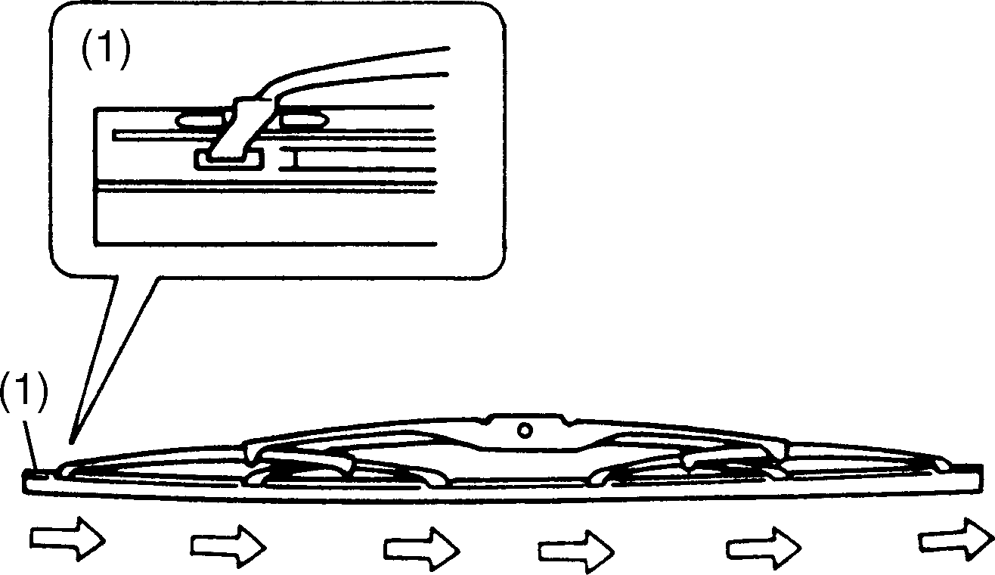

**EXAMPLE**

60A260

53M-09-064



**EXAMPLE**

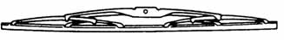

**EXAMPLE**

53M-09-061

* + - 1. Locked end

54G132

1. Up
2. Down

53M-09-065

### 7-30

#### INSPECTION AND MAINTENANCE

*NOTE:*

*When you install the metal retainers (3), make sure the direction of metal retainers as shown in the above illustrations.*

* + 1. Install the new blade in the reverse order of removal, with the locked end positioned toward the wiper arm.

Make sure the blade is properly retained by all the hooks. Lock the blade end into place.

* + 1. Reinstall wiper frame to arm, making sure that the lock lever is snapped securely into the arm.

## Windshield Washer Fluid

Front

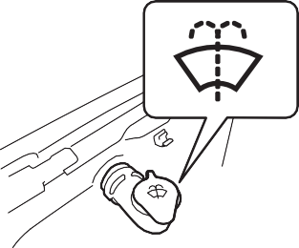

**EXAMPLE**

53M-09-066

Check that there is washer fluid in the tank. Refill it if necessary. Use a good quality windshield washer fluid, diluted with water as necessary.

## Air Conditioning System

If you do not use the air conditioner for a long period, such as during winter, it may not give the best performance when you start using it again. To help maintain opti- mum performance and durability of your air conditioner, it needs to be run periodically. Operate the air conditioner at least once a month for one minute with the engine idling. This circulates the refrigerant and oil and helps protect the internal components.



**Do not use “anti-freeze” solution in the windshield washer reservoir. This can severely impair visibility when sprayed on the windshield, and also damage your vehicle’s paint.**

**WARNING**

**Damage may result if the washer motor is operated with no fluid in the washer tank.**

***NOTICE***

### 7-31

**8**

**EMERGENCY SERVICE**

# EMERGENCY SERVICE

**Tire Changing Tool 8-1**

**Jacking Instructions 8-1**

**Changing Wheels 8-4**

**Jump Starting Instructions 8-5**

**Towing 8-6**

**If the Starter Does Not Operate 8-6**

**If the Engine is Flooded 8-6**

**If the Engine Overheats 8-7**

**Warning Triangle 8-8**

**EMERGENCY SERVICE**

## Tire Changing Tool

The jack handle and wheel brace are stowed in the storage bag.



**CAUTION**

**The jack should be used only to change wheels. It is important to read the jacking instructions in this sec- tion before attempting to use the jack.**

## Jacking Instructions

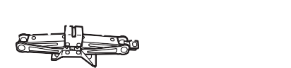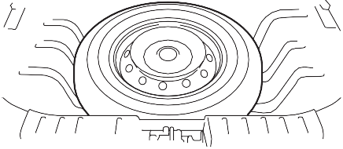

**EXAMPLE**

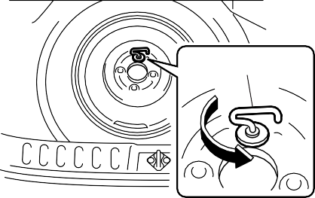

(1)



**EXAMPLE**

53MH0801



**EXAMPLE**

74LHT0807

The jack (1) is stowed below the luggage compartment board as shown in the above illustration.

68KH091

To remove the spare tire, turn its bolt (1) counterclockwise and remove it.

To remove the jack, remove the spare tire and turn the jacks shaft counterclockwise and pull the jack out of the storage bracket. To stow the jack, place it in the storage bracket and turn the shaft clockwise until the jack is securely held in place.



**After using the tire changing tools, be sure to stow them securely or they can cause injury if an accident occurs.**

**WARNING**

52KM119

1. Place the vehicle on level, hard ground.
2. Set the parking brake firmly and shift into “R” (Reverse) if your vehicle has a manual transaxle.



* **Be sure to shift into “R” (Reverse) when you jack up the vehicle.**
* **Never jack up the vehicle with the transaxle in “N” (Neutral). Other- wise, unstable jack may cause an accident.**

**WARNING**

### 8-1

#### EMERGENCY SERVICE

1. Turn on the hazard warning flasher if your vehicle is near traffic.
2. Block the front and rear of the wheel diagonally opposite of the wheel being lifted.

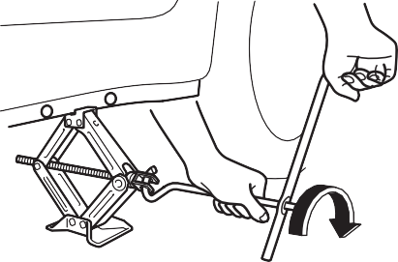

**EXAMPLE**



* **Use the jack only to change wheels on level, hard ground.**
* **Never jack up the vehicle on an inclined surface.**
* **Never raise the vehicle with the jack in a location other than the specified jacking point (shown in the illustration) near the wheel to be changed.**
* **Make sure that the jack is raised at least 51 mm (2 inches) before it contacts the suspension arm boss. Use of the jack when it is within 51 mm (2 inches) of being fully col- lapsed may result in failure of the jack.**
* **Never get under the vehicle when it is supported by the jack.**
* **Never run the engine when the vehicle is supported by the jack and never allow passengers to remain in the vehicle.**

**WARNING**

1. Place the spare wheel near the wheel being lifted as shown in the illustration in case that the jack slips.

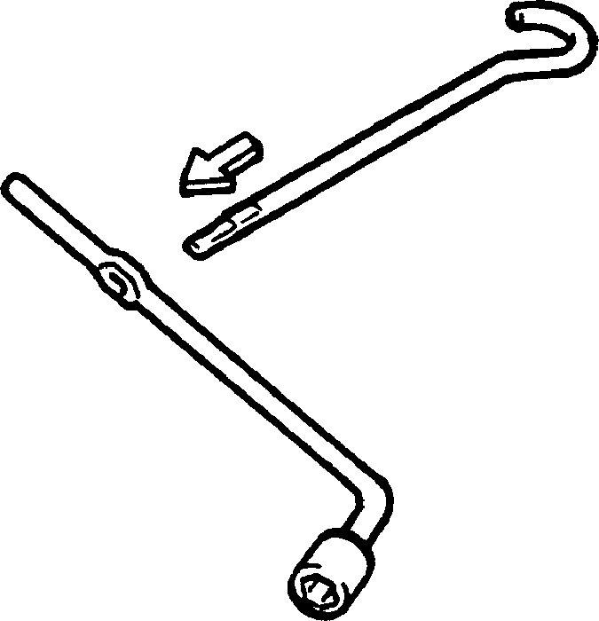

**EXAMPLE**

54G253

53MH0804

1. Position the jack vertically and raise the jack by turning the jack handle clock- wise until the jack head groove fits around the jacking bar beneath the vehicle body. See illustrations.
2. Continue to raise the jack slowly and smoothly until the tire clears the ground. Do not raise the vehicle more than necessary.

To Raise the Vehicle with a Garage Jack

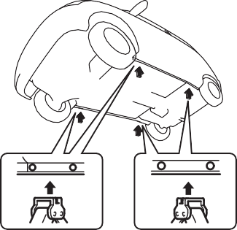

**EXAMPLE**

* + Apply the garage jack to one of the points indicated below.

53MH0803

### 8-2

#### EMERGENCY SERVICE

* + 1. Front
    2. Rear

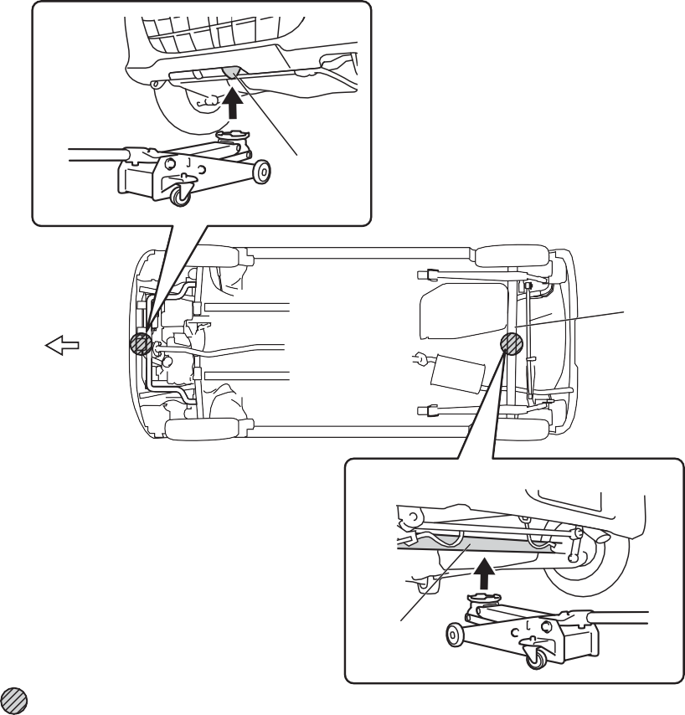

(1)

**EXAMPLE**

(3)

(4)

(1)

(2)

(4)

(5)

* + 1. Jack bracket
    2. Rear axle
    3. Jacking point for garage jack

**Never apply a garage jack to the exhaust pipe or engine undercover and rear torsion beam.**

***NOTICE***

*NOTE:*

*For more details, please contact an autho- rized MARUTI SUZUKI dealer.*

53MH0805

**8-3**

## Changing Wheels

To change a wheel, use the following pro- cedure:

1. Clear all passengers and luggage from the vehicle.

*NOTE:*

*Jack and the tools are located below the luggage compartment board.*

1. Remove the jack, tools and spare wheel from the vehicle.
2. Loosen, but do not remove the wheel nuts.
3. Jack up the vehicle.
4. Remove the wheel nuts and wheel.
5. Before installing the new wheel, clean any mud or dirt off from the surface of the wheel and hub with a clean cloth. Clean the hub carefully; it may be hot from driving.
6. Install the new wheel and replace the wheel nuts with their cone shaped end facing the wheel. Tighten each nut snugly by hand until the wheel is securely seated on the hub.

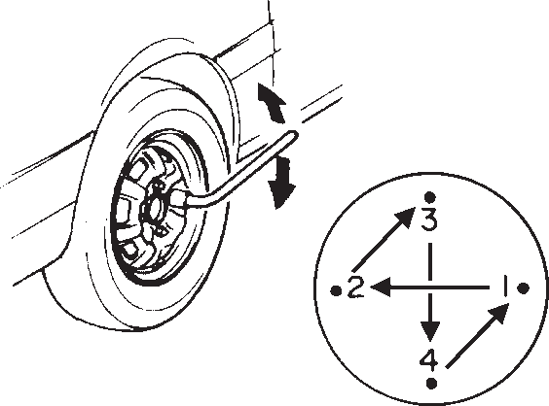

**EXAMPLE**

53M-10-009

Tightening torque for wheel nut 85 Nm (8.5 kg-m, 61.5 lb-ft)

1. Lower the jack and fully tighten the nuts in a crisscross fashion with a wrench as shown in the illustration.



**Use genuine wheel nuts and tighten them to the specified torque as soon as possible after changing wheels. Incorrect wheel nuts or improperly tightened wheel nuts may come loose or fall off, which can result in an accident. If you do not have a torque wrench, have the wheel nut torque checked by an authorized SUZUKI dealer.**

**WARNING**

#### EMERGENCY SERVICE

##### Full Wheel Cover (if equipped)

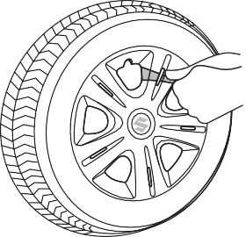

**EXAMPLE**

53M-10-010

Insert a piece of cloth between the spokes of the wheel cover and try to pull the cover outward (as shown in figure). Take out the detached wheel cover from the wheel rim. For installation first match the slot at the wheel cover with the air filling nozzle of the wheel. Apply equal pressure at the circum- ference of the wheel cover to fix it in the wheel rim.

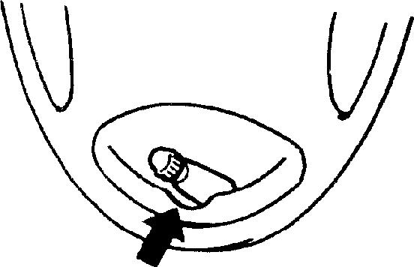

**EXAMPLE**

54G117

When installing the cover, make sure that it is positioned so that it does not cover or foul the air valve.

### 8-4

**EMERGENCY SERVICE**

## Jump Starting Instructions

**Your vehicle should not be started by pushing or towing. This starting method could result in permanent damage to the catalytic converter. Use jump leads to start a vehicle with a weak or flat battery.**

***NOTICE***

##### When Jump Starting Your Vehicle, Use the Following Procedure:



* **Never attempt to jump start your vehicle if the battery appears to be frozen. Batteries in this condition may explode or rupture if jump starting is attempted.**
* **When making jump lead connec- tions, be certain that your hands and the jump leads remain clear from pulleys, belts, or fans.**
* **Batteries produce flammable hydrogen gas. Keep flames and sparks away from the battery or an explosion may occur. Never smoke when working in the vicinity of the battery.**
* **If the booster battery you use for jump starting is installed in another vehicle, make sure the two vehicles are not touching each other.**
* **If your battery discharges repeat- edly, for no apparent reason, have your vehicle inspected by an authorized MARUTI SUZUKI dealer.**
* **To avoid harm to yourself or dam- age to your vehicle or battery, fol- low the jump starting instructions below precisely and in order.**

**If you are in doubt, call for qualified road service.**

**WARNING**

* 1. Use only a 12-volt battery to jump start your vehicle. Position the good 12-volt battery close to your vehicle so that the jump leads will reach both batteries. When using a battery installed on another vehicle, DO NOT LET THE VEHICLES TOUCH. Set the parking brakes fully on both vehicles.
  2. Turn off all vehicle accessories, except those necessary for safety reasons (for example, headlights or hazard lights).

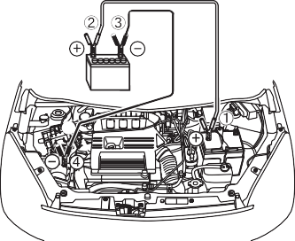

**EXAMPLE**

53M-10-012

* 1. Make jump lead connections as follows:
     1. Connect one end of the first jump lead to the positive (+) terminal of the flat battery (1).
     2. Connect the other end to the positive (+) terminal of the booster battery (2).
     3. Connect one end of the second jump lead to the negative (–) terminal of the booster battery (2).
     4. Make the final connection to an unpainted, heavy metal part (i.e. engine hook (3)) of the engine of the vehicle with the flat battery (1).



**Never connect the jump lead directly to the negative (–) terminal of the dis- charged battery, or an explosion may occur.**

**WARNING**

* 1. If the booster battery you are using is fitted to another vehicle, start the engine of the vehicle with the booster battery. Run the engine at moderate speed.
  2. Start the engine of the vehicle with the flat battery.
  3. Remove the jump leads in the exact reverse order in which you connected them.

**8-5**

## Towing

If you need to have your vehicle towed, contact a professional service. Your dealer can provide you with detailed towing instructions.

**To help avoid damage to your vehicle during towing, proper equipment and towing procedures must be used.**

***NOTICE***

2-Wheel Drive (2WD) Manual Transaxle or Automated Manual Transaxle

Manual transaxle vehicles or Automated Manual Transaxle may be towed using either of the following methods.

1. From the front, with the front wheels lifted and the rear wheels on the ground. Before towing, make sure that the parking brake is released.
2. From the rear, with the rear wheels lifted and the front wheels on the ground, provided the steering and drivetrain are in operational condition. Before towing, make sure that transaxle is in neutral, the steering wheel is unlocked (the ignition key should be in the “ACC” position), and the steering wheel is secured with a clamping device designed for towing service.

**EMERGENCY SERVICE**

## If the Starter Does Not Operate

**After shifting the auto gear shift gear- shift lever to the “N” position, always check the gear position indicator in the instrument cluster shows the “N” position to make sure that the transaxle is disengaged.**

**If the transaxle cannot be put in neu- tral, turn the key from the “OFF” to the “ON” position, and move the auto gear shift gearshift lever from “N” to “D”, “M” or “R”, then back to “N” again. Then turn the key from the “ON” to the “OFF” position.**

**These procedures may help put the transaxle in neutral. If the transaxle still cannot be put in neutral, you can- not tow the vehicle without using a towing dolly.**

***NOTICE***

1. Try turning the ignition switch to the “START” position with the headlights turned on to determine the battery con- dition. If the headlights go excessively dim or go off, it usually means that either the battery is flat or the battery terminal contact is poor. Recharge the battery or correct battery terminal con- tact as necessary.
2. If the headlights remain bright, check the fuses. If the reason for failure of the starter is not obvious, there may be a major electrical problem. Have the vehi-

cle inspected by your authorized MAR- UTI SUZUKI dealer.

## If the Engine is Flooded

If the engine is flooded with gasoline, it may be hard to start. If this happens, press the accelerator pedal all the way to the floor and hold it there while cranking the engine. (Do not operate the starter motor for more than 15 seconds).

**The steering column is not strong enough to withstand shocks trans- mitted from the front wheels during towing. Always unlock the steering wheel before towing.**

***NOTICE***

### 8-6

**EMERGENCY SERVICE**

## If the Engine Overheats

The engine could overheat temporarily under severe driving conditions. If the high engine coolant temperature warning light comes on as overheating during driving:

1. Turn off the air conditioner, if equipped.
2. Take the vehicle to a safe place and park.
3. Let the engine run at the normal idle speed for a few minutes until the high engine coolant temperature warning light goes off.



**If you see or hear escaping steam, stop the vehicle in a safe place and immediately turn off the engine to let it cool. Do not open the hood when steam is present. When the steam can no longer be seen or heard, open the hood to see if the coolant is still boiling. If it is, you must wait until it stops boiling before you proceed.**

**WARNING**

If the high engine coolant temperature warning light does not go off:

1. Turn off the engine and check that the water pump belt and pulleys are not damaged or slipping. If any abnormality is found, correct it.
2. Check the coolant level in the reservoir. If it is found to be lower than the “LOW” line, look for leaks at the radiator, water pump, and radiator and heater hoses. If you locate any leaks that may have caused the overheating, do not run the engine until these problems have been corrected.
3. If you do not find a leak, carefully add coolant to the reservoir and then the radiator, if necessary. (Refer to “Engine Coolant” in the “INSPECTION AND MAINTENANCE” section.)



* **It is hazardous to remove the radia- tor cap (or degassing tank cap for a diesel engine) when the water tem- perature is high, because scalding fluid and steam may be blown out under pressure. The cap should only be taken off when the coolant temperature has lowered.**
* **To help prevent personal injury, keep hands, tools and clothing away from the engine cooling fan and air-conditioner fan (if equipped). These electric fans can automatically turn on without warn- ing.**

**WARNING**

*NOTE:*

*If your engine overheats and you are unsure what to do, contact your MARUTI SUZUKI dealer.*

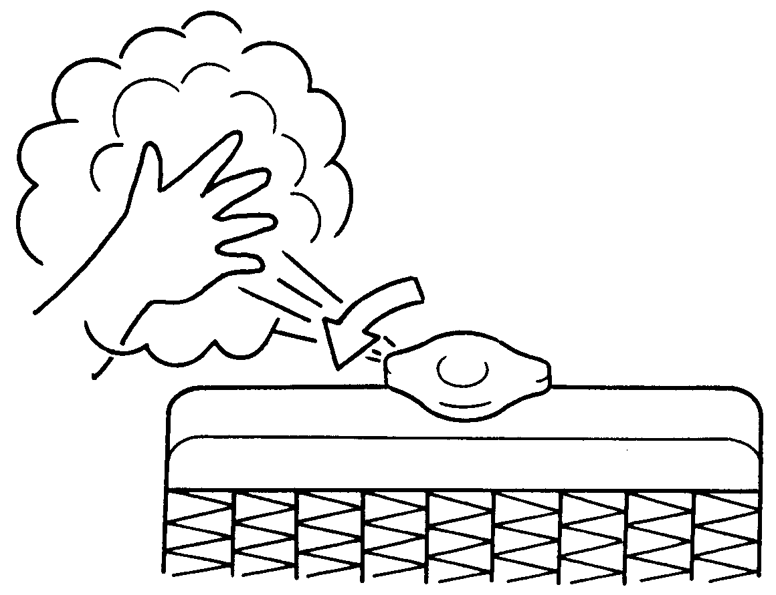

65D614

**8-7**

## Warning Triangle



**EXAMPLE**

53M-10-014

* + Remove the warning triangle carefully from the cover as shown by arrow 1.
  + Open both the reflector arms as shown by arrow and lock the arms with each other with the clip provided in the right arm. Open the bottom stand in counter clock-wise direction as shown by arrow

3. Position the warning triangle behind the vehicle on a plain surface.

* + Reverse the removal procedure for keep-

#### EMERGENCY SERVICE

In case of vehicle break-down or during emergency stopping, where, your vehicle could become a potential traffic hazard, keep the warning triangle, provided with your vehicle, on the road free from any obstacles behind your vehicle so as to warn the approaching traffic, at an approxi- mate distance of 50-100 m. The reflecting side of the triangle should face the on com- ing traffic. Please activate the hazard warning lamps before alighting the vehicle to keep the warning triangle.



**EXAMPLE**

53M-10-015

ing inside the cover.

53M-10-016

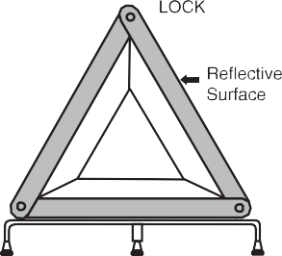

**EXAMPLE**

**8-8**

# APPEARANCE CARE

#### APPEARANCE CARE

Corrosion Prevention 9-1

**Vehicle Cleaning 9-2**

**9**

**APPEARANCE CARE**

## Corrosion Prevention

It is important to take good care of your vehicle to protect it from corrosion. Listed below are instructions for how to maintain your vehicle to prevent corrosion. Please read and follow these instructions carefully.

##### Important Information About Corrosion

Common causes of corrosion

1. Accumulation of road salt, dirt, mois- ture, or chemicals in hard-to-reach areas of the vehicle underbody or frame.
2. Chipping, scratches and any damage to treated or painted metal surfaces resulting from minor accidents or abra- sion by stones and gravel.

Environmental conditions which accel- erate corrosion

1. Road salt, dust control chemicals, sea air or industrial pollution will all acceler- ate the corrosion of metal.
2. High humidity will increase the rate of corrosion particularly when the tem- perature range is just above the freez- ing point.
3. Moisture in certain areas of a vehicle for an extended period of time may pro- mote corrosion even though other body sections may be completely dry.
4. High temperatures will cause an accel- erated rate of corrosion to parts of the

vehicle which are not well ventilated to permit quick drying.

This information illustrates the necessity of keeping your vehicle (particularly the underbody) as clean and dry as possible. It is equally important to repair any damage to the paint or protective coatings as soon as possible.

##### How to Help Prevent Corrosion

Wash your vehicle frequently

The best way to preserve the finish on your vehicle and to help avoid corrosion is to keep it clean with frequent washing. Wash your vehicle at least once during the winter and once immediately after the winter. Keep your vehicle, particularly the under- side, as clean and dry as possible. If you frequently drive on salted roads, your vehi- cle should be washed at least once a month during the winter. If you live near the ocean, your vehicle should be washed at least once a month throughout the year.

For washing instructions, refer to the “Vehi- cle Cleaning” section.

**Remove foreign material deposits** Foreign material such as salts, chemicals, road oil or tar, tree sap, bird droppings and industrial fall-out may damage the finish of your vehicle if it is left on painted surfaces. Remove these types of deposits as quickly as possible. If these deposits are difficult to wash off, an additional cleaner may be

required. Be sure that any cleaner you use is not harmful to painted surfaces and is specifically intended for your purposes. Follow the manufacturer’s directions when using these special cleaners.

Repair finish damage

Carefully examine your vehicle for damage to the painted surfaces. Should you find any chips or scratches in the paint, touch them up immediately to prevent corrosion from starting. If the chips or scratches have gone through to the bare metal, have a qualified body shop make the repair.

Keep passenger and luggage compart- ments clean

Moisture, dirt or mud can accumulate under the floor mats and may cause corro- sion. Occasionally, check under these mats to ensure that this area is clean and dry. More frequent checks are necessary if the vehicle is used off road or in wet weather.

Certain cargos such as chemicals, fertiliz- ers, cleaners, salts, etc. are extremely cor- rosive by nature. These products should be transported in sealed containers. If a spill or leak does occur, clean and dry the area immediately.

### 9-1

Store your vehicle in a dry, well-venti- lated area

Do not park your vehicle in a damp, poorly ventilated area. If you often wash your vehicle in the garage or if you frequently drive it in when wet, your garage may be damp. The high humidity in the garage may cause or accelerate corrosion. A wet vehicle may corrode even in a heated garage if the ventilation is poor.



**Do not apply additional undercoating or rust preventive coating on or around exhaust system components such as the catalytic converter, exhaust pipes, etc. A fire could be started if the undercoating substance becomes overheated.**

**WARNING**

## Vehicle Cleaning

#### APPEARANCE CARE

##### Cleaning the Interior

Vinyl upholstery

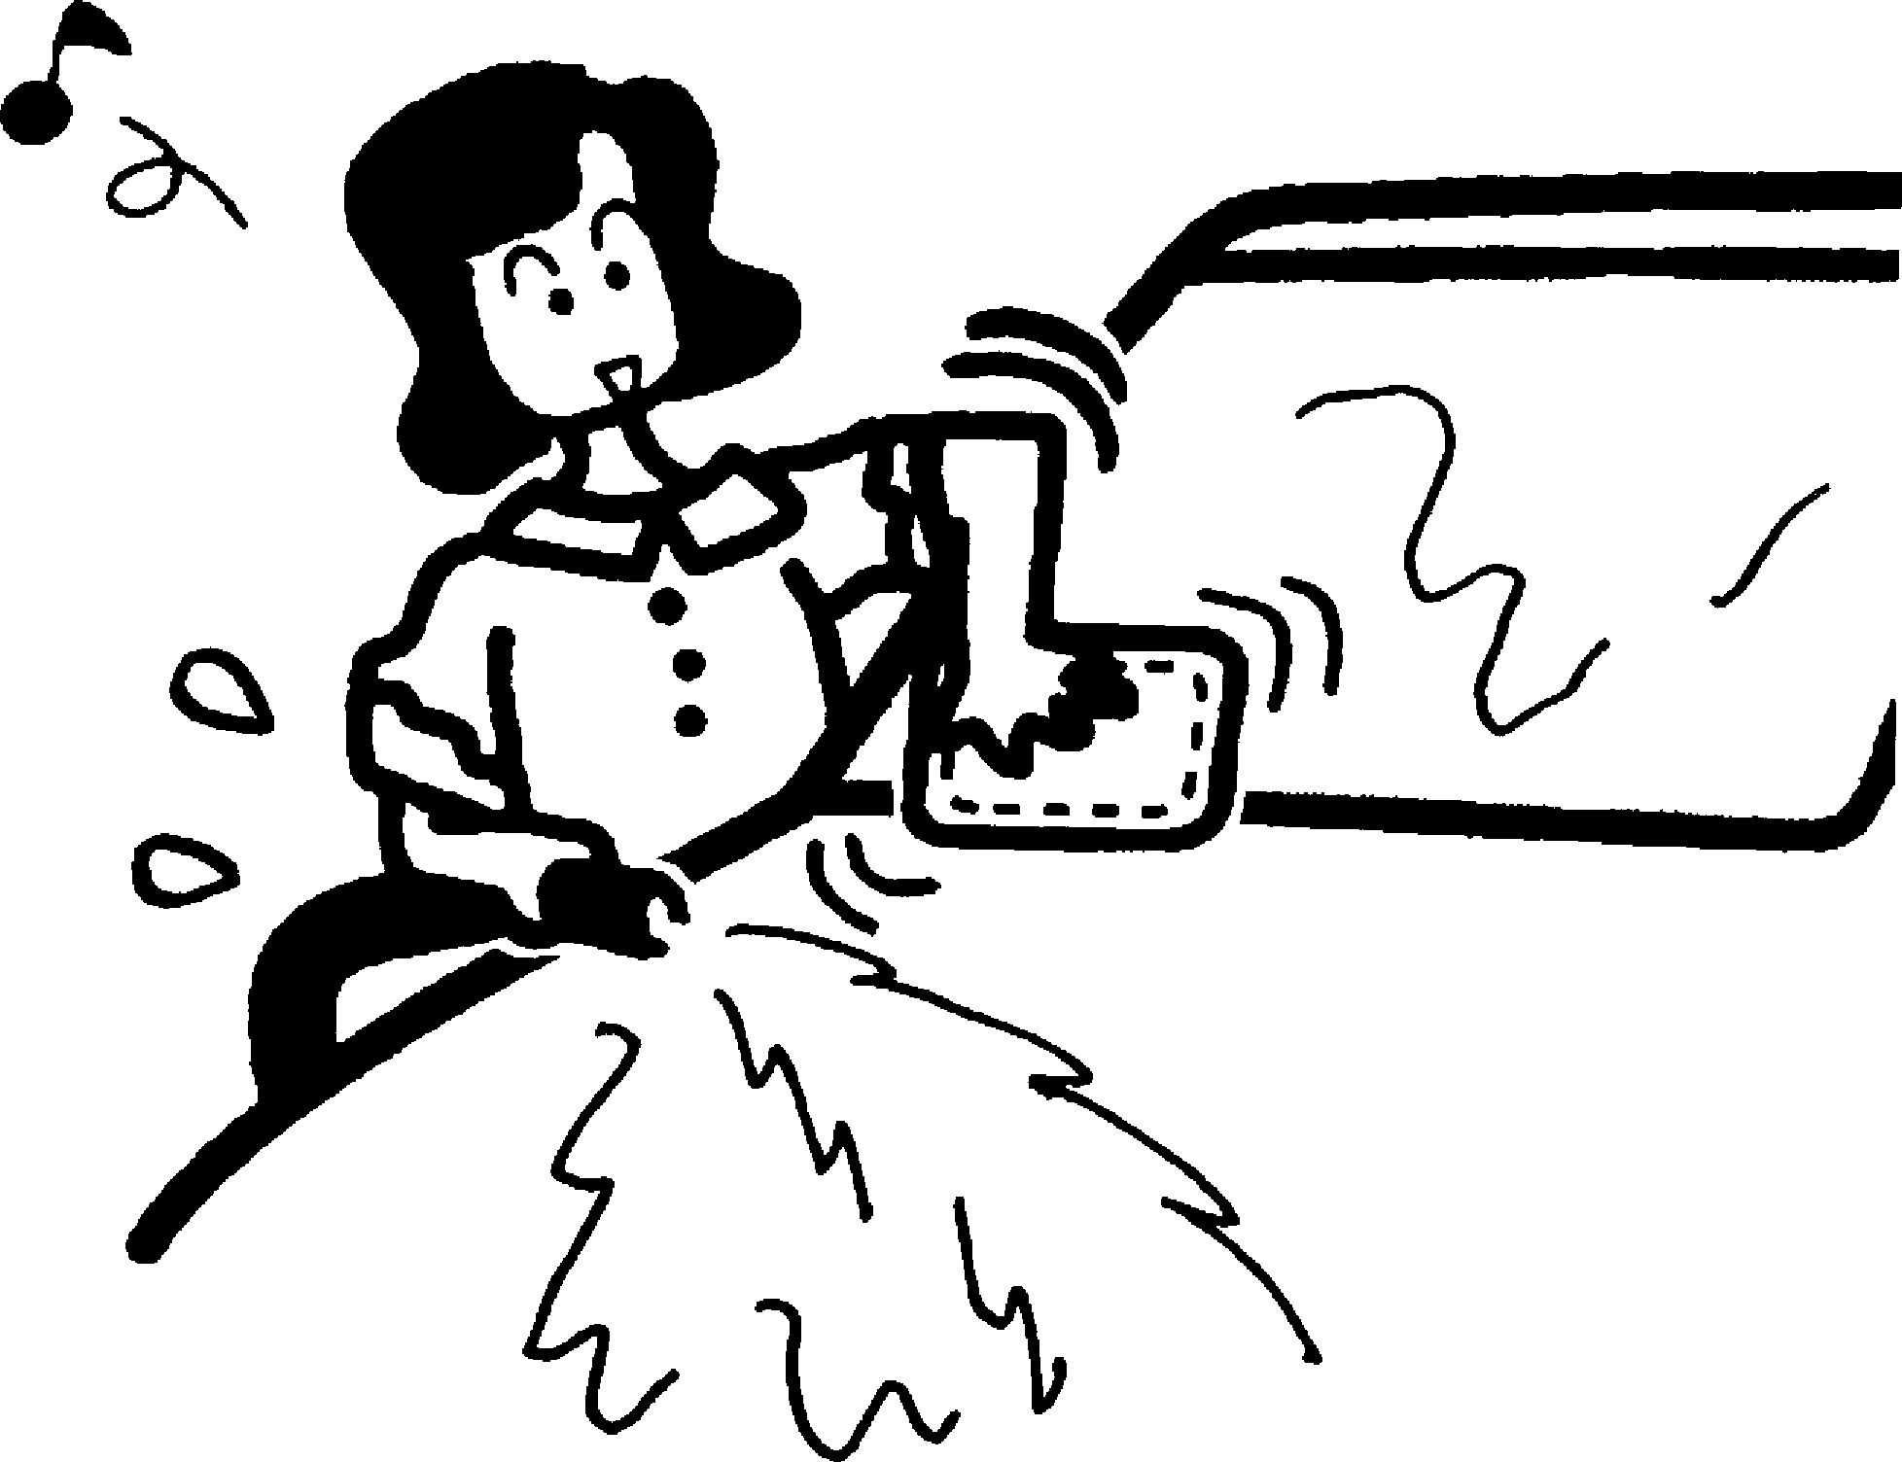

76G044S

**When cleaning the interior or exterior of the vehicle, NEVER USE flammable solvents such as lacquer thinners, gasoline, benzene or cleaning materi- als such as bleaches or strong household detergents. The materials could cause personal injury or dam- age to the vehicle.**

**WARNING**

**EXAMPLE**

Prepare a solution of soap or mild deter- gent mixed with warm water. Apply the solution to the vinyl with a sponge or soft cloth and let it soak for a few minutes to loosen dirt.

Rub the surface with a clean, damp cloth to remove dirt and the soap solution. If some dirt still remains on the surface, repeat this procedure.

Fabric upholstery

Remove loose dirt with a vacuum cleaner. Using a mild soap solution, rub stained areas with a clean damp cloth. To remove

soap, rub the areas again with a cloth dampened with water. Repeat this until the

stain is removed, or use a commercial fab- ric cleaner for tougher stains. If you use a fabric cleaner, carefully follow the manu- facturer’s instructions and precautions.

Seat belts

Clean seat belts with a mild soap and water. Do not use bleach or dye on the belts. They may weaken the fabric in the belts.

Vinyl floor mats

Ordinary dirt can be removed from vinyl with water or mild soap. Use a brush to help loosen dirt. After the dirt is loosened, rinse the mat thoroughly with water and dry it in the shade.

### 9-2

#### APPEARANCE CARE

Carpets

Remove dirt and soil as much as possible with a vacuum cleaner. Using a mild soap solution, rub stained areas with a clean damp cloth. To remove soap, rub the areas again with a cloth dampened with water. Repeat this until the stain is removed, or use a commercial carpet cleaner for tougher stains. If you use a carpet cleaner, carefully follow the manufacturer’s instruc- tions and precautions.

##### Cleaning the Exterior

**It is important that your vehicle be kept clean and free from dirt. Failure to keep your vehicle clean may result in fading of the paint or corrosion to various parts of the vehicle body.**

***NOTICE***

Caring for Aluminum Wheels

*NOTE:*

* *Do not use an acidic or alkaline deter- gent to wash aluminum wheels. These types of detergent will cause permanent spots, discoloration and cracks on fin- ished surfaces.*
* *Do not use a bristle brush and soap con- taining an abrasive material. These will damage finished surfaces.*

##### Washing

When washing the vehicle, park it where direct sunlight does not fall on it and follow the instructions below:

1. Flush the underside of body and wheel housings with pressurized water to remove mud and debris. Use plenty of water.

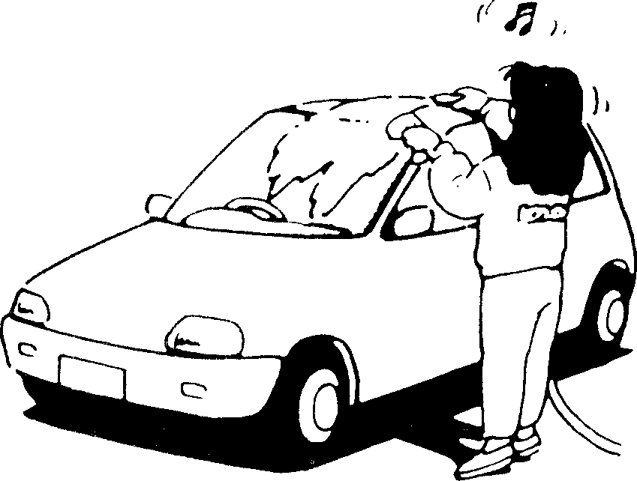

60B212S

* **Never attempt to wash and wax your vehicle with the engine run- ning.**
* **When cleaning the underside of the body and fender, where there may be sharp-edged parts, you should wear gloves and a long-sleeved shirt to protect your hands and arms from being cut.**
* **After washing your vehicle, care- fully test the brakes before driving to make sure they have maintained their normal effectiveness.**

**WARNING**

**EXAMPLE**

**When washing the vehicle:**

* **Avoid directing steam or hot water of more than 80°C (176°F) on plas- tic parts.**
* **To avoid damaging engine compo- nents, do not use pressurized water in the engine compartment.**

***NOTICE***

1. Rinse the body to loosen the dirt. Remove dirt and mud from the body exterior with running water. You may use a soft sponge or brush. Do not use hard materials which can scratch the paint or plastic. Remember that the headlight covers or lenses are made of plastic in many cases.

### 9-3

**To avoid damage to the paint or plas- tic surface, do not wipe the dirt off without ample water. Be sure to fol- low above procedure.**

***NOTICE***

#### APPEARANCE CARE

1. Wash the entire exterior with a mild detergent or car wash soap using a sponge or soft cloth. The sponge or cloth should be frequently soaked in the soap solution.

##### Waxing

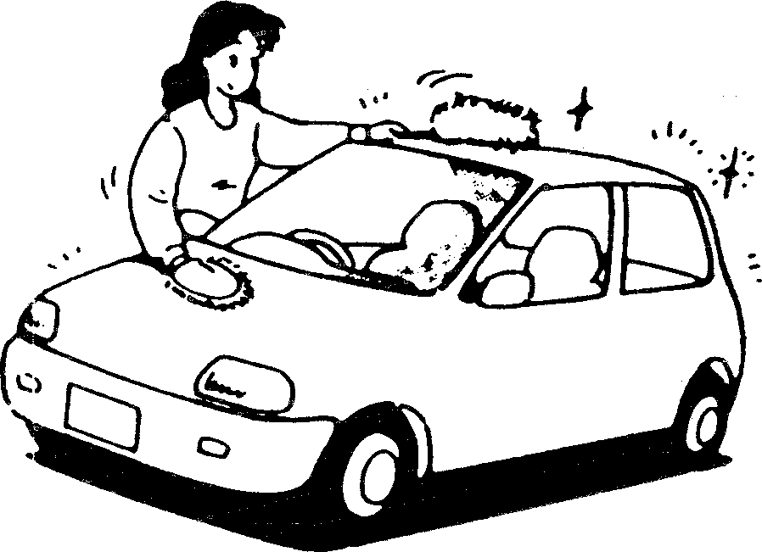

**EXAMPLE**

**When using a commercial car wash product, observe the cautions speci- fied by the manufacturer. Never use strong household detergents or soaps.**

***NOTICE***

**If you use an automatic car wash, make sure that your vehicle’s body parts, such as spoilers, cannot be damaged. If you are in doubt, consult the car wash operator for advice.**

***NOTICE***

1. Once the dirt has been completely removed, rinse off the detergent with running water.
2. After rinsing, wipe off the vehicle body with a wet chamois or cloth and allow it to dry in the shade.
3. Check carefully for damage to painted surfaces. If there is any damage, “touch-up” the damage following the procedure below:
   1. Clean all damaged spots and allow them to dry.
   2. Stir the paint and “touch-up” the damaged spots lightly using a small brush.
   3. Allow the paint to dry completely.

60B211S

After washing the vehicle, waxing and pol- ishing are recommended to further protect and beautify the paint.

* Only use waxes and polishes of good quality.
* When using waxes and polishes, observe the precautions specified by the manufacturers.

### 9-4

**GENERAL INFORMATION**

# GENERAL INFORMATION

Vehicle Identification 10-1

**10**

**GENERAL INFORMATION**

## Vehicle Identification

##### Chassis Serial Number

53M-12-001

The chassis and/or engine serial numbers are used to register the vehicle. They are also used to assist your dealer when order- ing or referring to special service informa- tion. Whenever you have occasion to consult your MARUTI SUZUKI dealer, remember to identify your vehicle with this number. Should you find the number diffi- cult to read, you will also find it on the iden- tification plate.

##### Engine Serial Number

###### ALTO 800



**ALTO K10**

53M-12-002

The engine serial number is stamped on the cylinder block as shown in the illustra- tion.

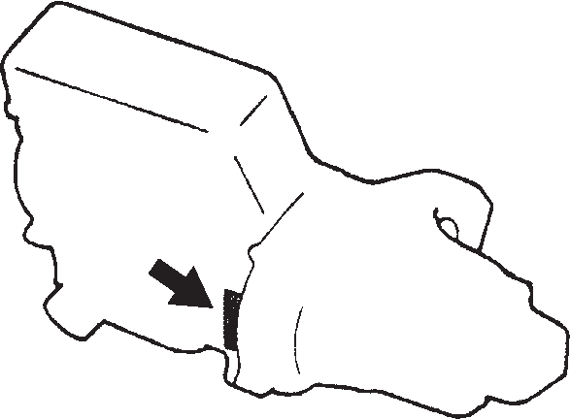53M-12-003

**10-1**

# SPECIFICATIONS

*NOTE:*

*Specifications are subject to change without notice.*

#### SPECIFICATIONS

|  |  |  |  |
| --- | --- | --- | --- |
| **ITEM: Dimensions UNIT: mm** | | | |
|  | | **ALTO 800** | **ALTO K10** |
| Overall length | | 3430 | 3545 |
| Overall width | With Body Side Molding | 1515 | 1515 |
| Without Body Side Molding | 1490 | 1490 |
| Overall height | | 1475 | 1475 |
| Wheelbase | | 2360 | 2360 |
| Track Front | | 1295 | 1295 |
| Rear | | 1290 | 1290 |
| Ground clearance | | 160 | 160 |

**11**

|  |  |  |  |
| --- | --- | --- | --- |
| **ITEM: Mass (weight) UNIT: kg** | | | |
|  | | **ALTO 800** | **ALTO K10** |
| Curb mass (weight) | | 695-727 | 740-755 |
| Gross vehicle mass (weight) rating | | 1185 | 1210 |
| Permissible maximum Axle Weight | Front | 630 | 630 |
| Rear | 630 | 630 |

### 11-1

**SPECIFICATIONS**

|  |  |  |
| --- | --- | --- |
| **ITEM: Engine** | | |
|  | **ALTO 800** | **ALTO K10** |
| Type | F8D | K10B |
| Number of cylinders | 3 | 3 |
| Bore | 68.5 mm | 73 mm |
| Stroke | 72.0 mm | 79.5 mm |
| Piston displacement | 796 cm3 (796 cc) | 998 cm3 (998 cc) |
| Compression ratio | 10.95 ± 0.4 : 1 | 11 ± 0.4 : 1 |

|  |  |  |  |
| --- | --- | --- | --- |
| **ITEM: Electrical** | | | |
|  | | **ALTO 800** | **ALTO K10** |
| Standard spark plug | Nickel plug | NGK DCPR7E, BOSCH YR7DC | NGK, KR6A-10 |
| Battery | | 12V 34B19 | 12V 34B19 |
| Fuses | | See “INSPECTION AND MAINTENANCE” section. | |

### 11-2

**SPECIFICATIONS**

|  |  |  |  |  |  |
| --- | --- | --- | --- | --- | --- |
| **ITEM: Lights** | | | | | |
|  | | **ALTO 800** | | **ALTO K10** | |
|  | | **WATTAGE** | **BULB No.** | **WATTAGE** | **BULB No.** |
| Headlight | | 12V 60/55W | H4 | 12V 60/55W | H4 |
| Turn signal light | Front | 12V 21W | P21W | 12V 21W | PY21W |
| Rear | 12V 21W | PY21W | 12V 21W | PY21W |
| Side turn signal light | | 12V 5W | W5W | 12V 5W | W5W |
| Position light | | 12V 5W | W5W | 12V 5W | W5W |
| Brake/tail light | | 12V 21/5W | P21/5W | 12V 21/5W | P21/5W |
| License plate light | | 12V 5W | W5W | 12V 5W | W5W |
| Reversing light | | 12V 21W | P21W | 12V 21W | P21W |
| Interior light | | 12V 8W | – | 12V 8W | – |
| High mount stop light | | 12V 16W | W16W | 12V 16W | W16W |

### 11-3

#### SPECIFICATIONS

|  |  |  |
| --- | --- | --- |
| **ITEM: Wheels and Tires** | | |
|  | **ALTO 800** | **ALTO K10** |
| Tire size, front and rear | 145/80R12 74S*1 | 155/65 R13 73S*1 |
| 145/80R12 74H*1 | 155/65 R13 73T*1 |
| 145/80R12 74T*1 | — |
| Rim size | 145/80R12 74S*1: 12 × 3.50B | 155/65 R13 73S*1 : 13X4 1/2J |
| 145/80R12 74H*1: 12 × 3.50B | 155/65 R13 73T*1 : 13X4 1/2J |
| 145/80R12 74T*1: 12 × 3.50B | — |
| Tire pressures | For the specified tire pressure, see the Tire Information Label located the driver’s door lock pillar. | |

*1: When tire replacement is necessary and if the specified load index and speed rated tire is not available, then use a tire of higher load index and speed rating.

|  |  |  |
| --- | --- | --- |
| **ITEM: Capacities (approx.)** | | |
|  | **ALTO 800** | **ALTO K10** |
| Coolant (including reservoir tank) | 3.5 L | 4.5 L |
| Fuel tank | 35 L | 35 L |
| Engine oil | 3.0 L (replacement with oil filter) | 2.8 L (replacement with oil filter) |
| Transaxle oil | 1.5 L | 1.45 L |

**11-4**